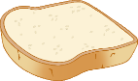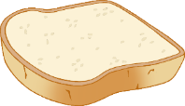

Picnic Area

© 2021 Little Owls Resources



Picnic Area

© 2021 Little Owls Resources

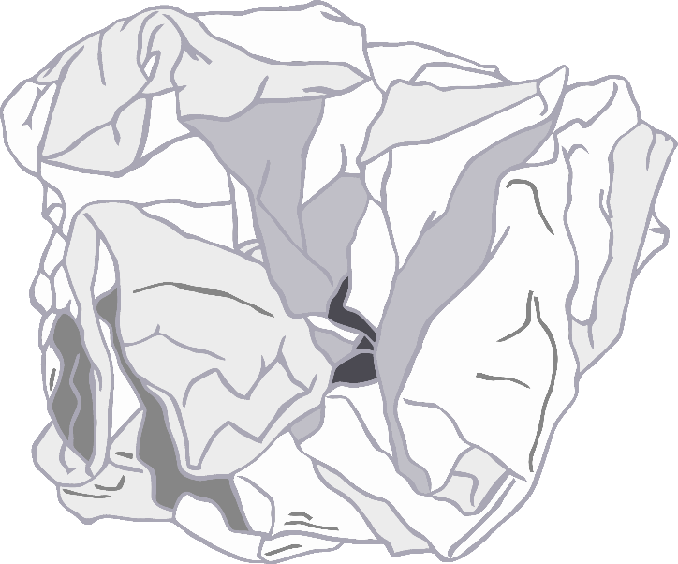

© 2021 Little Owls Resources

goes here

Rubbish

Recycling

© 2021 Little Owls Resources

goes here

© 2021 Little Owls Resources

go here

Cups

© 2021 Little Owls Resources

Plates

go here

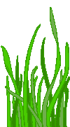

Outdoor

Eating!

© 2021 Little Owls Resources

Wash your hands before touching food!

© 2021 Little Owls Resources