\*Counters to be cut and laminated (page 3)

\*Print as many sets as there are players.

\*Words for game to be cut and laminated (pages 4-11). Only one set needed.

1. Place leaves on the tree.
2. Shuffle words cards and place upside down. (Either in a pile or spread across the table).
3. Take turns to turn over a card and read the word. Share with other players.
4. If word is correctly read remove the number of leaves displayed on the card from the tree.
5. If all cards are read before the end of the game, shuffle cards and use again.
6. Winner is first person to remove all leaves.

Phase 2 Words Autumn Game

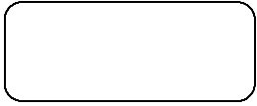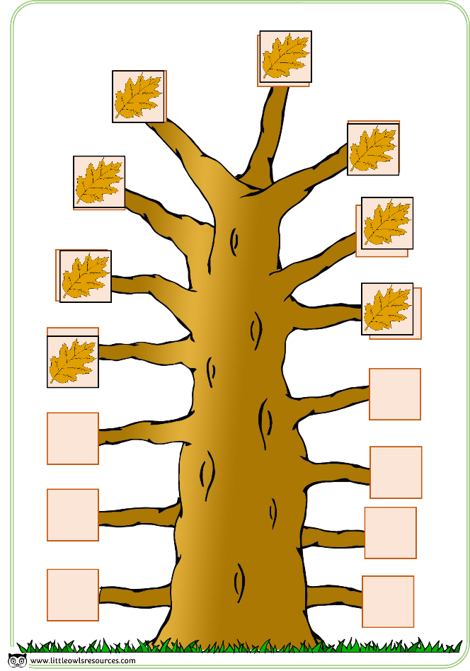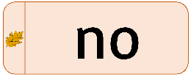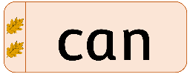



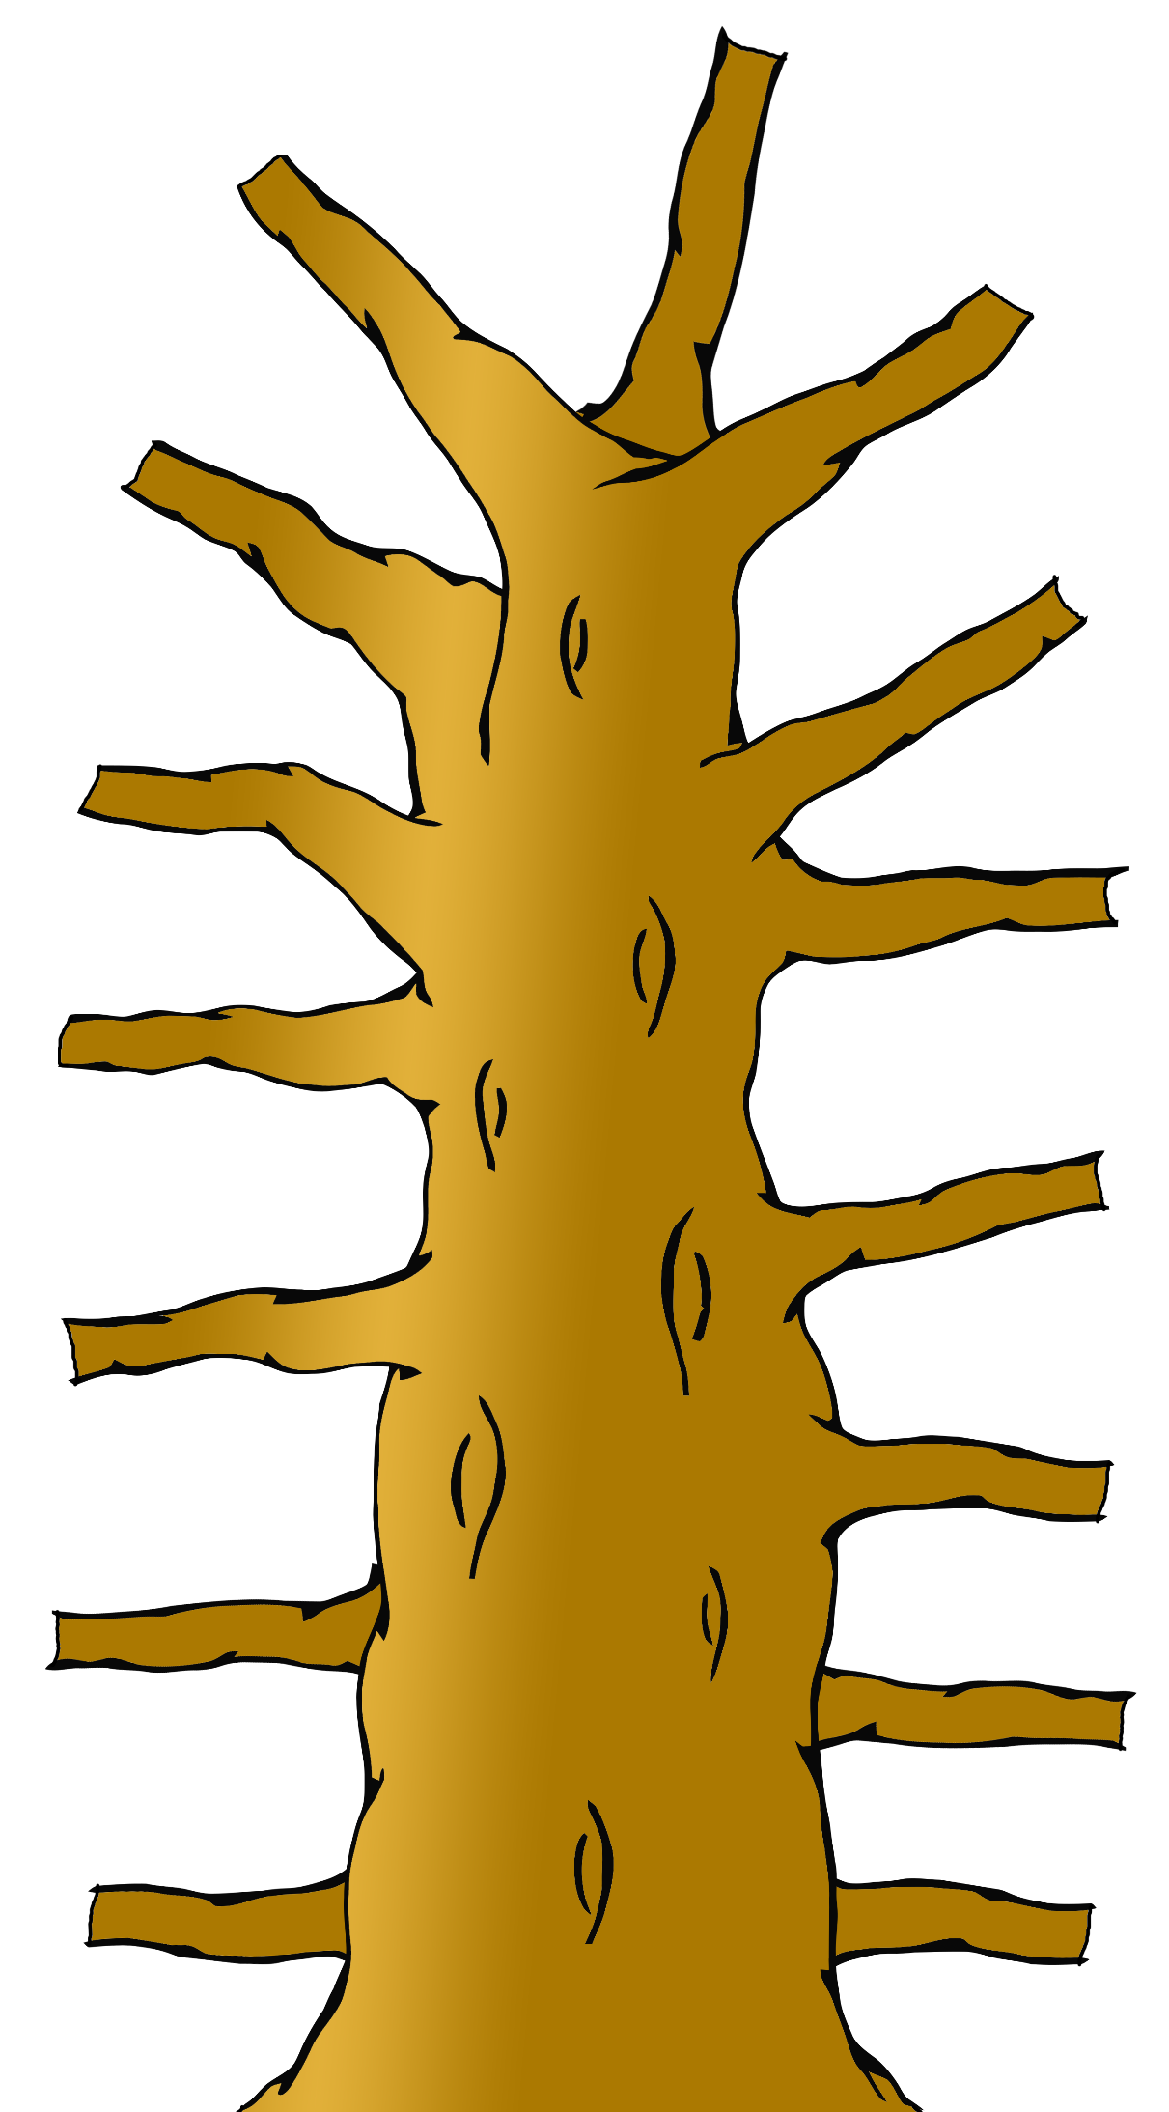

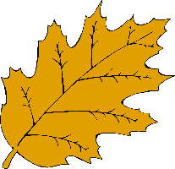

a

at

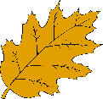

an



as



© 2019 Little Owls Resources

© 2019 Little Owls Resources

© 2019 Little Owls Resources

© 2019 Little Owls Resources

go

I



is



if



© 2019 Little Owls Resources

© 2019 Little Owls Resources

© 2019 Little Owls Resources

© 2019 Little Owls Resources

it

of



in



up



© 2019 Little Owls Resources

© 2019 Little Owls Resources

© 2019 Little Owls Resources

© 2019 Little Owls Resources

no

on



can



got





© 2019 Little Owls Resources

© 2019 Little Owls Resources

© 2019 Little Owls Resources

© 2019 Little Owls Resources

back

dad



had

big



© 2019 Little Owls Resources

© 2019 Little Owls Resources

© 2019 Little Owls Resources

© 2019 Little Owls Resources

get

him



and

but



© 2019 Little Owls Resources

© 2019 Little Owls Resources

© 2019 Little Owls Resources

© 2019 Little Owls Resources

his

not



the

two



© 2019 Little Owls Resources

© 2019 Little Owls Resources

© 2019 Little Owls Resources

© 2019 Little Owls Resources

mum

off



into

big



© 2019 Little Owls Resources

© 2019 Little Owls Resources

© 2019 Little Owls Resources

© 2019 Little Owls Resources

© 2019 Little Owls Resources

© 2019 Little Owls Resources

© 2019 Little Owls Resources

Mum

Dad



to

