tree

tree

© 2020 Little Owls Resources

ant

ant

© 2020 Little Owls Resources

star

star

© 2020 Little Owls Resources

nest

nest

© 2020 Little Owls Resources

frog

frog

© 2020 Little Owls Resources

crab

crab

© 2020 Little Owls Resources

stem

stem

© 2020 Little Owls Resources

skeleton

skeleton

© 2020 Little Owls Resources

dragon

dragon

© 2020 Little Owls Resources

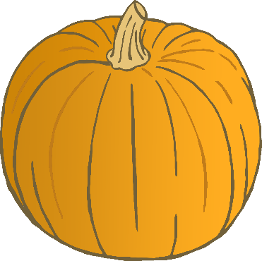

pumpkin

pumpkin

© 2020 Little Owls Resources

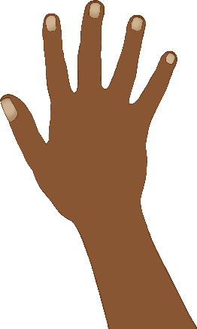

hand

hand

© 2020 Little Owls Resources

chimp

chimp

© 2020 Little Owls Resources

sand

sand

© 2020 Little Owls Resources

block

block

© 2020 Little Owls Resources

snail

snail

© 2020 Little Owls Resources

train

train

© 2020 Little Owls Resources

spoon

spoon

© 2020 Little Owls Resources

scooter

scooter

© 2020 Little Owls Resources

tractor

tractor

© 2020 Little Owls Resources

flo**w**er

flo**w**er

© 2020 Little Owls Resources

starfish

starfish

**w**

© 2020 Little Owls Resources

stocking

stocking

© 2020 Little Owls Resources

t**w**eezers

t**w**eezers

**w**

© 2020 Little Owls Resources

footprint

footprint

© 2020 Little Owls Resources