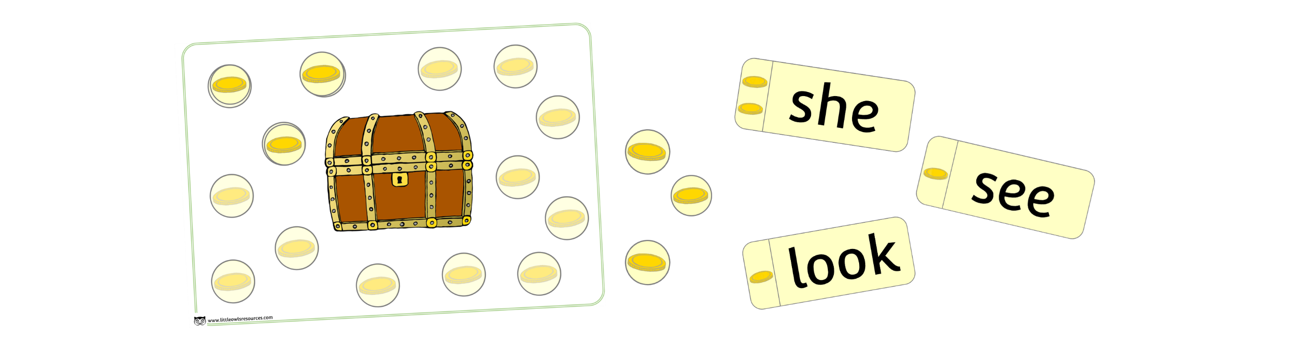

*Counters to be cut and laminated (page 4)

*Print as many sets as there are players.

*Words for game to be cut and laminated (pages 5-8). Only one set needed.

1. Shuffle words cards and place upside down. (Either in a pile or spread across the table).
2. Take turns to turn over a card and read the word. Share with other players.
3. If word is correctly read gather the number of coins displayed on the card and add to the treasure chest sheet.
4. If all cards are read before the end of the game, shuffle cards and use again.
5. The winner is first person to fill their treasure chest sheet.

Phase 3 Words Pirate Gold Game

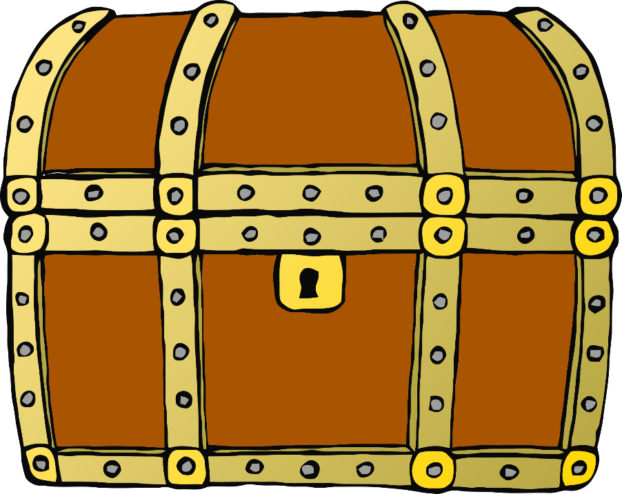









**w**ill

as



that



this



then

as



them



**w**ith



© 2019 Little Owls Resources

© 2019 Little Owls Resources

© 2019 Little Owls Resources

© 2019 Little Owls Resources

© 2019 Little Owls Resources

© 2019 Little Owls Resources

see

as



for



no**w**



do**w**n

as



look



too



© 2019 Little Owls Resources

© 2019 Little Owls Resources

© 2019 Little Owls Resources

© 2019 Little Owls Resources

© 2019 Little Owls Resources

© 2019 Little Owls Resources

he

as



she

**w**e

me

as



be

**w**as



© 2019 Little Owls Resources

© 2019 Little Owls Resources

© 2019 Little Owls Resources

© 2019 Little Owls Resources

© 2019 Little Owls Resources

© 2019 Little Owls Resources

© 2019 Little Owls Resources

© 2019 Little Owls Resources

© 2019 Little Owls Resources

© 2019 Little Owls Resources

© 2019 Little Owls Resources

© 2019 Little Owls Resources

you

as



they

all

are

as



my

her

