bee

bee

© 2020 Little Owls Resources

co**w**

co**w**

© 2020 Little Owls Resources

koi

koi

© 2020 Little Owls Resources

ear

ear

© 2020 Little Owls Resources

**6**

six

six

© 2020 Little Owls Resources

yak

yak

© 2020 Little Owls Resources

**✔**

yes

yes

© 2020 Little Owls Resources

zip

zip

© 2020 Little Owls Resources

buzz

buzz

© 2020 Little Owls Resources

jam

jam

© 2020 Little Owls Resources

sheep

sheep

© 2020 Little Owls Resources

fish

fish

© 2020 Little Owls Resources

ship

ship

© 2020 Little Owls Resources

thick

thick

© 2020 Little Owls Resources

thin

thin

© 2020 Little Owls Resources

hood

hood

© 2020 Little Owls Resources

song

song

© 2020 Little Owls Resources

ring

ring

© 2020 Little Owls Resources

**w**ing

**w**ing

© 2020 Little Owls Resources

tail

tail

© 2020 Little Owls Resources

rain

rain

© 2020 Little Owls Resources

**w**eep

**w**eep

© 2020 Little Owls Resources

**w**eb

**w**eb

© 2020 Little Owls Resources

fox

foxc

© 2020 Little Owls Resources

deer

deer

© 2020 Little Owls Resources

leek

leek

© 2020 Little Owls Resources

night

night

© 2020 Little Owls Resources

light

light

© 2020 Little Owls Resources

goat

goat

© 2020 Little Owls Resources

coat

coat

© 2020 Little Owls Resources

foal

foal

© 2020 Little Owls Resources

boot

boot

© 2020 Little Owls Resources

hoof

hoof

© 2020 Little Owls Resources

moon

moon

© 2020 Little Owls Resources

harp

harp

© 2020 Little Owls Resources

fork

fork

© 2020 Little Owls Resources

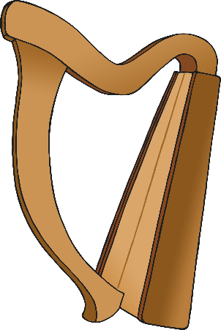

look

look

© 2020 Little Owls Resources

book

book

© 2020 Little Owls Resources

hurt

hurt

© 2020 Little Owls Resources

coin

coin

© 2020 Little Owls Resources

quack

quack

© 2020 Little Owls Resources

tear

tear

© 2020 Little Owls Resources

hair

hair

© 2020 Little Owls Resources

pair

pair

© 2020 Little Owls Resources

north

north

**w**

© 2020 Little Owls Resources

teeth

teeth

© 2020 Little Owls Resources

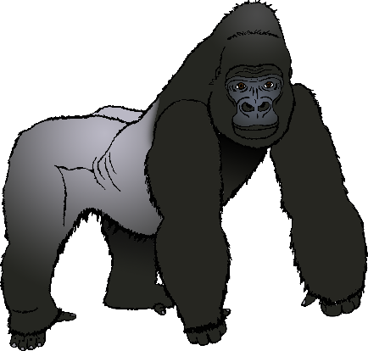

gorilla

gorilla

© 2020 Little Owls Resources

meerkat

meerkat

© 2020 Little Owls Resources

quail

quail

© 2020 Little Owls Resources

Saturn

Saturn

© 2020 Little Owls Resources

toilet

toilet

© 2020 Little Owls Resources

ear**w**ig

ear**w**ig

**w**

© 2020 Little Owls Resources

shamrock

shamrock

© 2020 Little Owls Resources

vulture

vulture

© 2020 Little Owls Resources

hammer

hammer

© 2020 Little Owls Resources

pepper

pepper

© 2020 Little Owls Resources

hard hat

hard hat

© 2020 Little Owls Resources