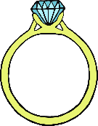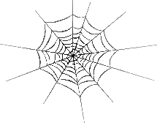



Jam

© 2020 Little Owls Resources

Phase 3 Sound Mat

igh

oa

oo

oo

ure

air

ear

er

ee

ng

sh

ai

th

oi

or

ar

ur

o**w**

ch

qu

j

v

**w**

x

y

z

zz

?

