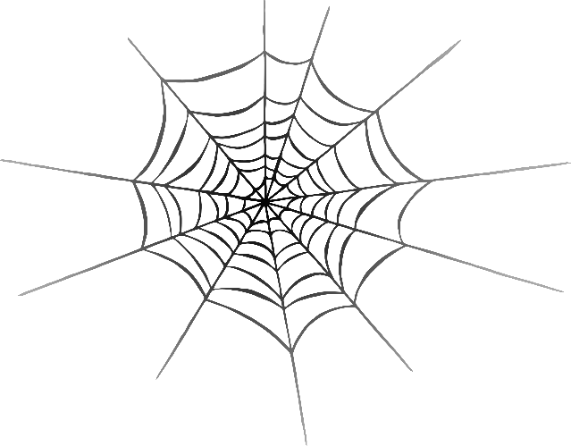

j

van

jam

**w**eb

v

**w**

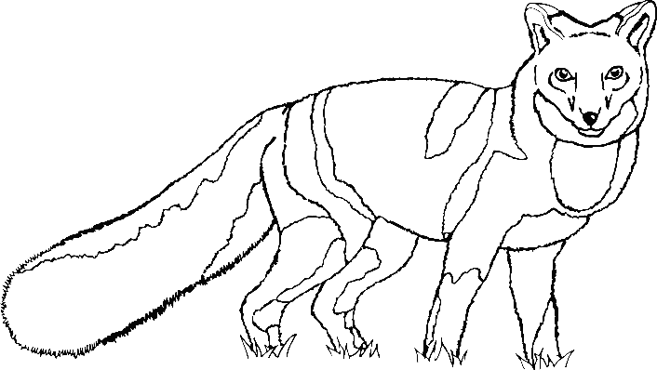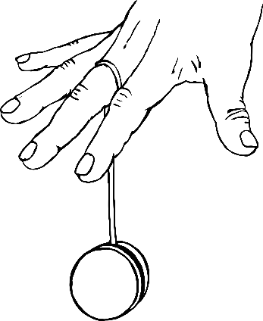

fox

x

z

yo-yo

zip

y

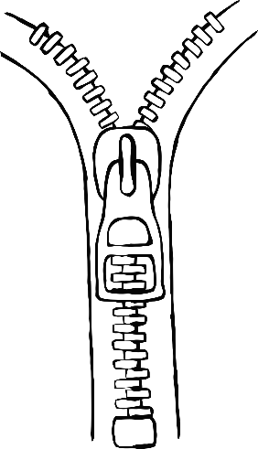

buzz

chick

?

zz

qu

ch

question

ng

th

sh

ring

thumb

sheep

igh

ee

ai

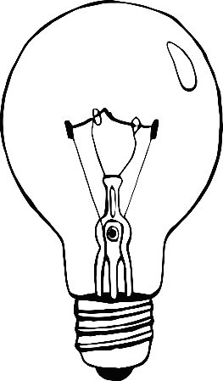

tree

snail

light

oo

oo

oa

book

moon

boat

ar

or

ur

star

turtle

fork

toilet

cow

ear

oi

o**w**

ear

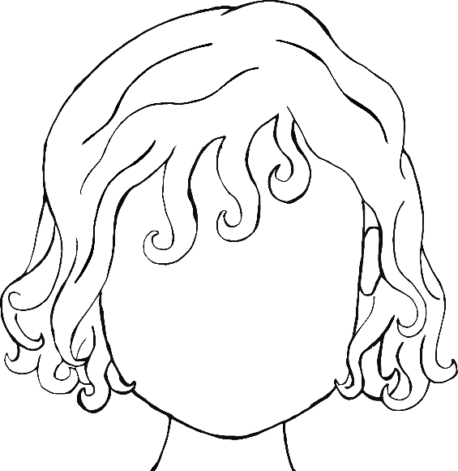

ure

air

er

hair

scooter

picture