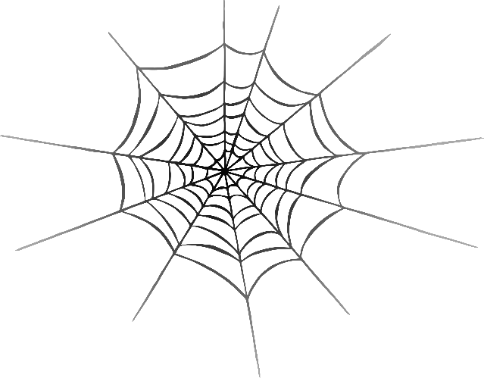

van

Jam

jam

j

**w**eb

v

**w**

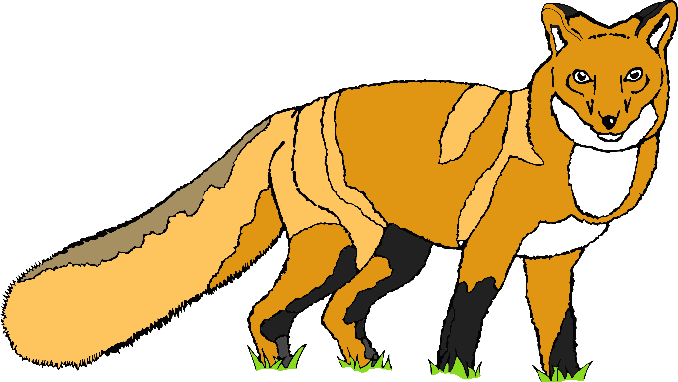

fox

x

z

yo-yo

zip

y

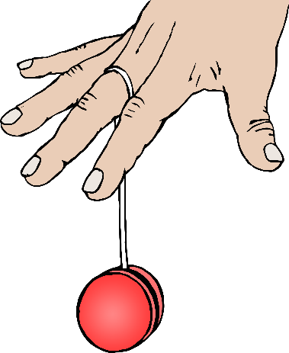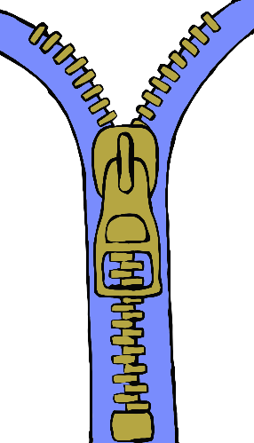

ch

qu

zz

?

question

chick

buzz

ng

th

sh

ring

thumb

sheep

igh

ee

ai

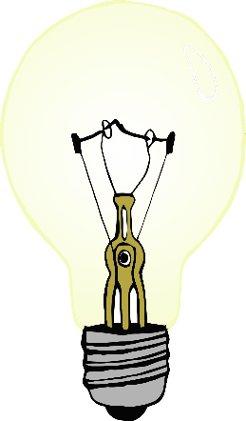

tree

snail

light

boat

moon

book

oa

oo

oo

ar

or

ur

star

turtle

fork

toilet

co**w**

ear

oi

o**w**

ear

ure

air

er

hair

scooter

picture