in

in

© 2020 Little Owls Resources

on

on

© 2020 Little Owls Resources

cat

cat

© 2020 Little Owls Resources

up

up

© 2020 Little Owls Resources

sad

sad

© 2020 Little Owls Resources

bat

bat

© 2020 Little Owls Resources

hat

hat

© 2020 Little Owls Resources

pan

pan

© 2020 Little Owls Resources

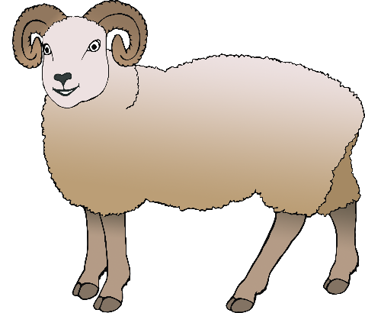

ram

ram

© 2020 Little Owls Resources

rat

rat

© 2020 Little Owls Resources

map

map

© 2020 Little Owls Resources

net

net

© 2020 Little Owls Resources

pig

pig

© 2020 Little Owls Resources

cup

cup

© 2020 Little Owls Resources

fin

fin

© 2020 Little Owls Resources

pen

pen

© 2020 Little Owls Resources

hen

hen

© 2020 Little Owls Resources

bun

bun

© 2020 Little Owls Resources

kick

kick

© 2020 Little Owls Resources

duck

duck

© 2020 Little Owls Resources

bell

bell

© 2020 Little Owls Resources

ten

ten

© 2020 Little Owls Resources

**10**

dog

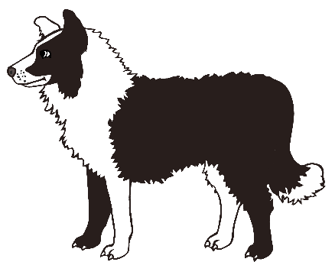

dog

© 2020 Little Owls Resources

sun

sun

© 2020 Little Owls Resources

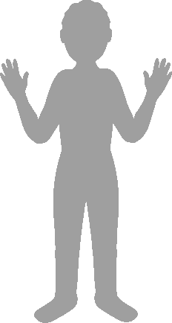

leg

leg

© 2020 Little Owls Resources

hop

hop

© 2020 Little Owls Resources

bag

bag

© 2020 Little Owls Resources

bus

bus

© 2020 Little Owls Resources

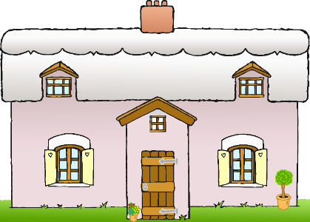

fog

fog

© 2020 Little Owls Resources

neck

neck

© 2020 Little Owls Resources

mug

mug

© 2020 Little Owls Resources

bug

bug

© 2020 Little Owls Resources

doll

doll

© 2020 Little Owls Resources

sssss

hiss

hiss

© 2020 Little Owls Resources

muffin

muffin

© 2020 Little Owls Resources

carrot

carrot

© 2020 Little Owls Resources

robin

robin

© 2020 Little Owls Resources

melon

melon

© 2020 Little Owls Resources

parrot

parrot

© 2020 Little Owls Resources

rocket

rocket

© 2020 Little Owls Resources

rabbit

rabbit

© 2020 Little Owls Resources