Phase 2 Sound Mat

© 2020 Little Owls Resources

ll

l

ff

f

b

h

r

u

e

k

c

o

ck

s

a

t

p

i

n

m

d

g

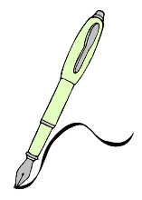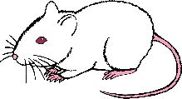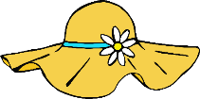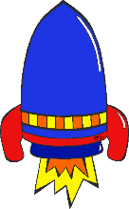

ss