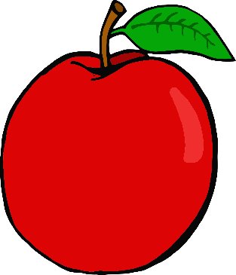

s

a

t

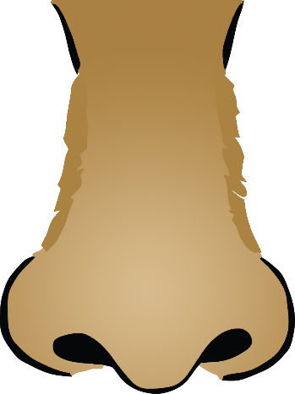

n

i

p

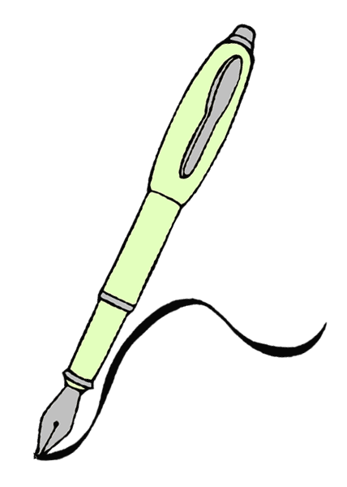

g

m

d

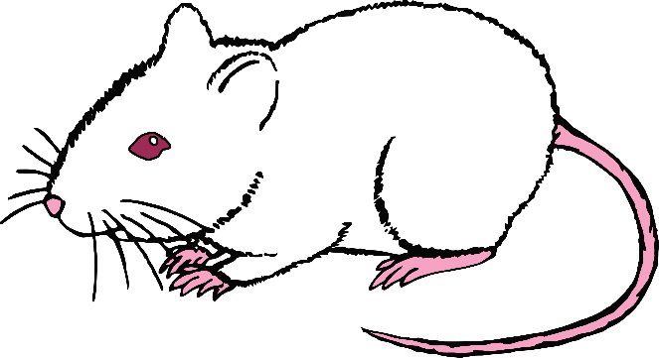

c

o

k

ck

k

e

u

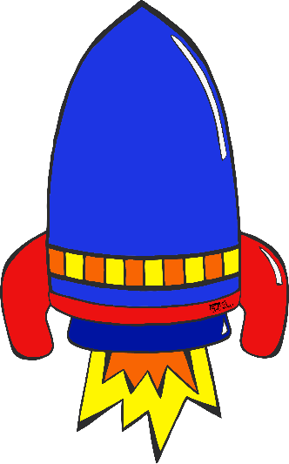

r

h

b

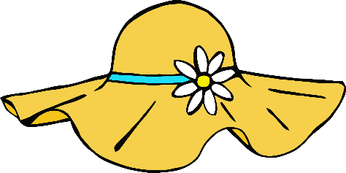

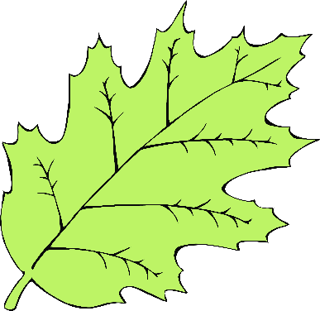|

ff

f

l

ll

ss