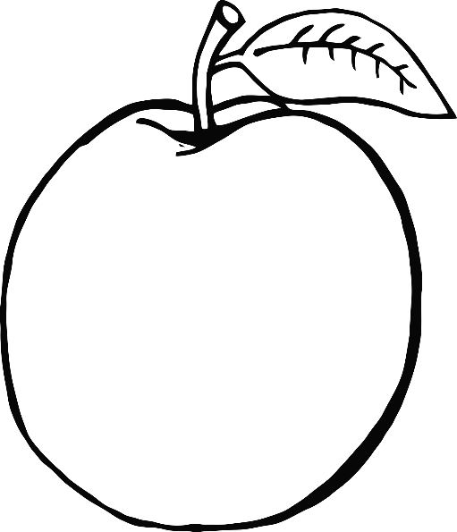

tiger

sun

**s**

a

t

apple

i

p

n

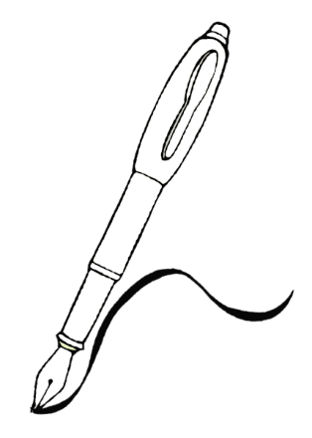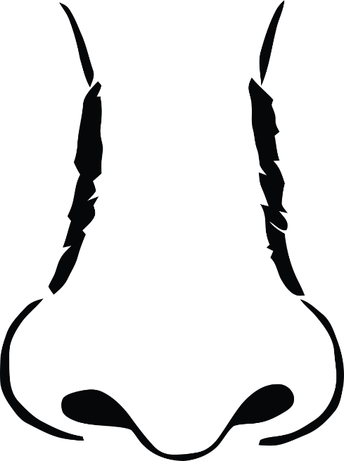

ink

pig

nose

d

g

m

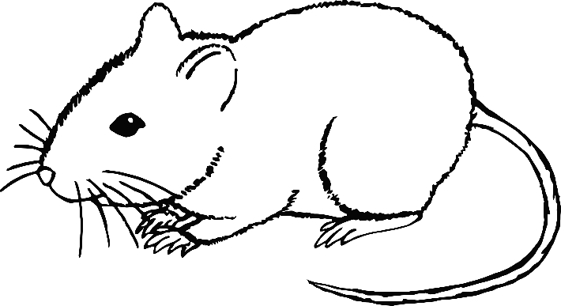

dog

goat

mouse

k

c

o

kangaroo

cat

octopus

ck

k

u

e

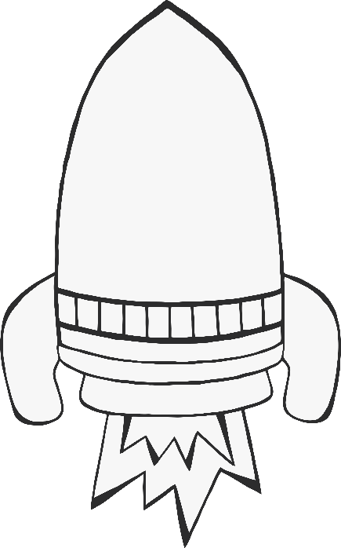

egg

rocket

umbrella

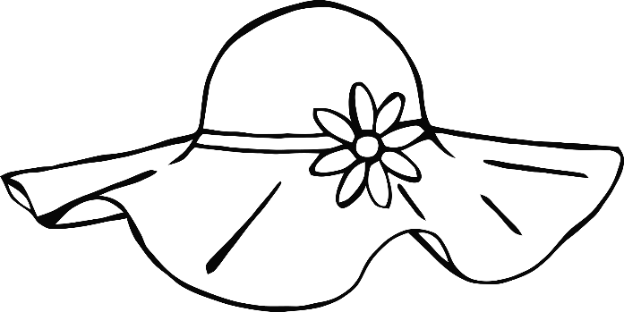

h

b

r

bag

hat

rain



fish

muffin

leaf

f

ff

l

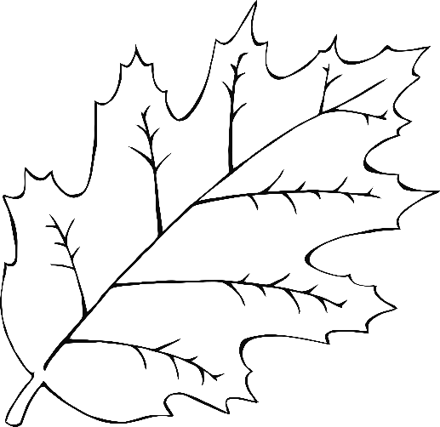

ss

ll

grass

ball