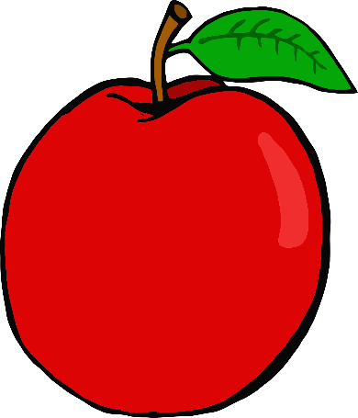

tiger

sun

s

a

t

apple

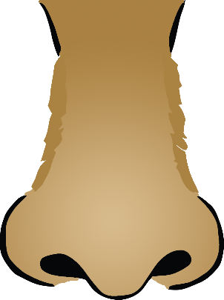

nose

ink

n

i

p

pig

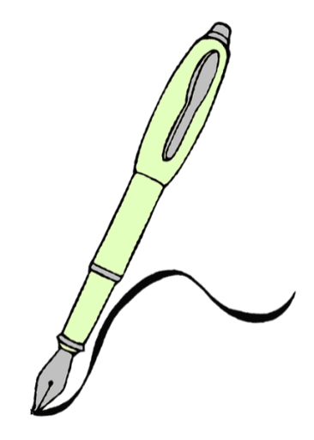

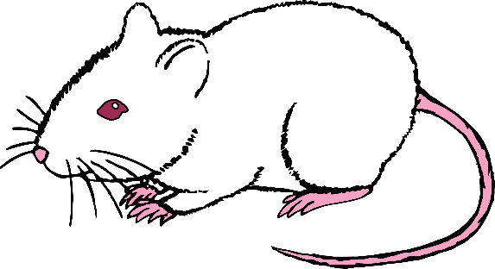

g

m

d

goat

mouse

dog

c

o

k

kangaroo

cat

octopus

ck

e

u

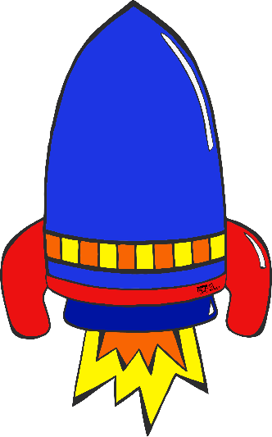

egg

rocket

umbrella

rain

hat

bag

b

h

r

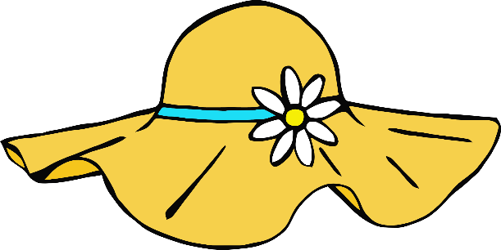



ff

f

l

muffin

leaf

fish

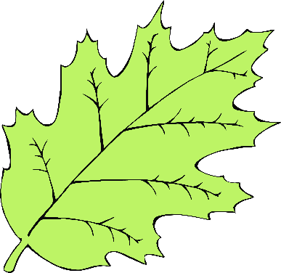

ss

ll

ball

grass