s

\

s s s s s s _

s s s s s _ _

s s s s _ _ _

s s s _ _ _ _

s

\

s s s s s s _ _

\

a

a a a a a a _

a a a a a _ _

a a a a _ _ _

a a a _ _ _ _

\

a

a a a a a _ _

t

\

t t t t t t _

t t t t t _ _

t t t t _ _ _

t t t _ _ _ _

\

t

t t t t t t _ _

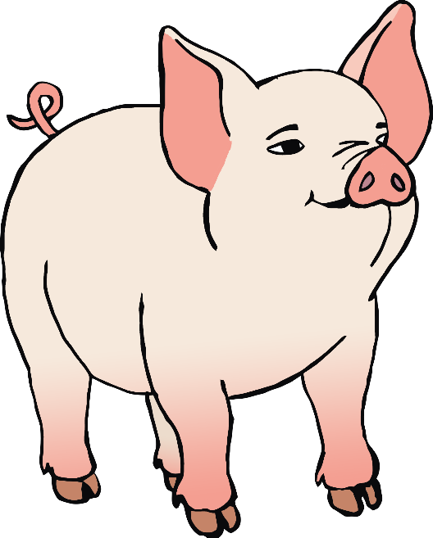

p

\

p p p p p p _

p p p p p _ _

p p p p _ _ _

p p p _ _ _ _



p

\

p p p p p _

i

\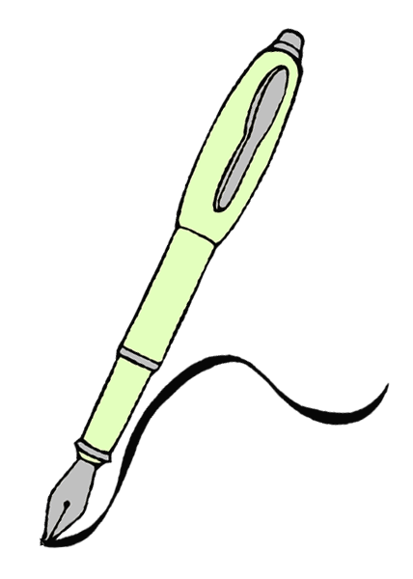

i i i i i i _

i i i i i _ _

i i i i _ _ _

i i i _ _ _ _

i



i i i i

i i _ _



n

\

n n n n n n _

n n n n n _ _

n n n n _ _ _

n n n _ _ _ _



\

n

n n n n n _

m

\

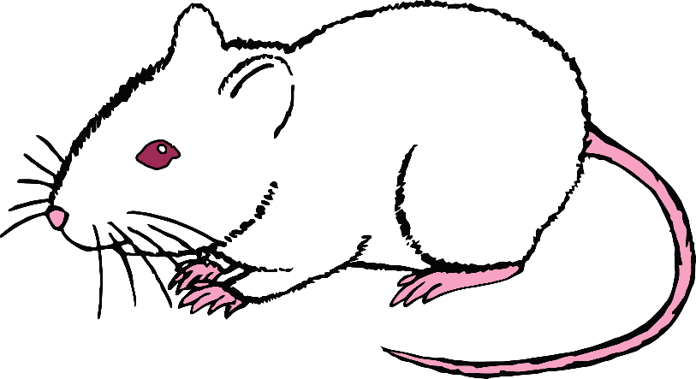

m m m m m

m m m m

m m m

m m

m

m

\



m m m m

d

\

d d d d d d _

d d d d d _ _

d d d d _ _ _

d d d _ _ _ _

d

\

d d d d d _

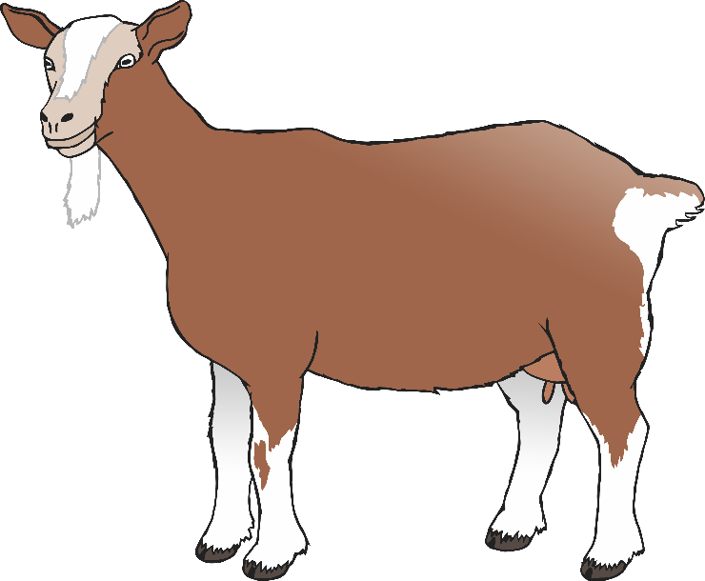

\

g

g g g g g g _

g g g g g _ _

g g g g _ _ _

g g g _ _ _ _



g

\

g g g g g _

o

\

o o o o o o _

o o o o o _ _

o o o o _ _ _

o o o _ _ _ _

\

o o o o o _

o

c

\

c c c c c c _

c c c c c _ _

c c c c _ _ _

c c c _ _ _ _

\

c

c c c c c _

\

k

k k k k k k _

k k k k k _ _

k k k k _ _ _

k k k _ _ _ _

\

k

k k k k k k _ _



\

e

e e e e e e _

e e e e e _ _

e e e e _ _ _

e e e _ _ _ _



\

e e e e e _

e

\

u u u u u u _

u u u u u _ _

u u u u _ _ _

u u u _ _ _ _

u

\

u

u u u u u _

\

r

r r r r r r _

r r r r r _ _

r r r r _ _ _

r r r _ _ _ _

\

r r r r r r _ _

r

\

h



h h h h h h _

h h h h h _ _

h h h h _ _ _

h h h _ _ _ _

**\**

h h h h h _

h



\

b

b b b b b b _

b b b b b _ _

b b b b _ _ _

b b b _ _ _ _

b

\

b b b b b _

\

f

f f f f f f _

f f f f f _ _

f f f f _ _ _

f f f _ _ _ _

\

f

f f f f f f _ _

l

\

l l l l l l _ _

l l l l l _ _ _

l l l l _ _ _ _

l l l _ _ _ _ _

\

l

l l l l

l l _ _