© 2020 Little Owls Resources

**zzzzzzzzzzzzz**

**The bee says…**

**I hear the bell…**

**© 2020 Little Owls Resources**

**ding dong ding dong**

**I dropped my ice-cream!...**

© 2020 Little Owls Resources



**ohhhhhh noooooo**

**I hear the clock…**

© 2020 Little Owls Resources

**tick tock tick tock**

© 2020 Little Owls Resources

**I have a present!…**

**ooooooooooooo**

**I hear the rain…**

© 2020 Little Owls Resources

**pitter patter pitter patter**

**The baby is sleeping…**

© 2020 Little Owls Resources

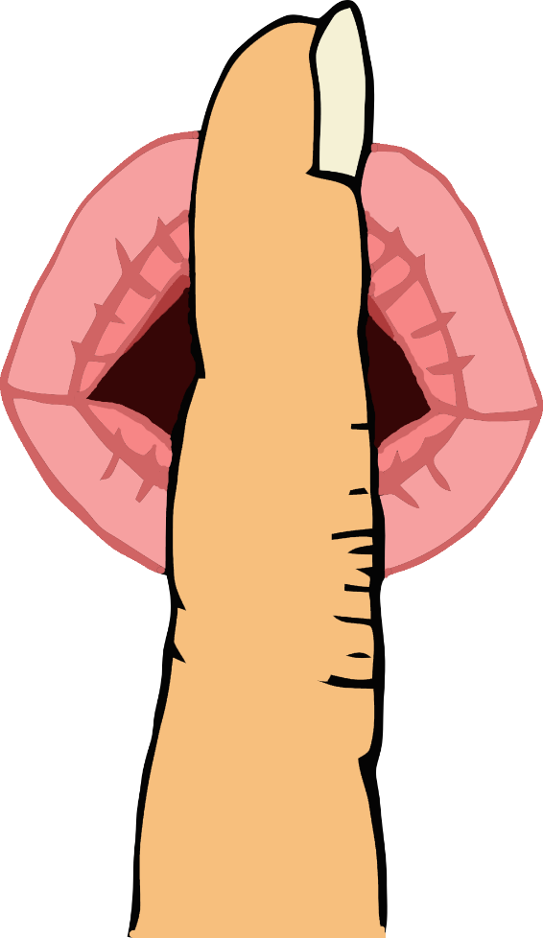

**shhhhhhhhhhhh**

**Let’s go down the slide!…**

© 2020 Little Owls Resources

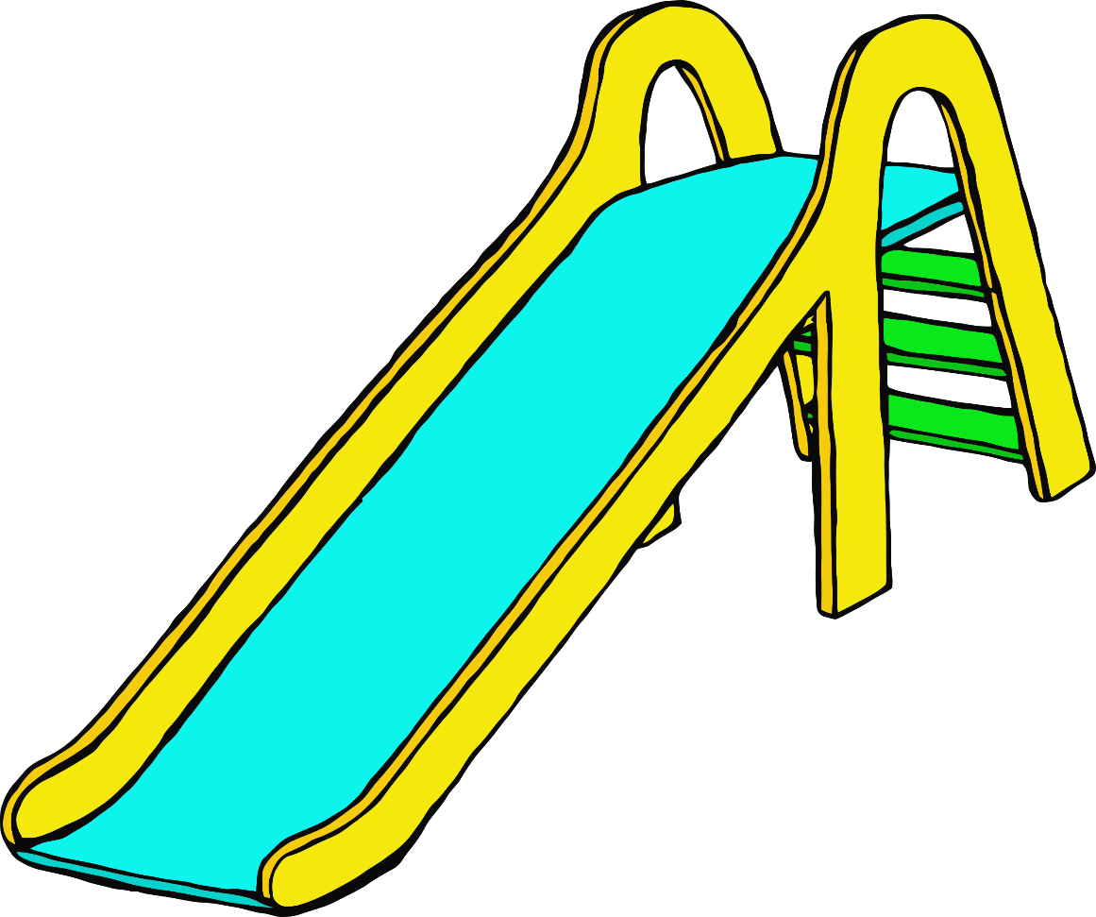

**weeeeeeeeeeee**

**The snake says…**

© 2020 Little Owls Resources

**sssssssssssss**

**The cow says…**

© 2020 Little Owls Resources

**mmmmmooooooo**

**I hear the car…**

© 2020 Little Owls Resources

**brrmm brrmm**

**The frog says…**

© 2020 Little Owls Resources

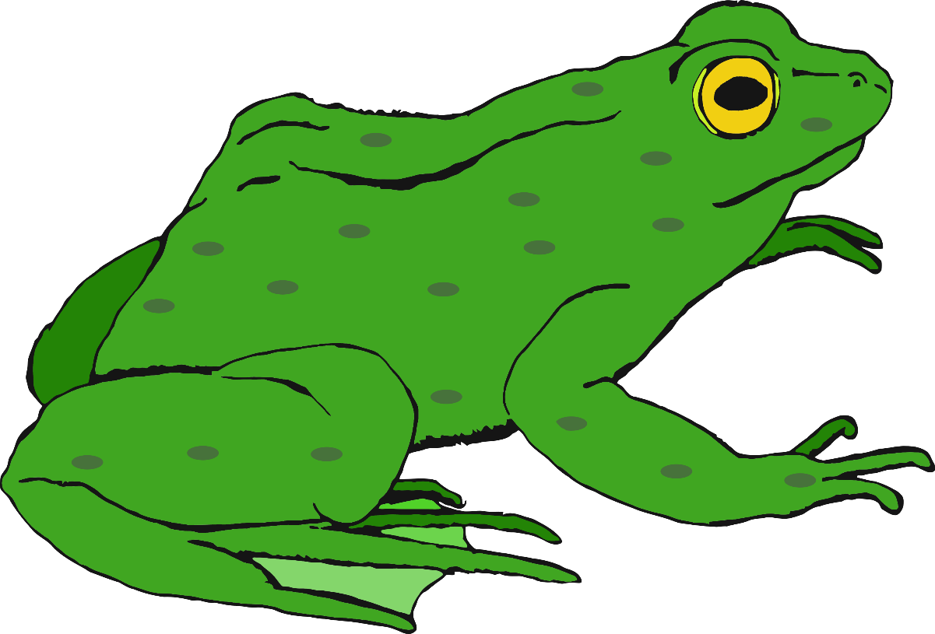

**croooaaak**

**Delicious fruit…**

© 2020 Little Owls Resources

**mmmmmmmmmm**



**The wind blows the leaves…**

© 2020 Little Owls Resources

**whoooooooshhh**

**I hear a bouncing ball…**

© 2020 Little Owls Resources

**boing boing boing**

**I hear the train…**

**ch ch ch ch ch ch ch**

© 2020 Little Owls Resources