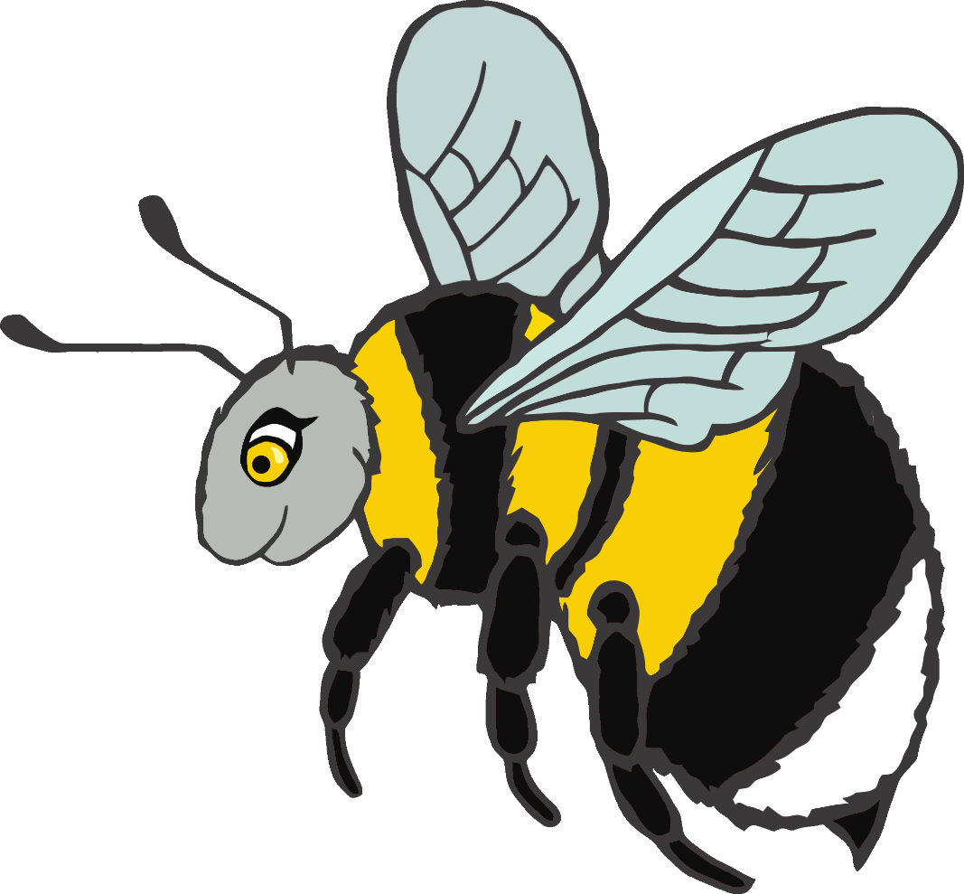

© 2020 Little Owls Resources

zzzzzzzzzzzzz

The bee says…

I hear the bell…

**© 2020 Little Owls Resources**

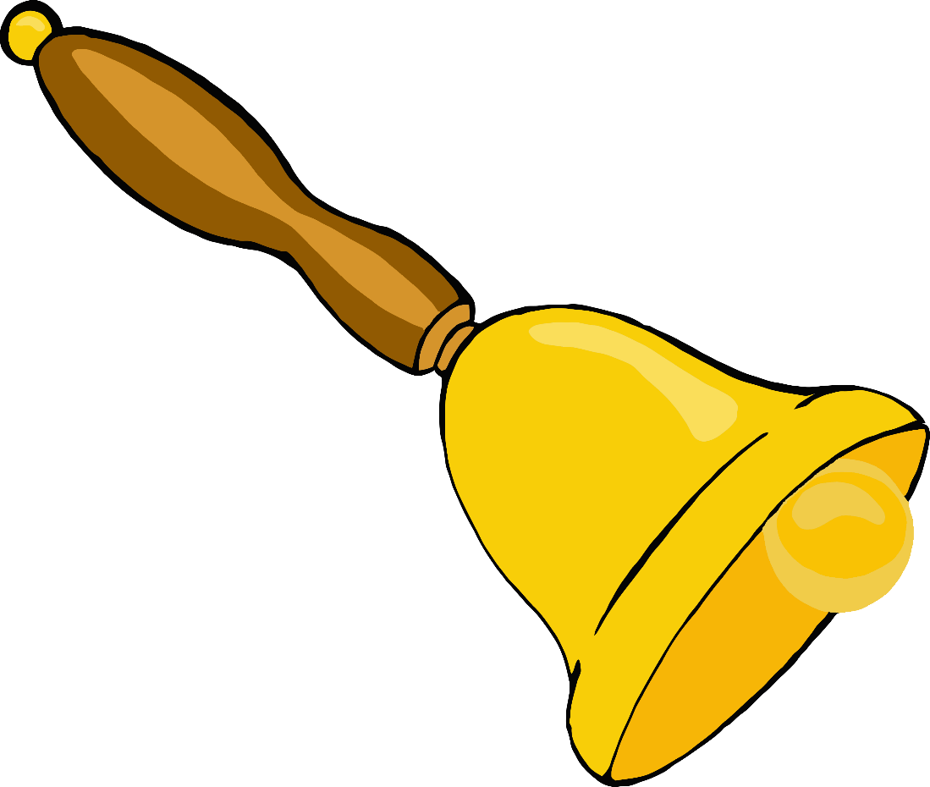

ding dong ding dong

I dropped my ice-cream!...

© 2020 Little Owls Resources

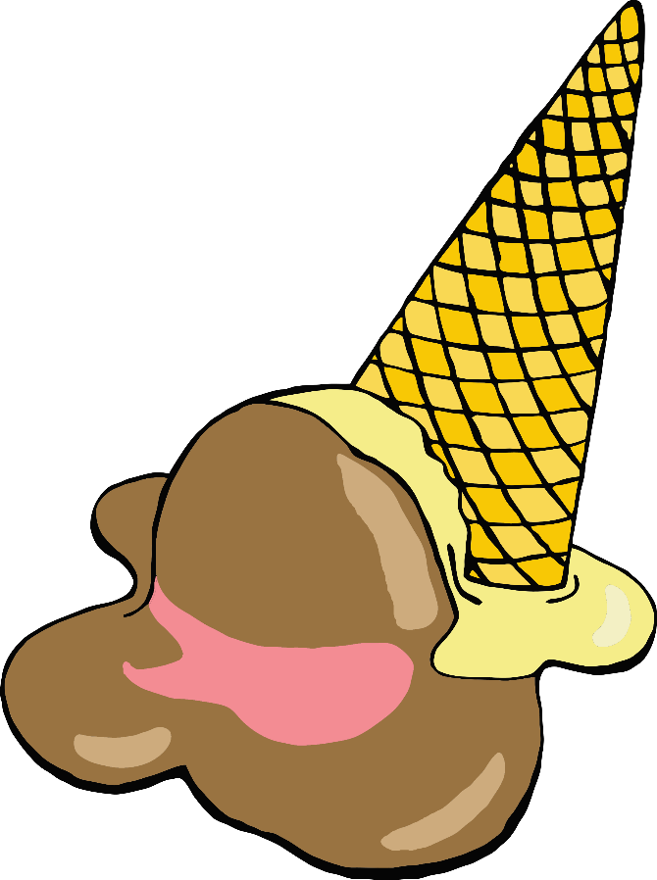

ohhhhhh noooooo

I hear the clock…

© 2020 Little Owls Resources

tick tock tick tock



© 2020 Little Owls Resources

I have a present!…

ooooooooooooo

I hear the rain…

© 2020 Little Owls Resources

pitter patter pitter patter

The baby is sleeping…

© 2020 Little Owls Resources

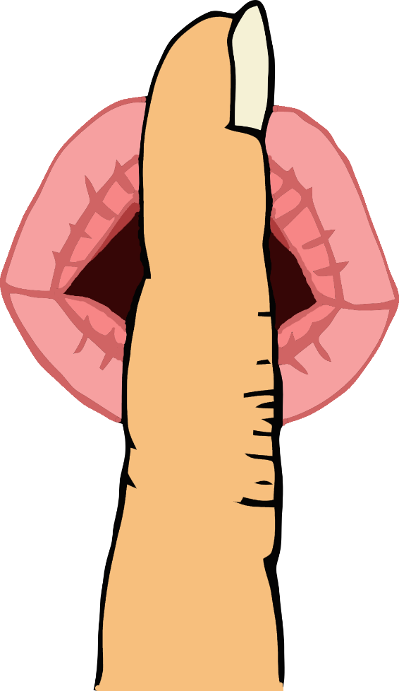

shhhhhhhhhhhh

Let’s go down the slide!…

© 2020 Little Owls Resources

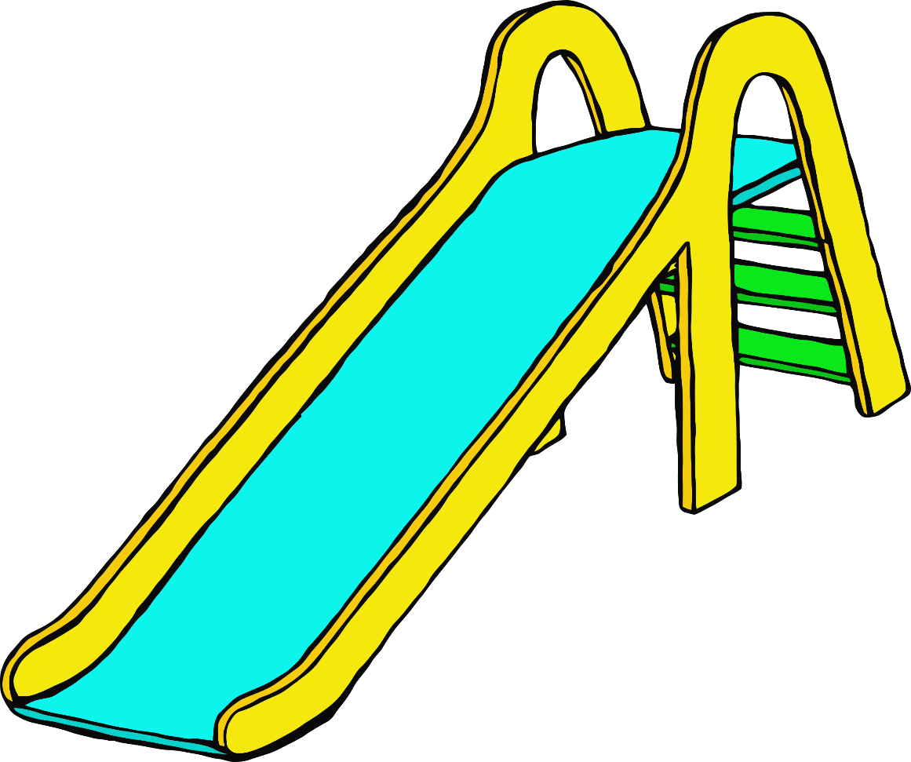

**w**eeeeeeeeeeee

The snake says…

© 2020 Little Owls Resources

sssssssssssss

The cow says…

© 2020 Little Owls Resources

mmmmmooooooo

I hear the car…

© 2020 Little Owls Resources

brrmm brrmm

The frog says…

© 2020 Little Owls Resources

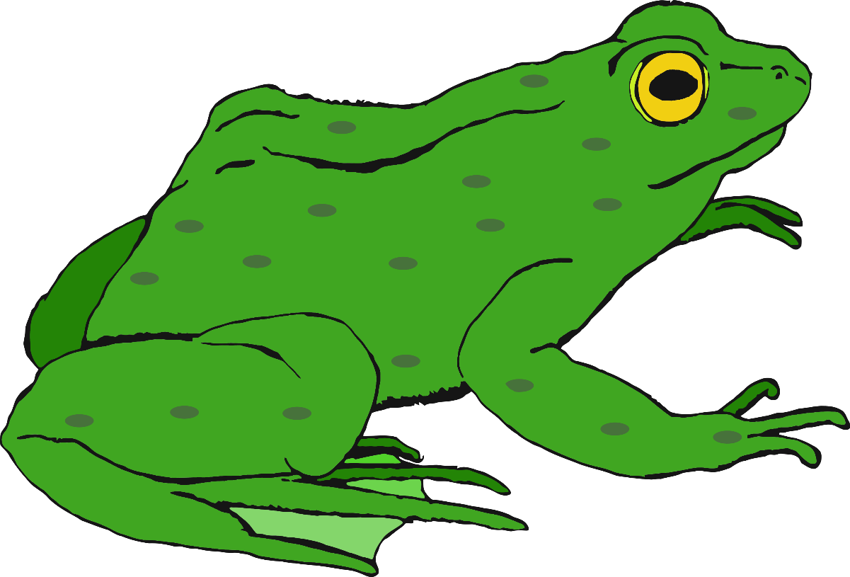

croooaaak

Delicious fruit…

© 2020 Little Owls Resources

mmmmmmmmmm

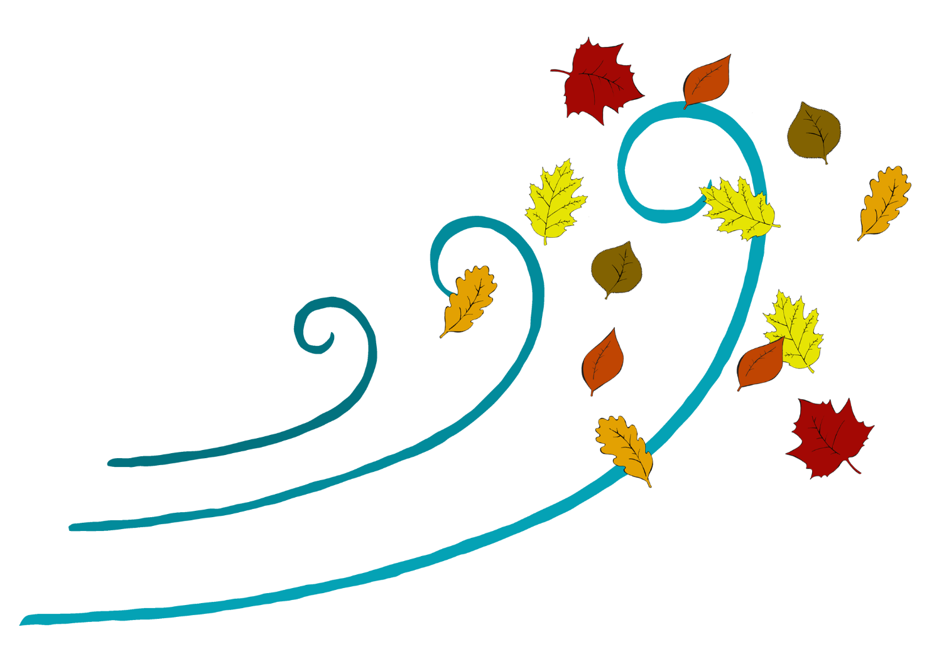

The wind blows the leaves…

© 2020 Little Owls Resources

**w**hoooooooshhh

I hear a bouncing ball…

© 2020 Little Owls Resources

boing boing boing

ch ch ch ch ch ch ch

I hear the train…

© 2020 Little Owls Resources