‘1-3’ Dice required

Farm Animal Thunderstorm Sounds Game

Game pieces to be cut and laminated

(or use your own counters)

Phase 1

The aim of this game is to encourage the link between images and specific repeatable sounds.

* Choose a game piece
* Roll the dice
* Move your game piece along the board
* Make the right noise for the square you land on
* First to the finish is the winner!

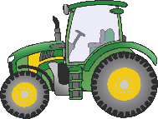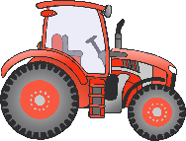

A thunderstorm! Quick get round the farm and check on all the animals.

They must be a bit frightened; they’re making a lot of noise!

Start

Finish

m

© 2020 Little Owls Resources