© 2020 Little Owls Resources

The sound a cow makes is a moo.

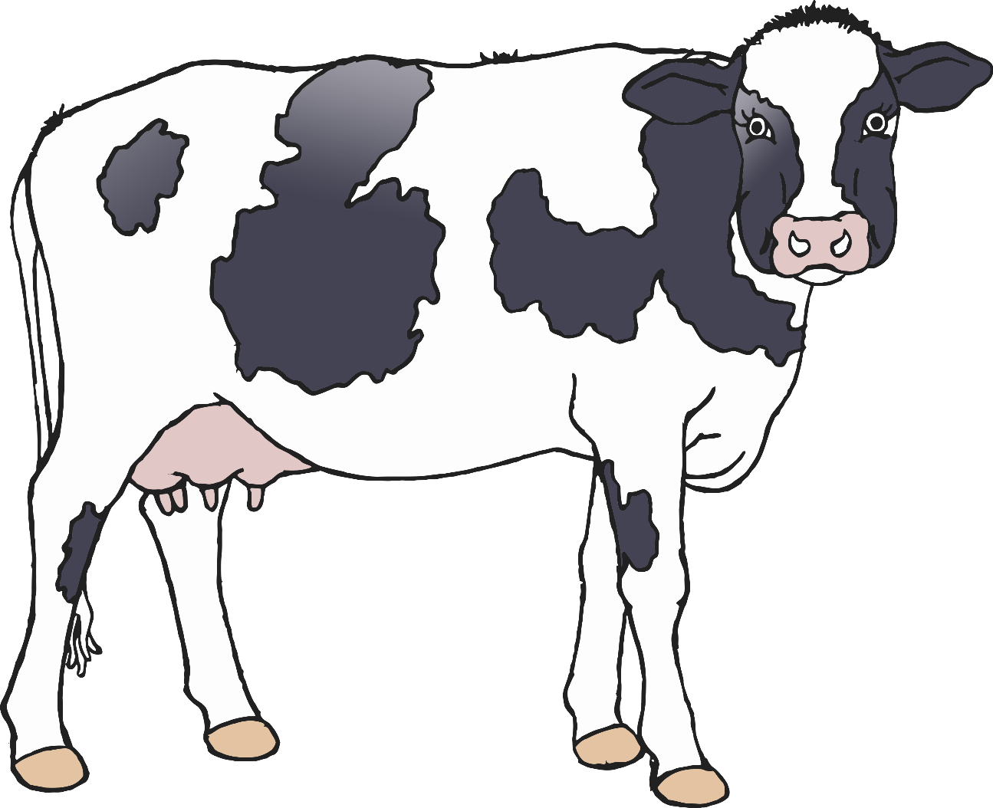

mmmmmooooooo

© 2020 Little Owls Resources

The sound a horse makes is a neigh.

naaayyyy

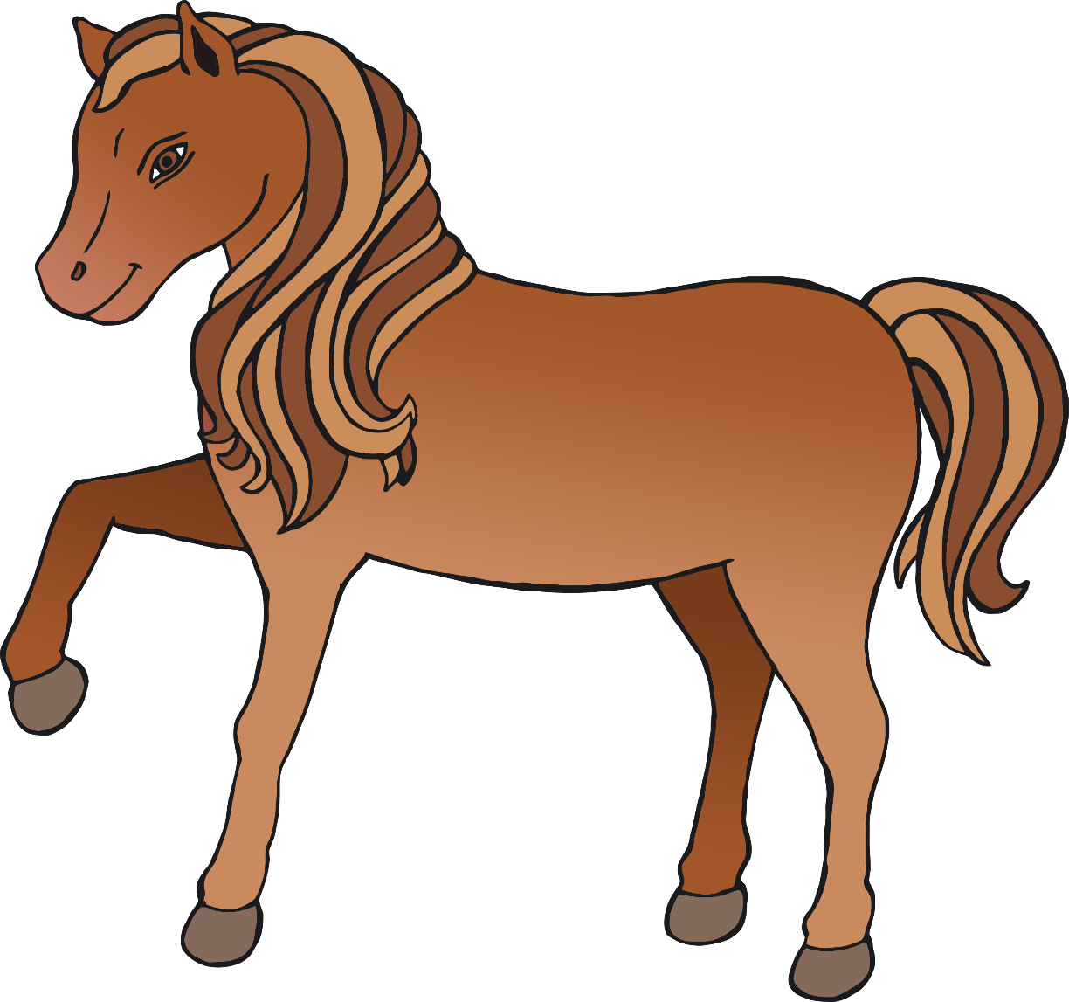

© 2020 Little Owls Resources

The sound a donkey makes is a bray.

heeee-hoorrr

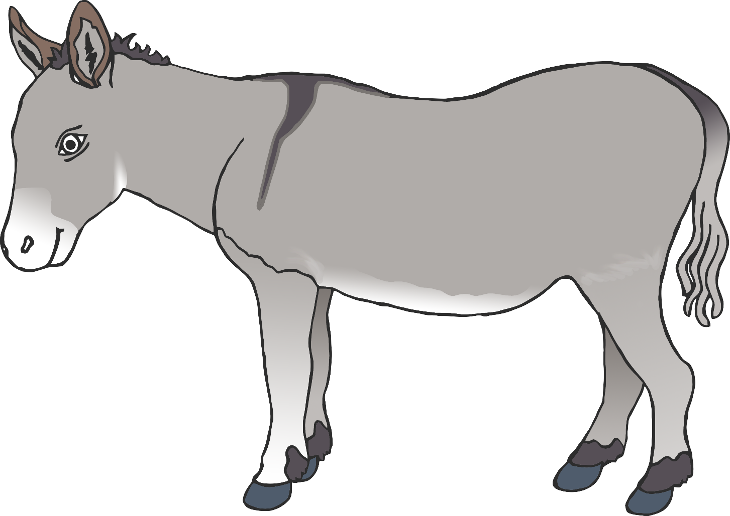

© 2020 Little Owls Resources

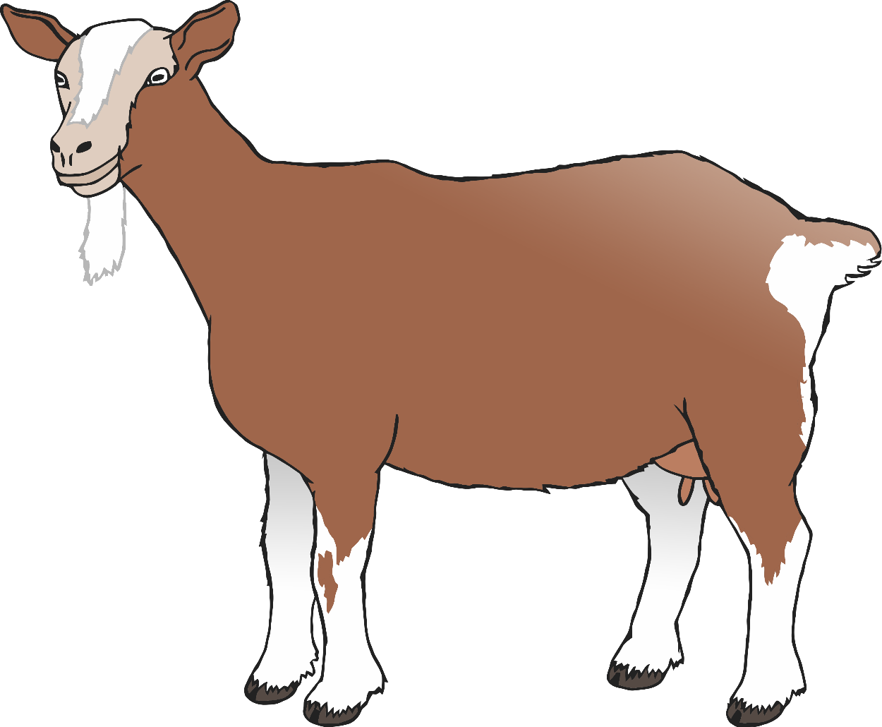

The sound a goat makes is a bleat.

meh-eh-eh-eh

© 2020 Little Owls Resources

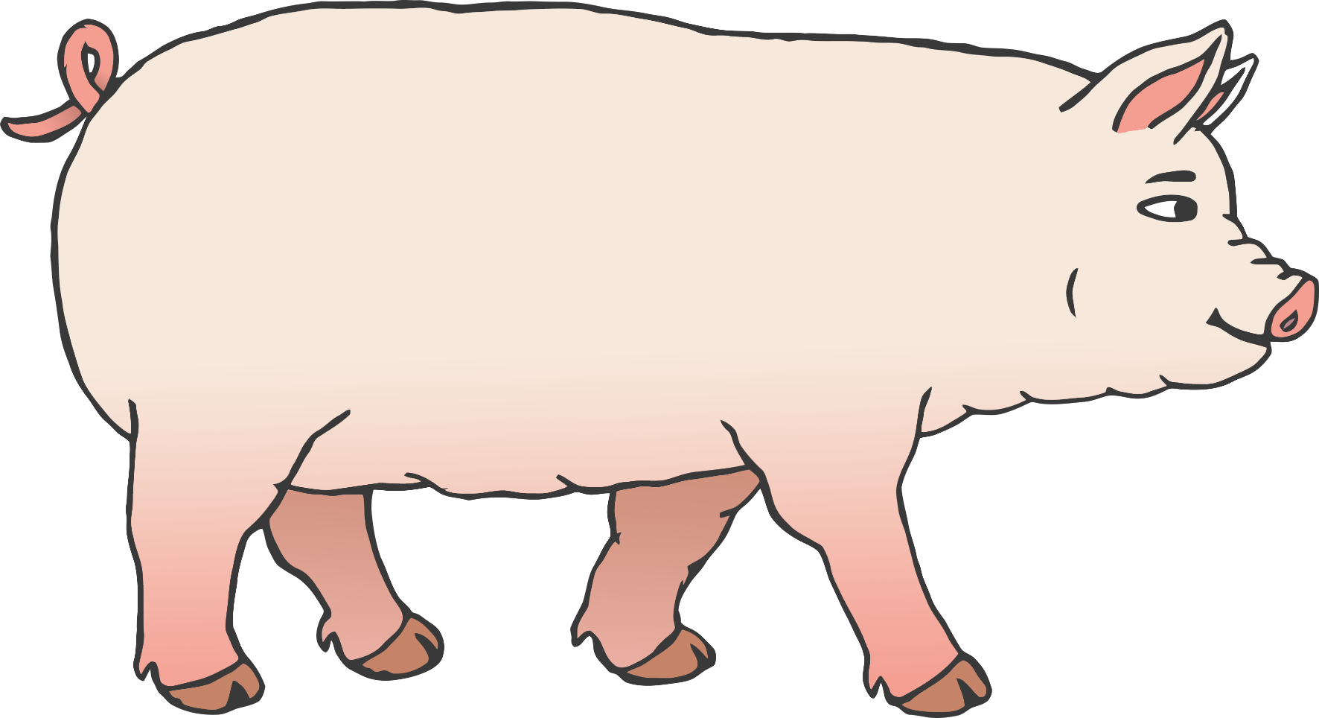

The sound a pig makes is an oink.

oink - oink

© 2020 Little Owls Resources

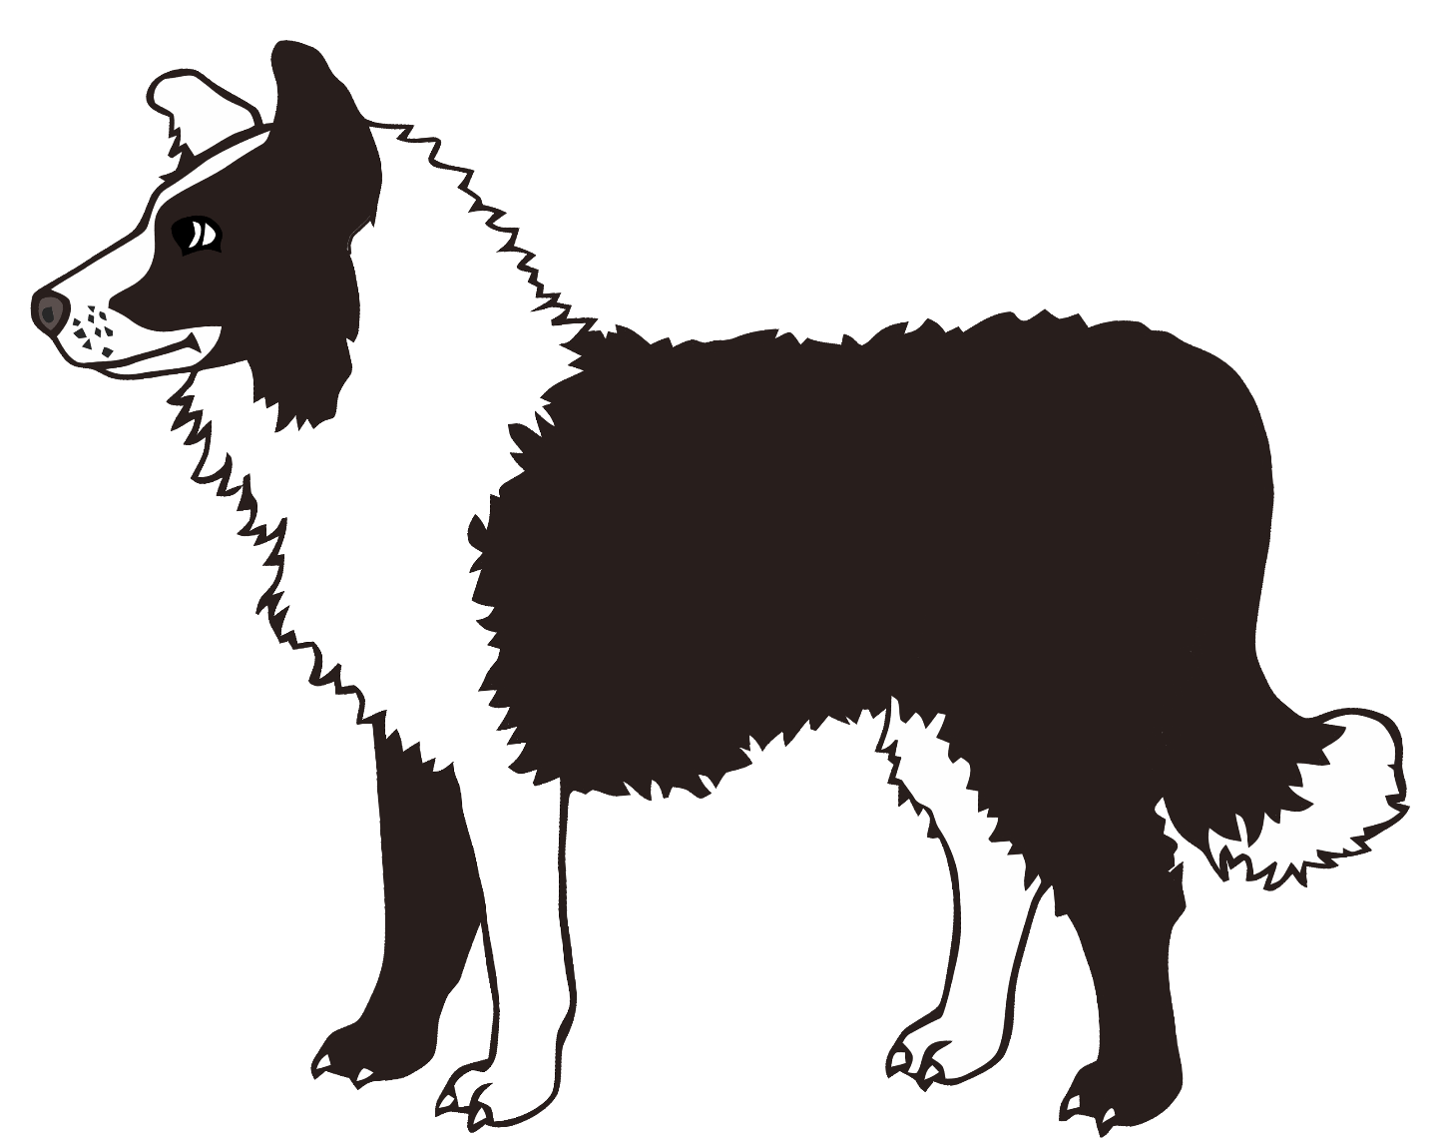

The sound a dog makes is a bark.

ruff – ruff - ruff

© 2020 Little Owls Resources

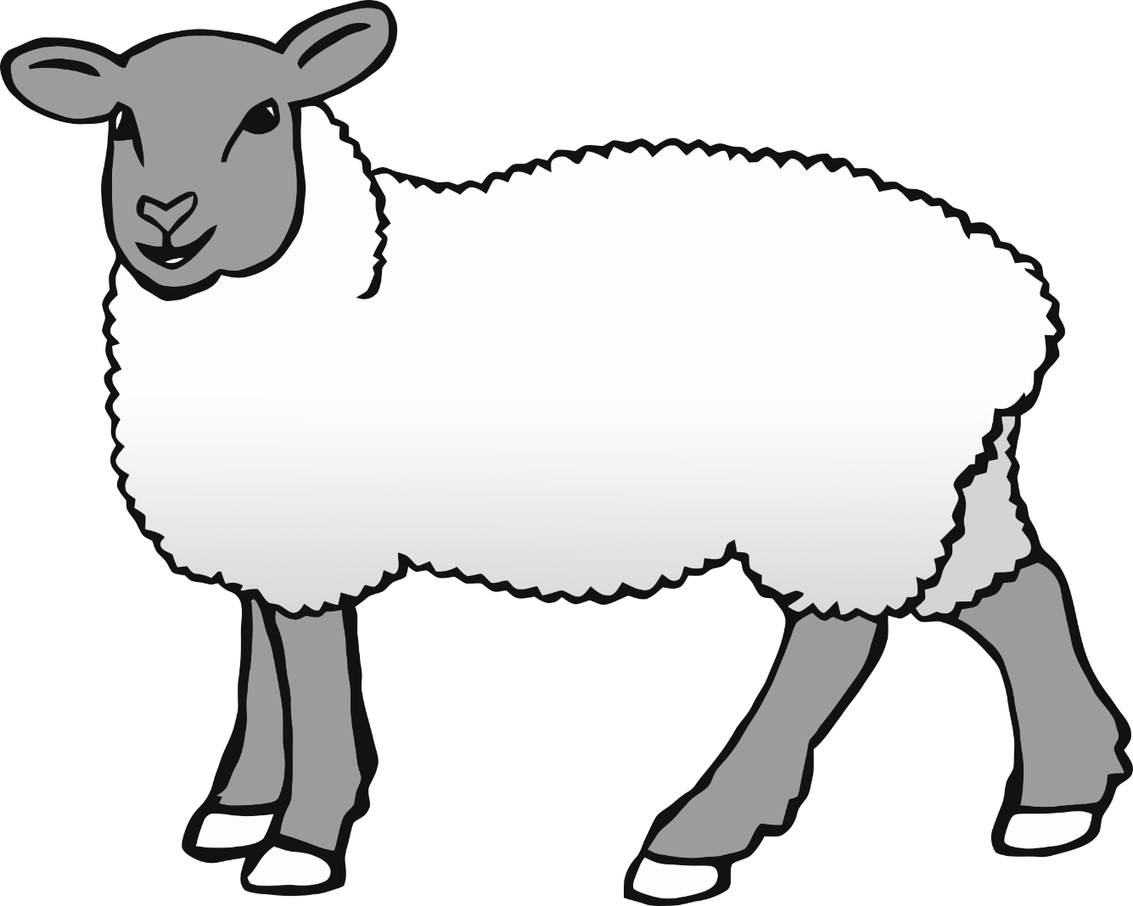

The sound a sheep makes is a bleat.

baaaaaaaaaaa

© 2020 Little Owls Resources

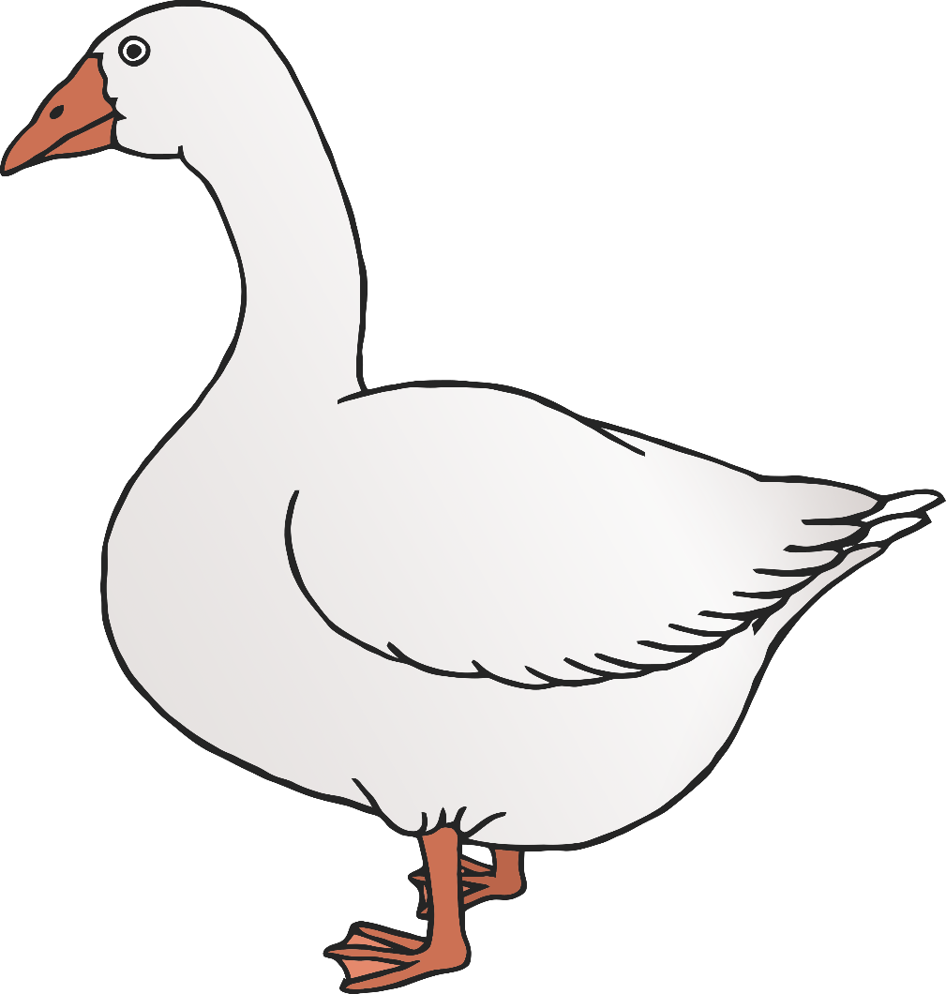

The sound a goose makes is a honk.

honk-honk-honk

© 2020 Little Owls Resources

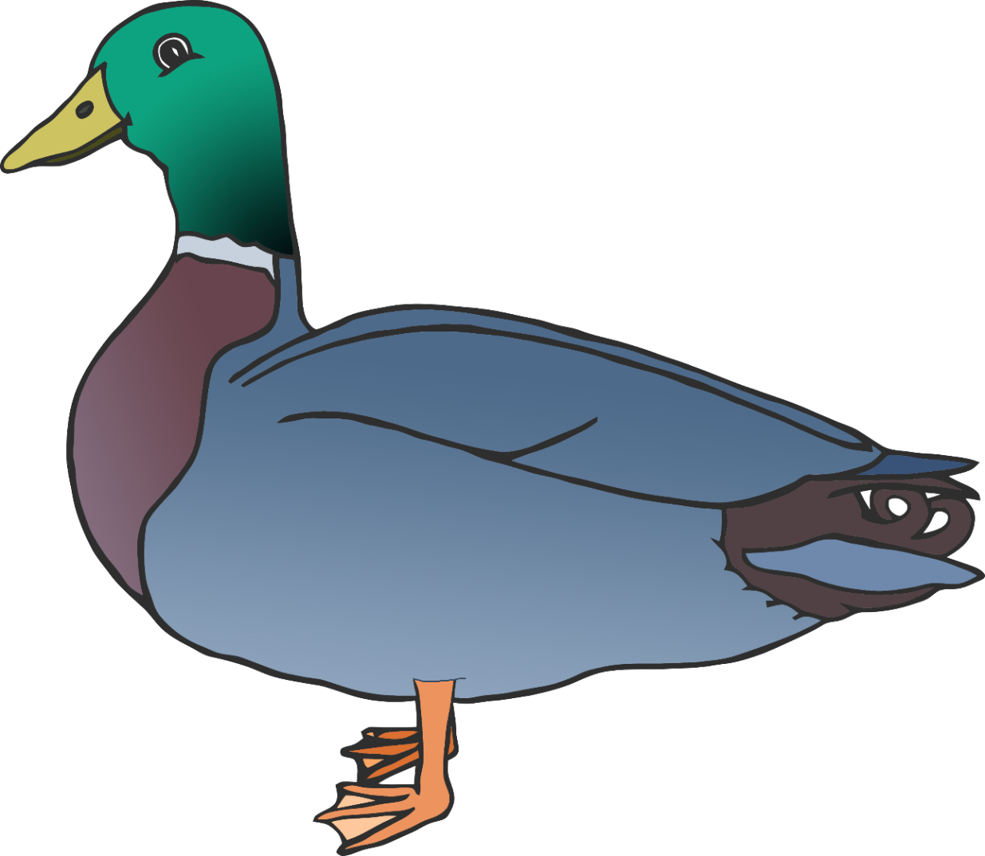

The sound a duck makes is a quack.

waak-waak-waak

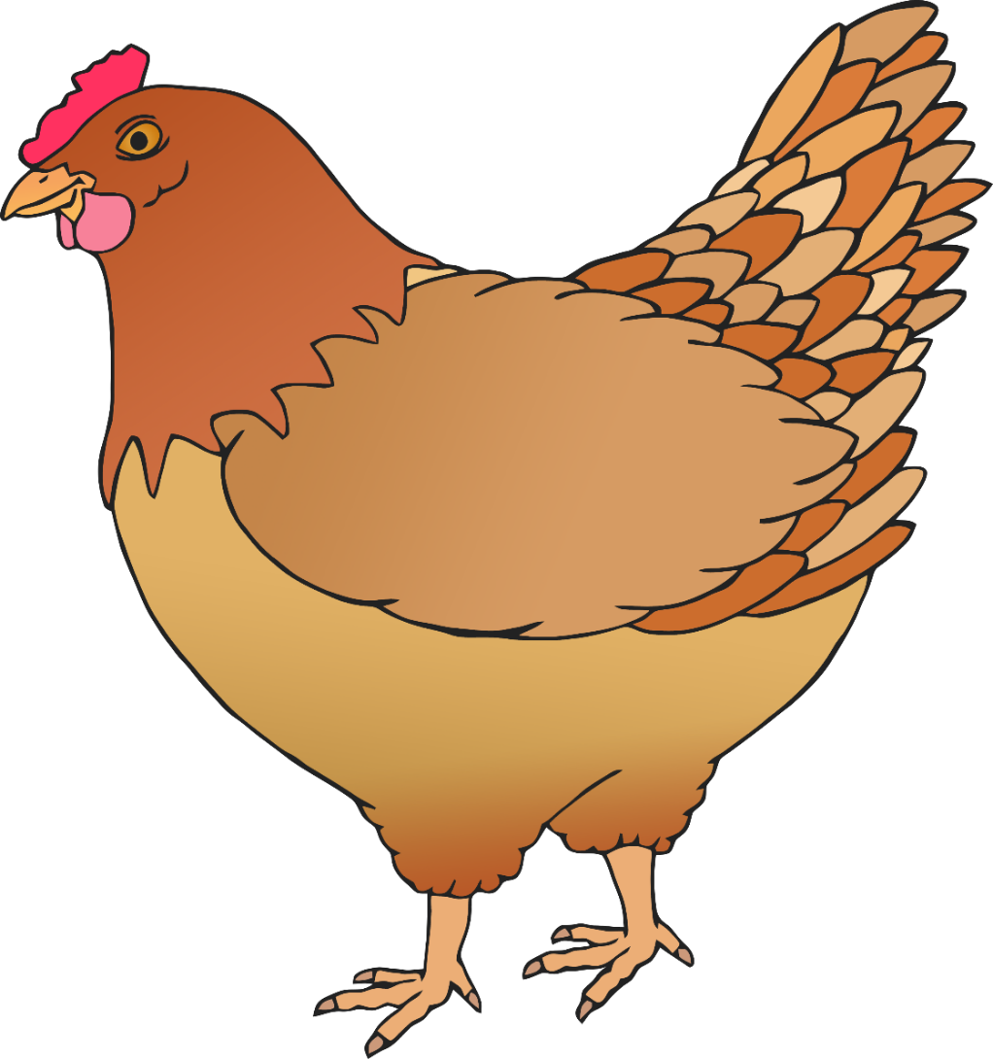

The sound a chicken makes is a cluck.

buc-buc

© 2020 Little Owls Resources