**Dinosaur Sounds – Phase 1 Activity**

These card prompts are for encouraging the children to think of what sounds these dinosaurs might have made.

* Tell the children that no-one knows for sure what these dinosaurs sounded like, so we need some great ideas.
* When showing these card prompts draw attention to whether the dinosaur is small, large, or gigantic! Will this affect the sound?
* How about whether the dinosaur looks fierce or timid… does this change what they think?

*An additional sound activity could be to think about the sounds the dinosaurs’ footsteps would make, paying attention to the size of the dinosaur and how heavy it would have been.*

© 2020 Little Owls Resources

Tyrannosaurus Rex

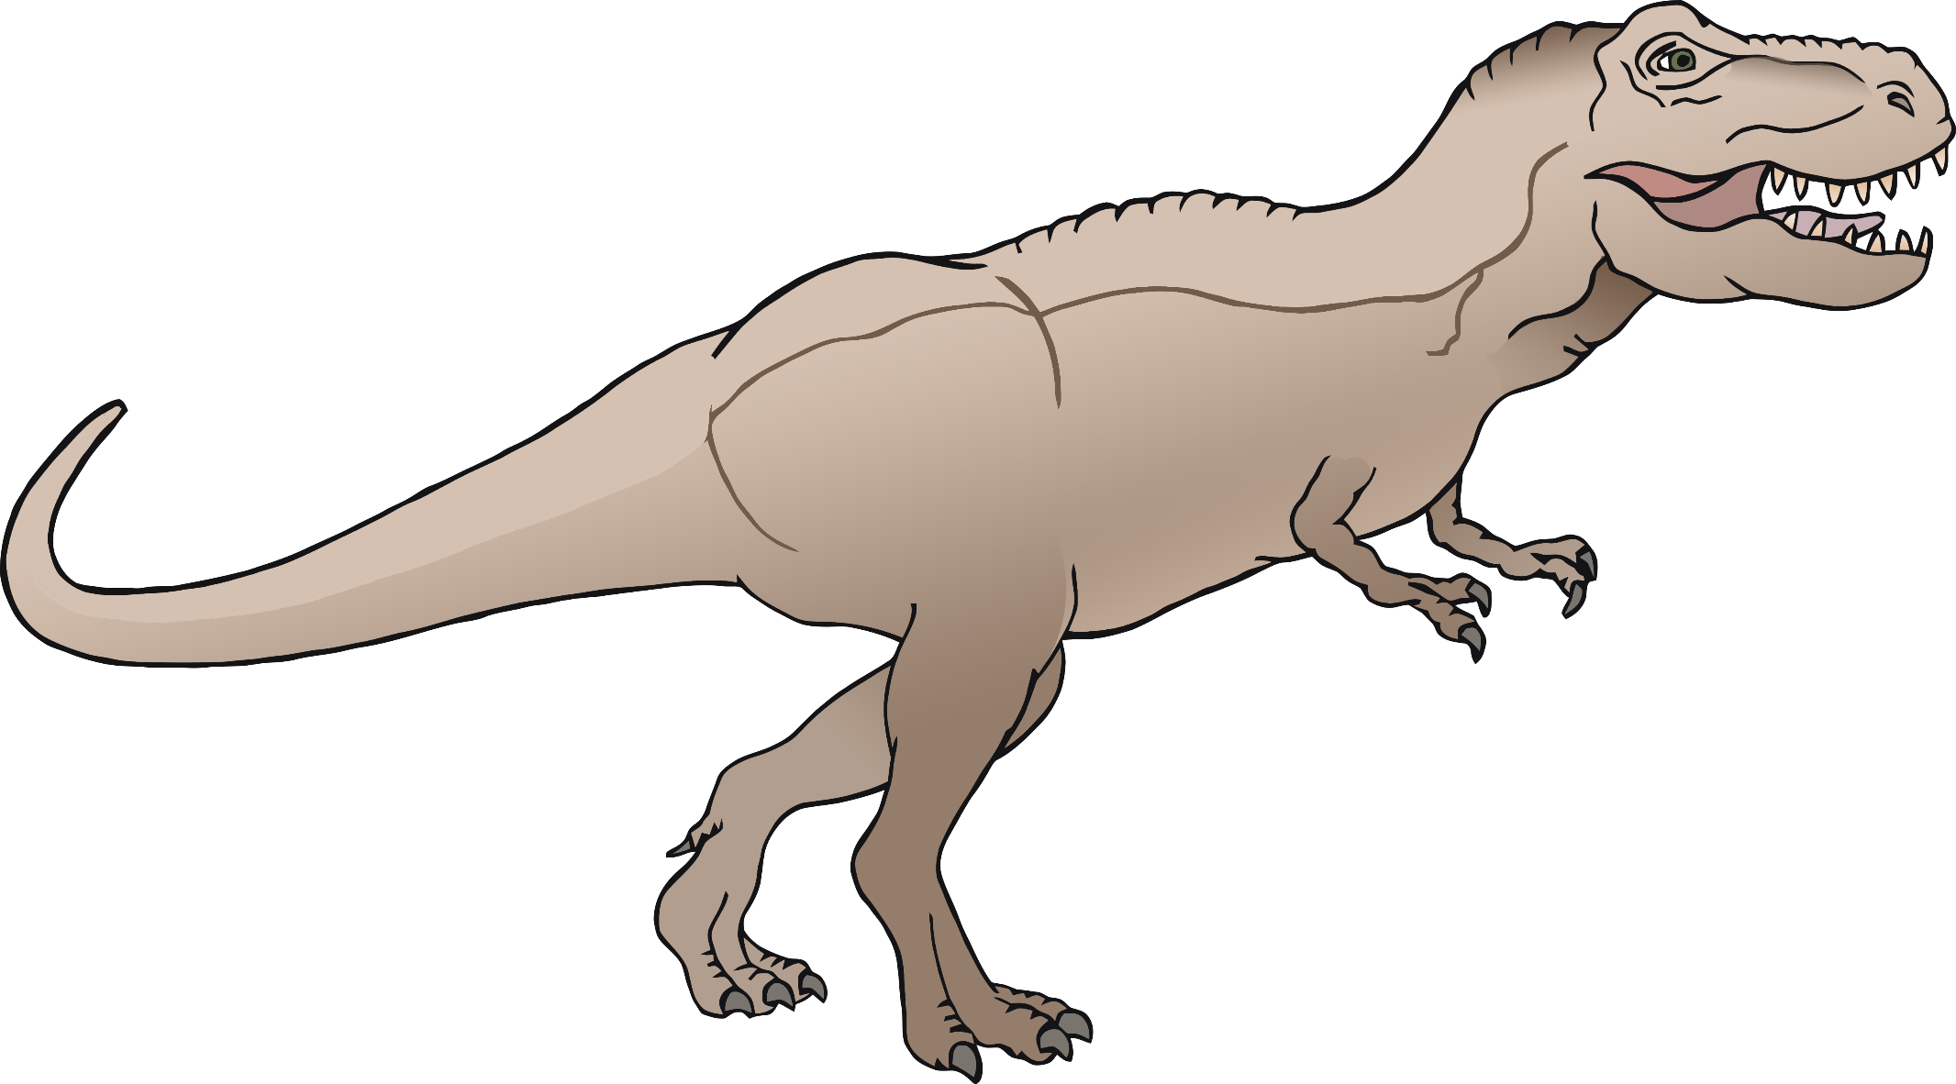

Spinosaurus

© 2020 Little Owls Resources

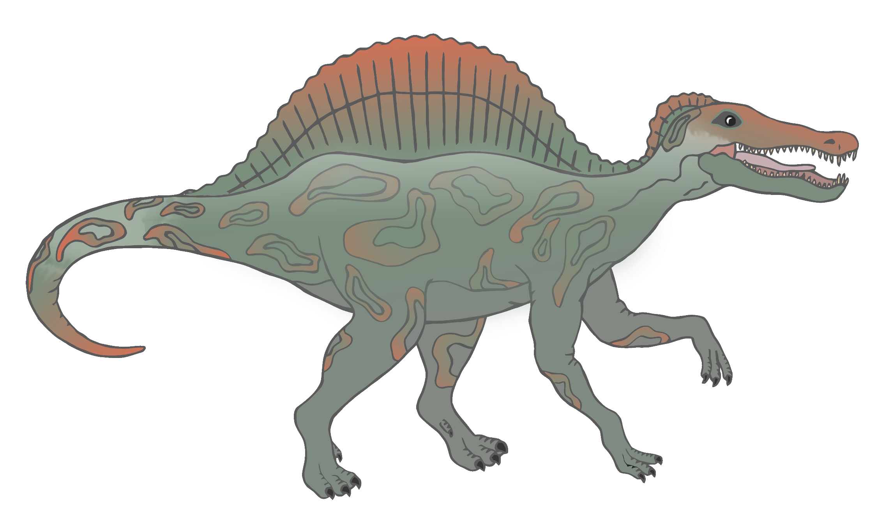



Ankylosaurus

© 2020 Little Owls Resources

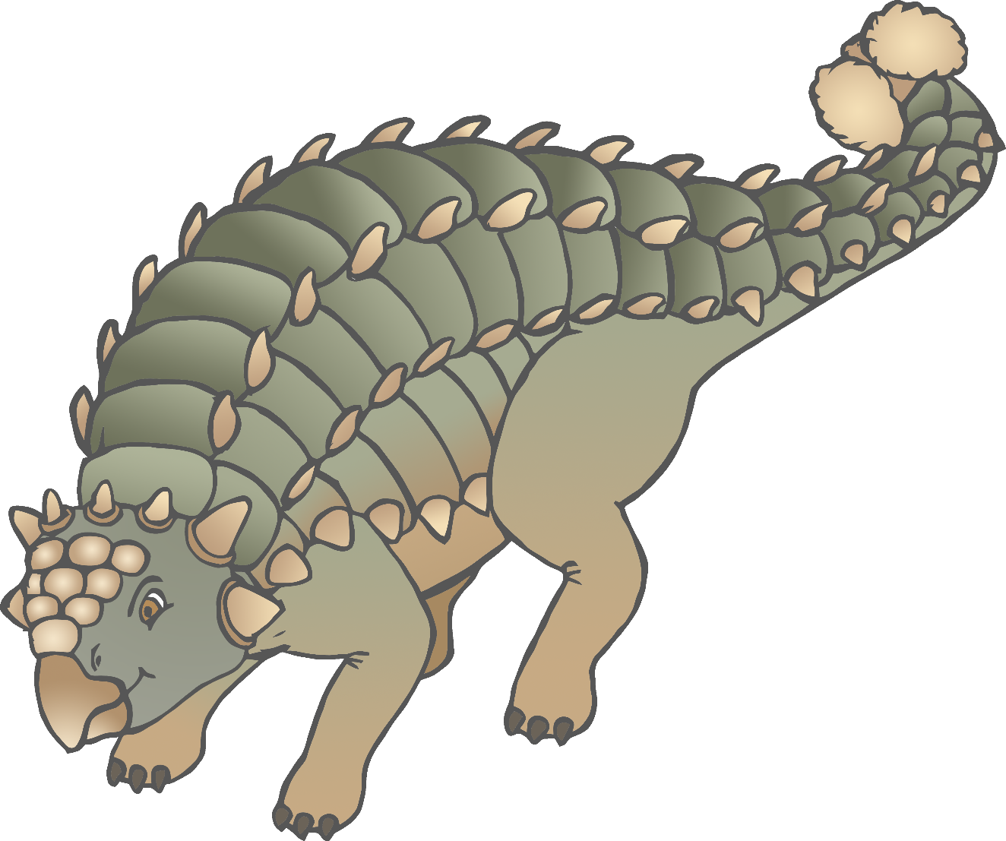

Stegosaurus

© 2020 Little Owls Resources

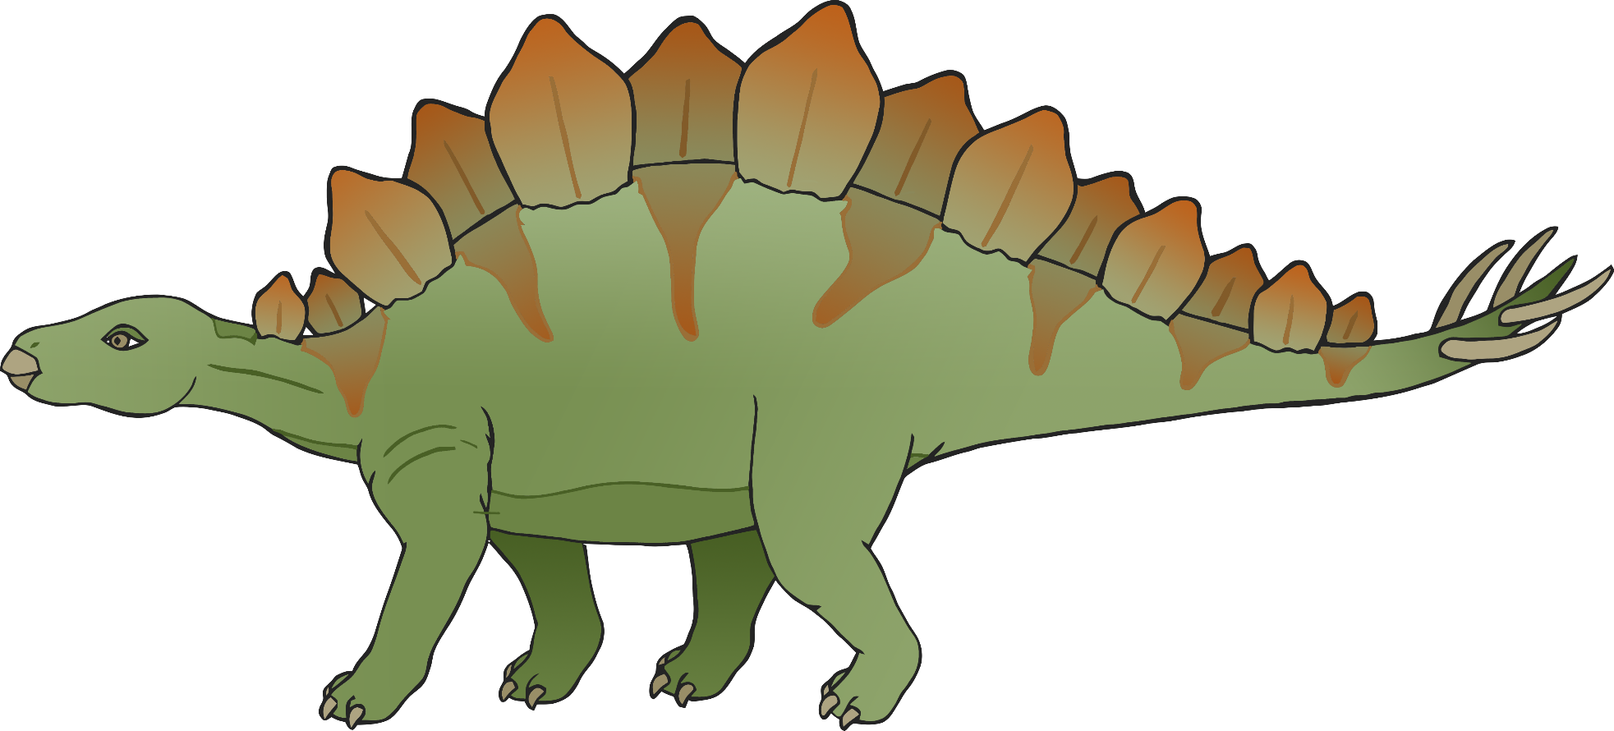

Parasaurolophus

© 2020 Little Owls Resources

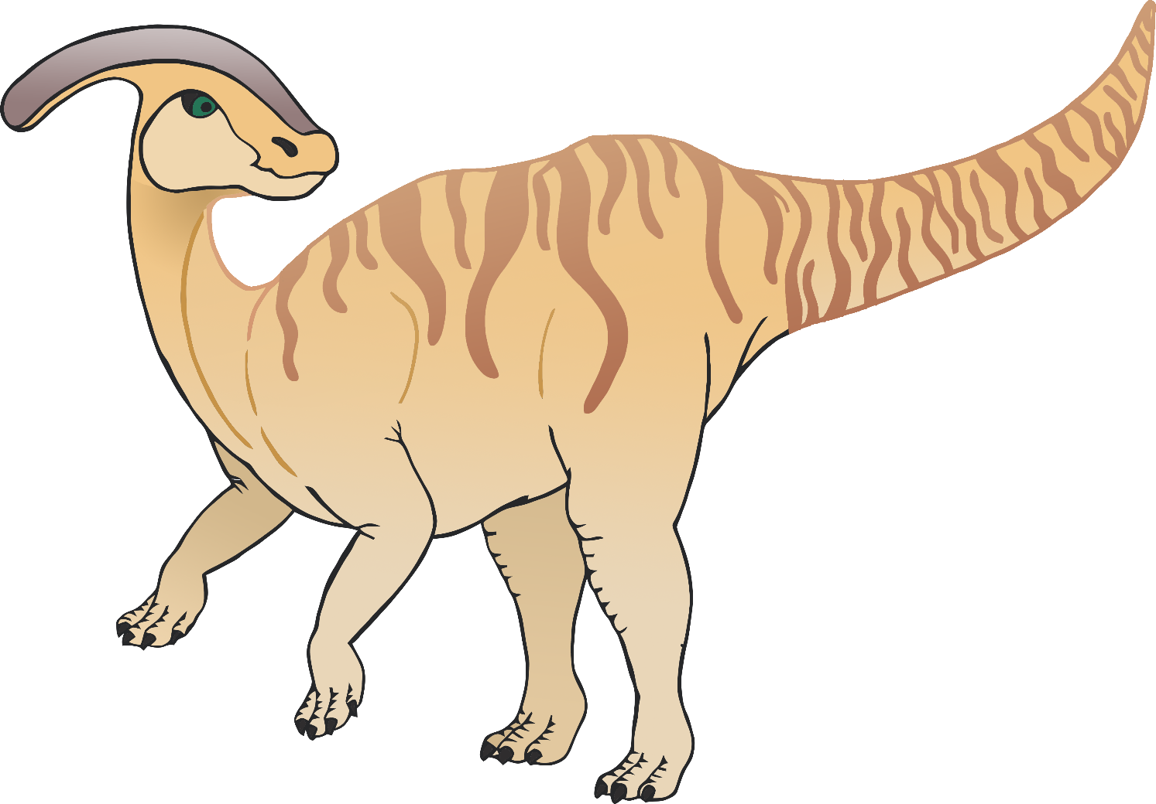

Pachycephalosaurus

© 2020 Little Owls Resources

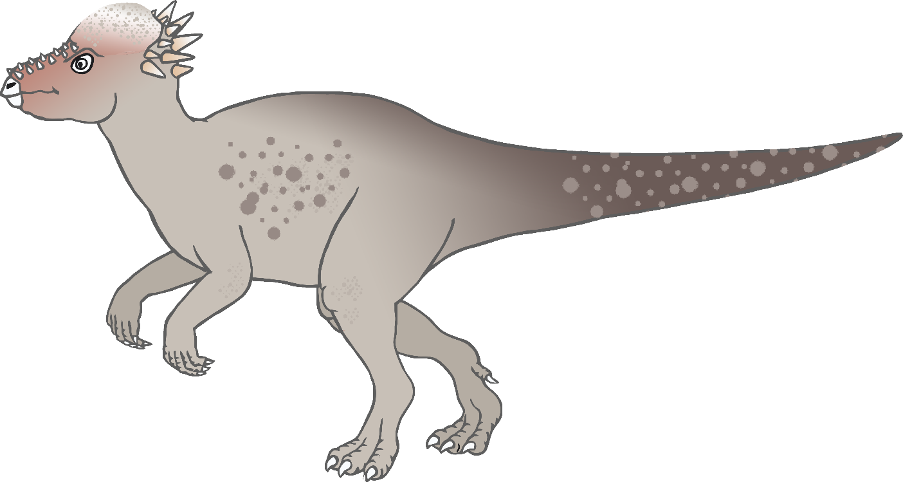

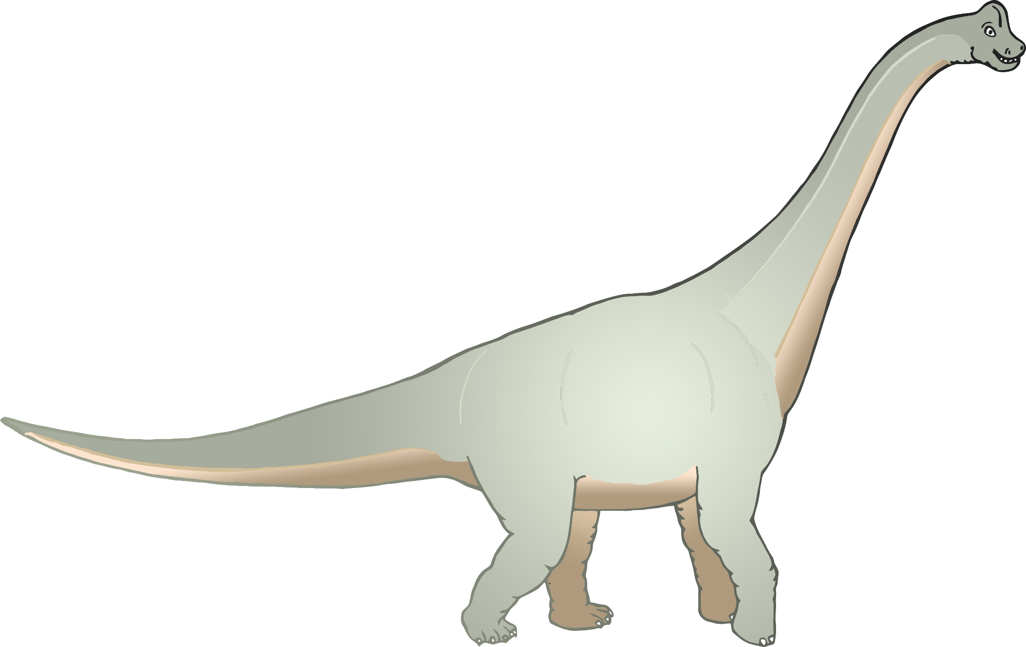

Brachiosaurus

© 2020 Little Owls Resources



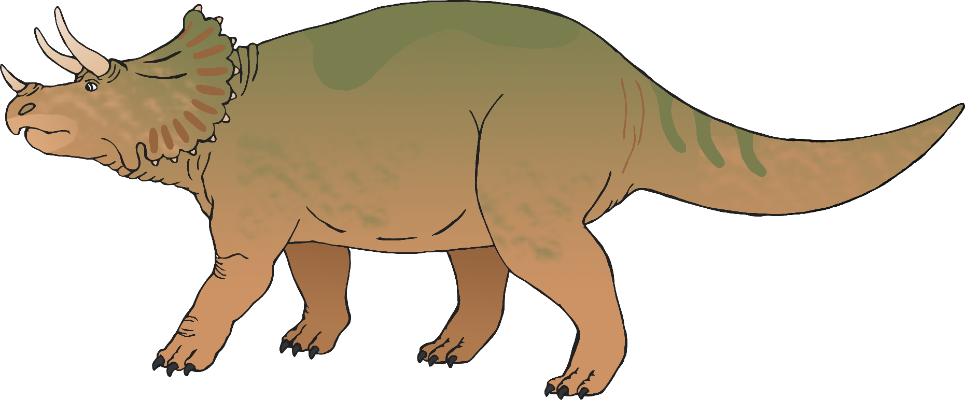

Triceratops

© 2020 Little Owls Resources