Cat

Rabbit

Dog

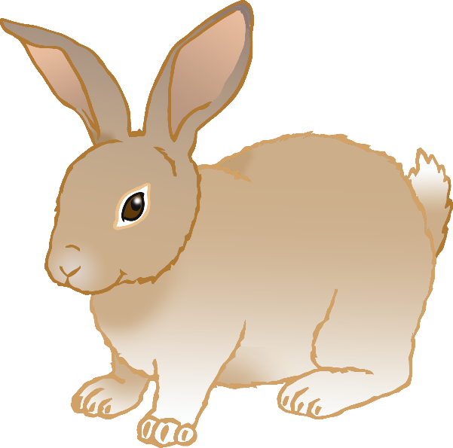

© 2021 Little Owls Resources

© 2021 Little Owls Resources

© 2021 Little Owls Resources

© 2021 Little Owls Resources

© 2021 Little Owls Resources

© 2021 Little Owls Resources

Hamster

Goldfish

Canary

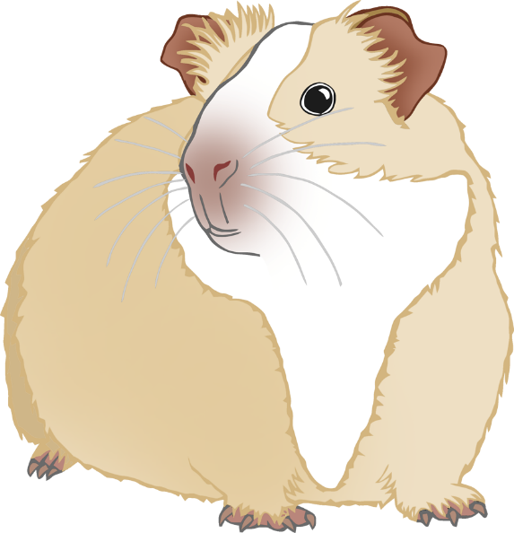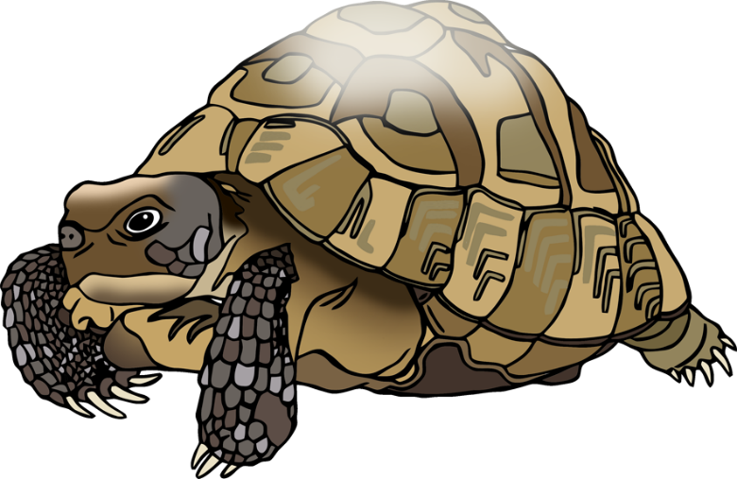

© 2021 Little Owls Resources

© 2021 Little Owls Resources

© 2021 Little Owls Resources

Guinea Pig

Tortoise

Snake

Chicken

© 2021 Little Owls Resources

rabbit

cat

dog

© 2021 Little Owls Resources

© 2021 Little Owls Resources

© 2021 Little Owls Resources

© 2021 Little Owls Resources

© 2021 Little Owls Resources

© 2021 Little Owls Resources

canary

goldfish

hamster

© 2021 Little Owls Resources

© 2021 Little Owls Resources

© 2021 Little Owls Resources

guinea pig

snake

tortoise

chicken

rtle

© 2021 Little Owls Resources