© 2021 Little Owls Resources

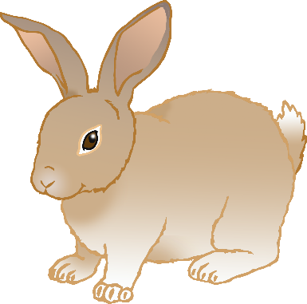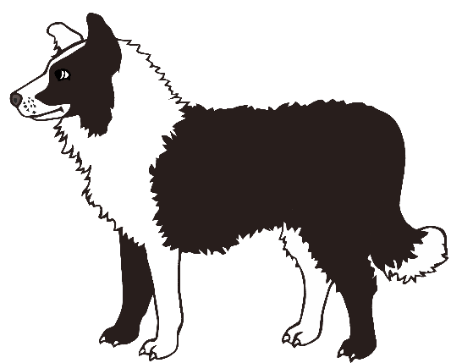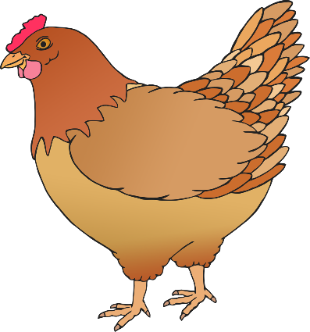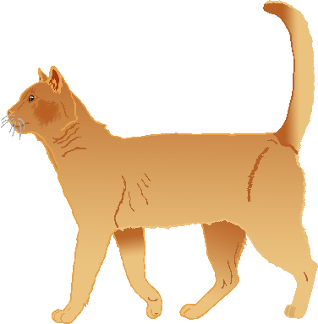

Cat

Rabbit

Chicken

Hamster

Tortoise

Goldfish

Guinea Pig

Snake

Canary

**Pets Word Mat**

Dog

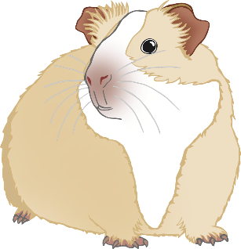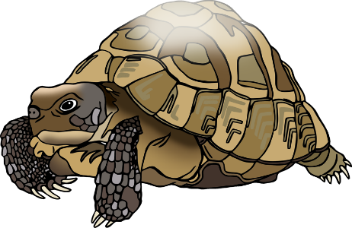

© 2021 Little Owls Resources



cat

rabbit

chicken

hamster

tortoise

goldfish

guinea pig

snake

canary

**Pets Word Mat**

dog