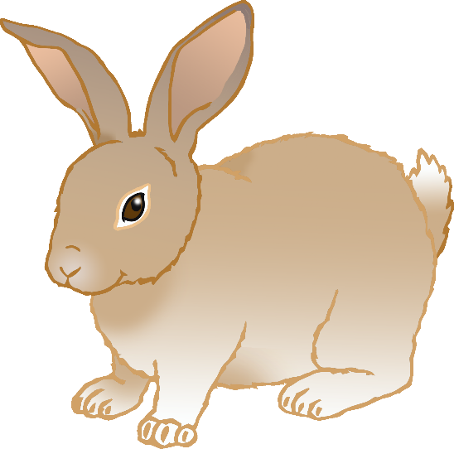

* Lives for 5-8 years.
* Eats hay and fresh vegetables.
* Baby is called a bunny.
* Lives for 13-17 years.
* Eats meat.
* Baby is called a kitten.
* Lives for 10-13 years.
* Eats meat and some vegetables.
* Baby is called a puppy.

**Rabbit**

**Cat**

**Dog**

© 2021 Little Owls Resources

© 2021 Little Owls Resources

© 2021 Little Owls Resources

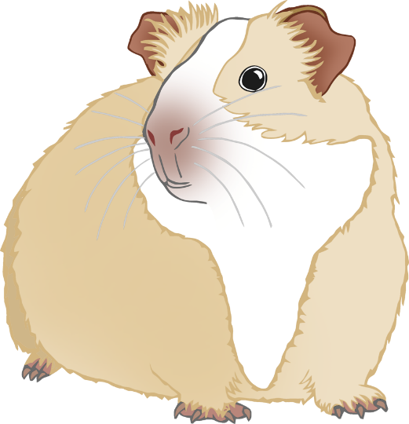

* Lives for 15-30 years.
* Eats meat.
* Baby is called a snakelet.
* Lives for 4-8 years.
* Eats hay and fresh vegetables.
* Baby is called a pup.
* Lives for 3-5 years.
* Eats mixed seeds.
* Baby is called a pup.

**Snake**

**Guinea Pig**

**Hamster**

© 2021 Little Owls Resources

© 2021 Little Owls Resources

© 2021 Little Owls Resources

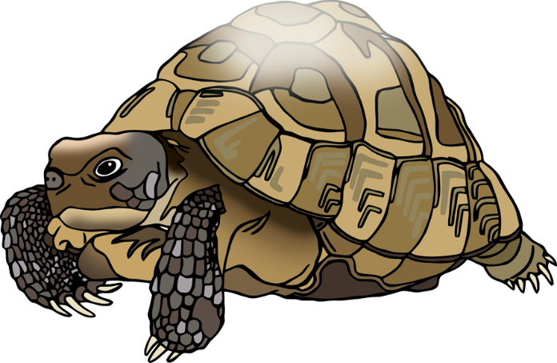

**Canary**

* Lives for up to 15 years
* Eats seeds.
* Baby is called a chick.
* Lives for 50-100 years.
* Fresh vegetables and plants.
* Baby is called a hatchling.
* Lives for 8 years.
* Eats fruit, grain, and vegetables.
* Baby is called a chick.

**Tortoise**

**Chicken**

© 2021 Little Owls Resources

© 2021 Little Owls Resources

© 2021 Little Owls Resources

* Lives for 10-15 years.
* Eats bloodworm and brine shrimp.
* Baby is called a fry.

**Goldfish**

© 2021 Little Owls Resources