**Pet Descriptions**

Children to guess which pet is being described to them!

© 2021 Little Owls Resources

Fold along the line

**?**

© 2021 Little Owls Resources

This animal twitches its nose.

This animal eats vegetables.

This animal’s baby is called a bunny.

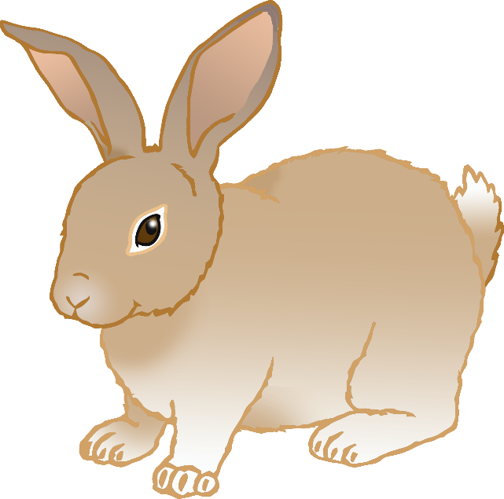

**?**

© 2021 Little Owls Resources

This animal loves going for walks.

This animal wags its tail.

This animal likes bones.

**?**

© 2021 Little Owls Resources

This animal has four legs.

This animal likes to catch mice.

This animal has whiskers.

**?**

© 2021 Little Owls Resources

This animal eats meat.

This animal sticks its tongue in and out.

This animal has no legs.

**?**

© 2021 Little Owls Resources

This animal has two wings.

This animal has two legs.

We get eggs from this animal.

**?**

© 2021 Little Owls Resources

This animal is a small animal.

This animal keeps food in its cheeks.

This animal eats seeds.

**?**

© 2021 Little Owls Resources

This animal walks very slowly.

This animal has a thick shell.

This animal can live a very long time.

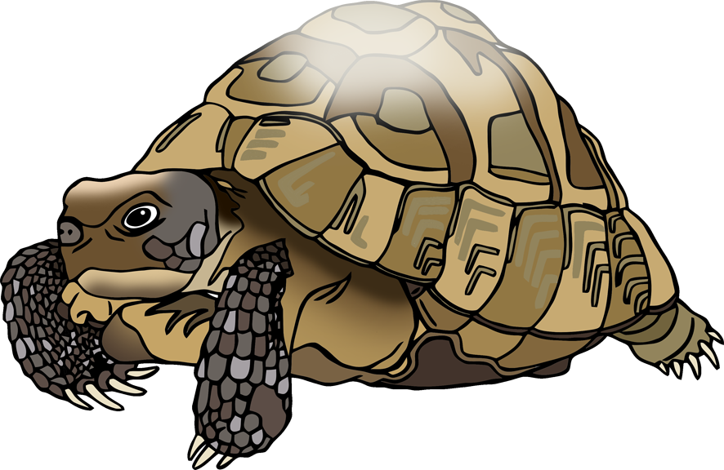

**?**

© 2021 Little Owls Resources

This animal has two legs.

This animal can fly.

This animal is yellow.

**?**

© 2021 Little Owls Resources

This animal has no legs.

This animal lives in the water.

This animal’s babies are called fry.

**?**

© 2021 Little Owls Resources

This animal has no tail.

This animal eats grass and vegetables.

This animal’s babies are called pups.

