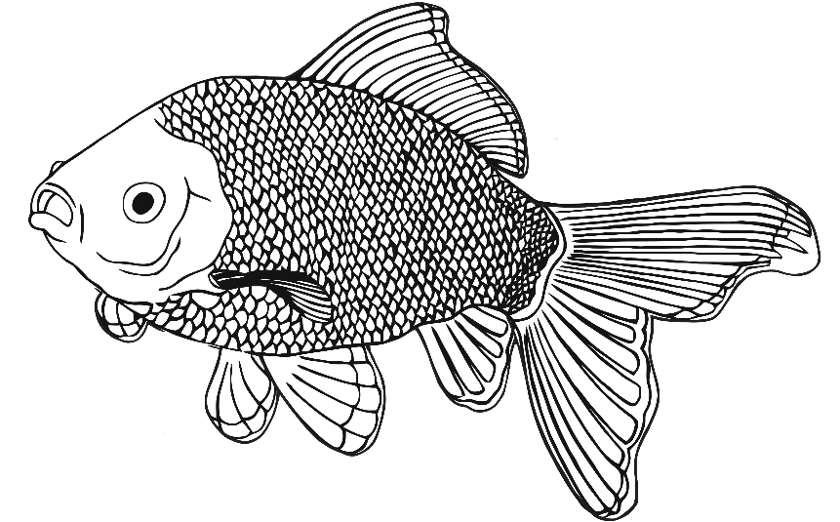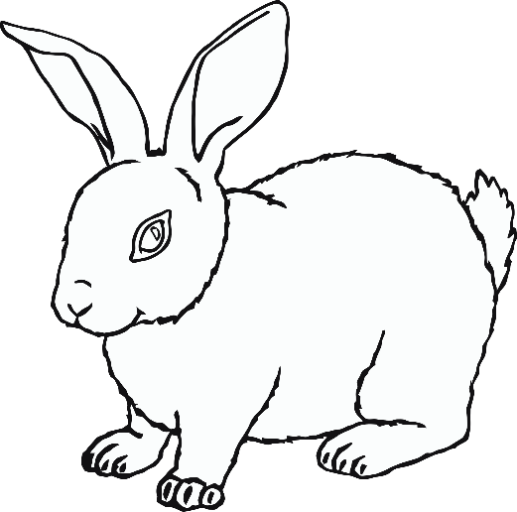

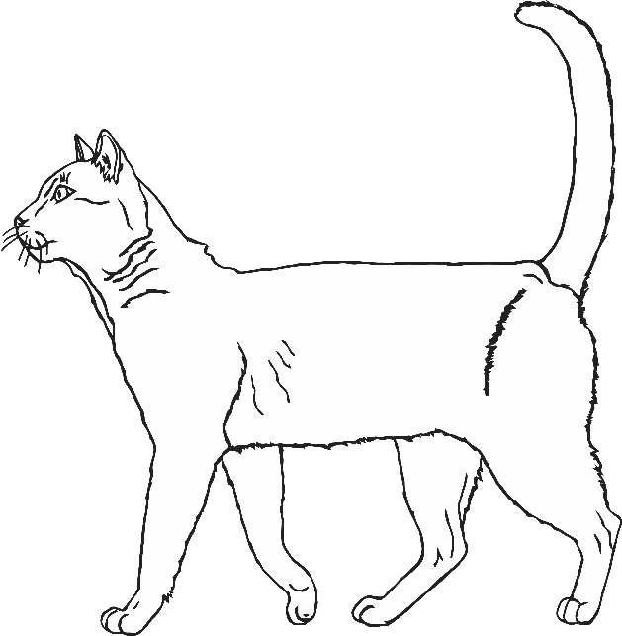

**PETS**

**dog**

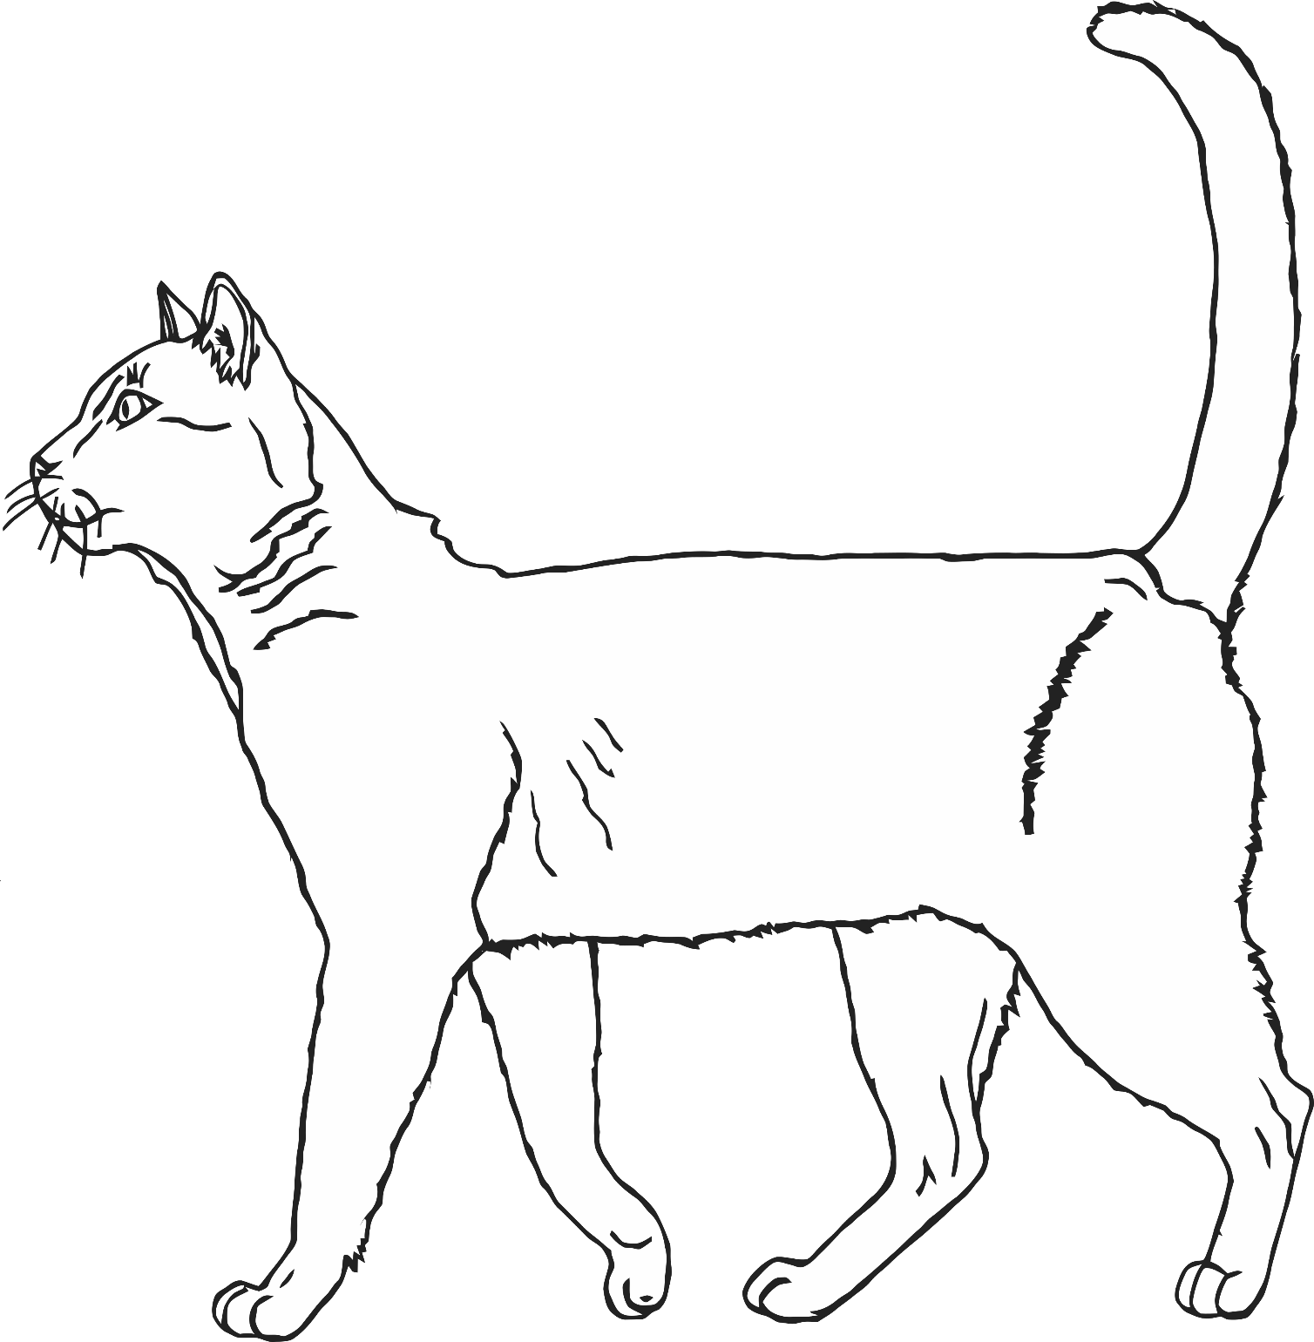

**cat**

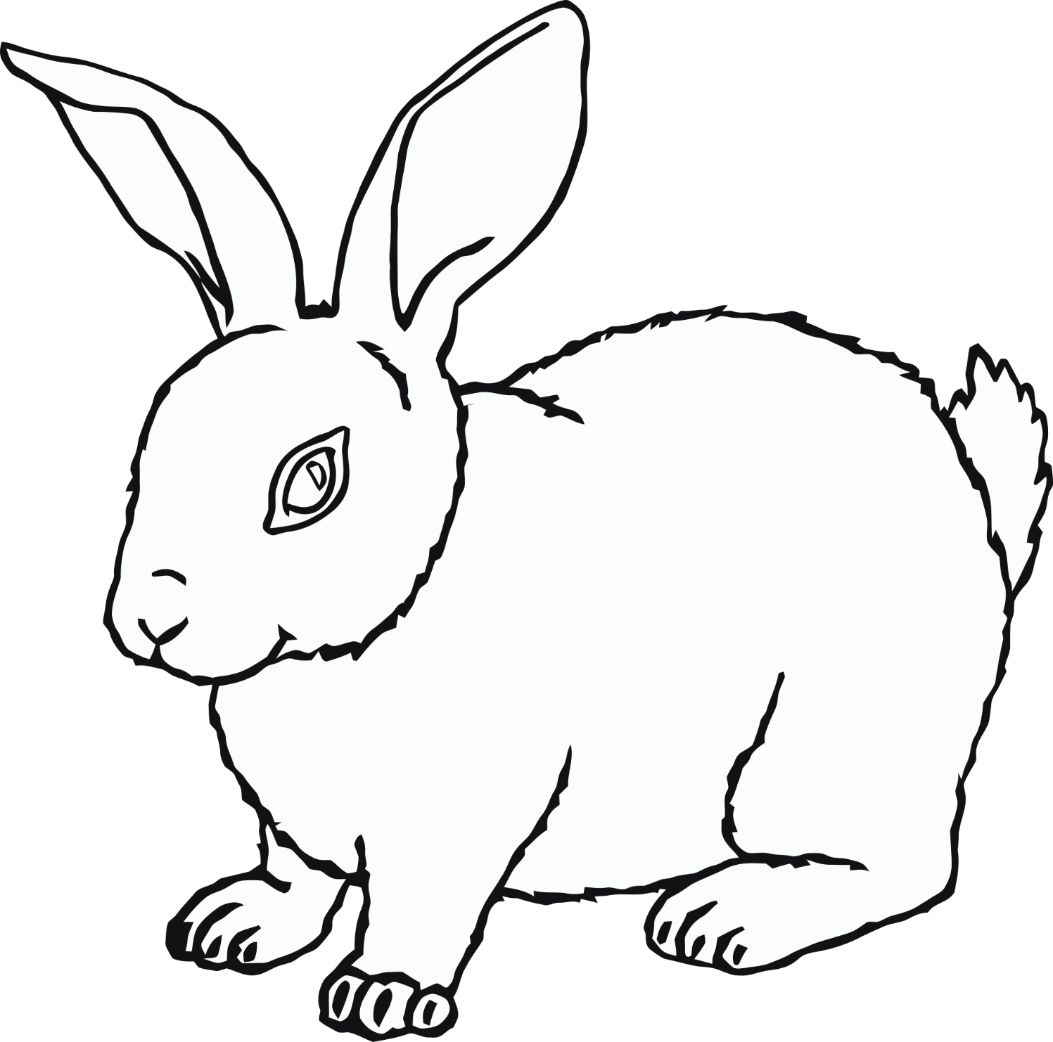

**rabbit**

**snake**

**canary**

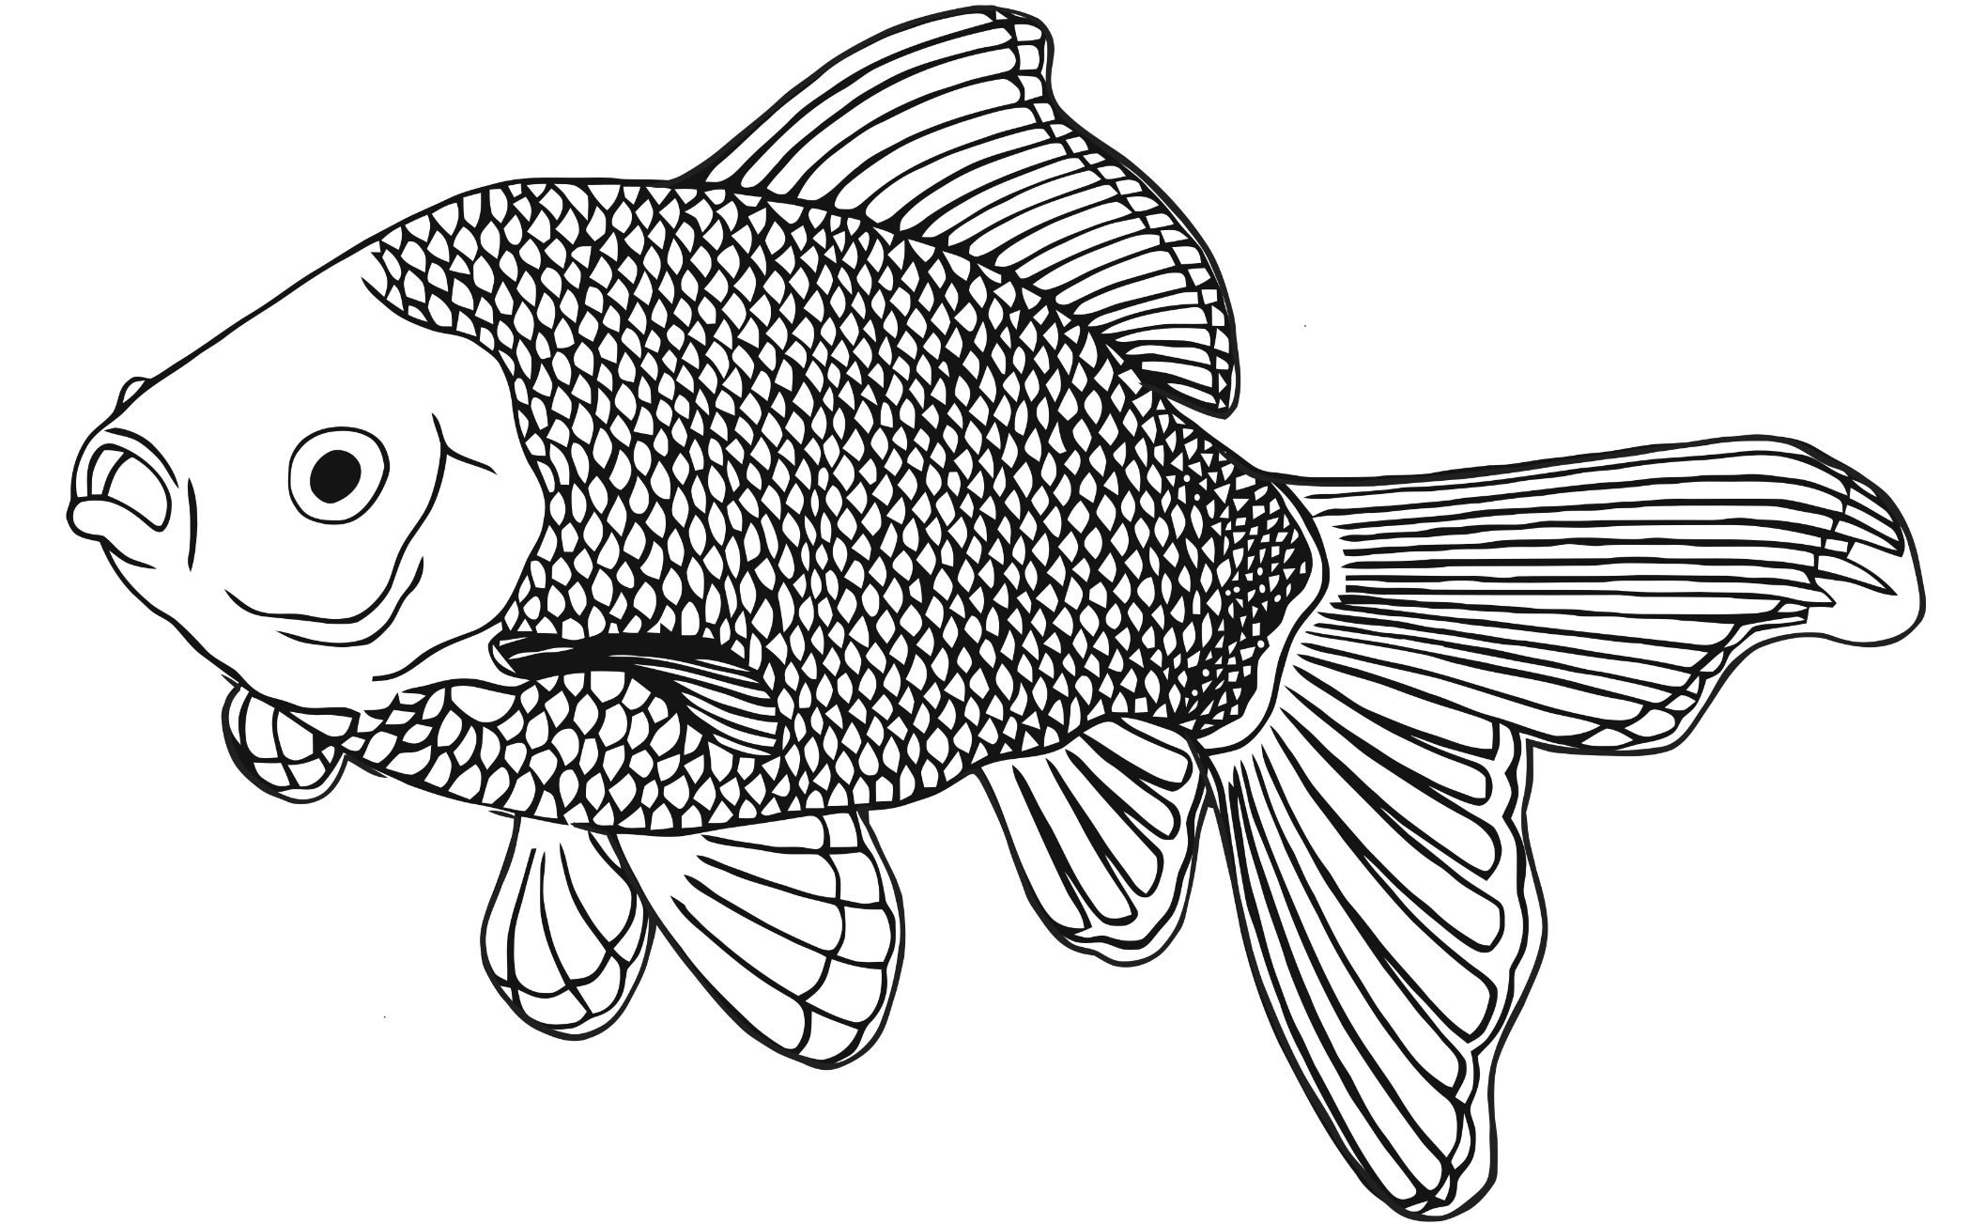

**goldfish**

**guinea pig**

**hamster**

**chicken**

**tortoise**

