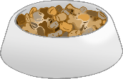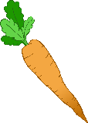

**Pet Monitor**

© 2021 Little Owls Resources

**Pet Monitor**

© 2021 Little Owls Resources



**Pet Monitor**

© 2021 Little Owls Resources

**Pet Monitor**

© 2021 Little Owls Resources

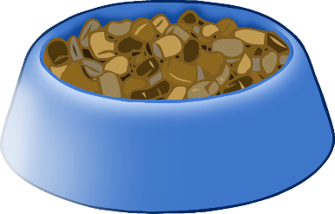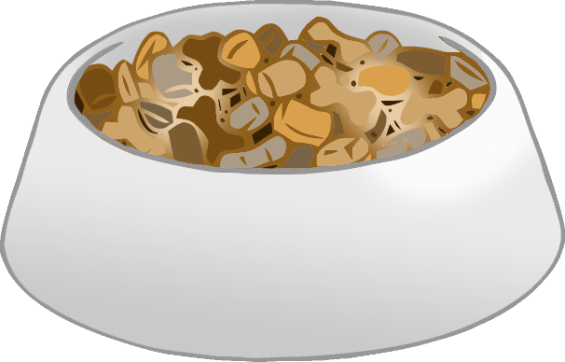

**Refill the food!**

© 2021 Little Owls Resources

**Don’t forget**

**to change the water!**

© 2021 Little Owls Resources

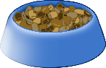



**Write your name here when you have refilled the food.**

© 2021 Little Owls Resources





© 2021 Little Owls Resources

**Write your name here when you have refilled the food.**

_______________________________________________________________________________________________________________________

**Write your name here when you have changed the water.**

© 2021 Little Owls Resources

**Write your name here when you have changed the water.**

© 2021 Little Owls Resources

_______________________________________________________________________________________________________________________