Perseids

Fact Sheet

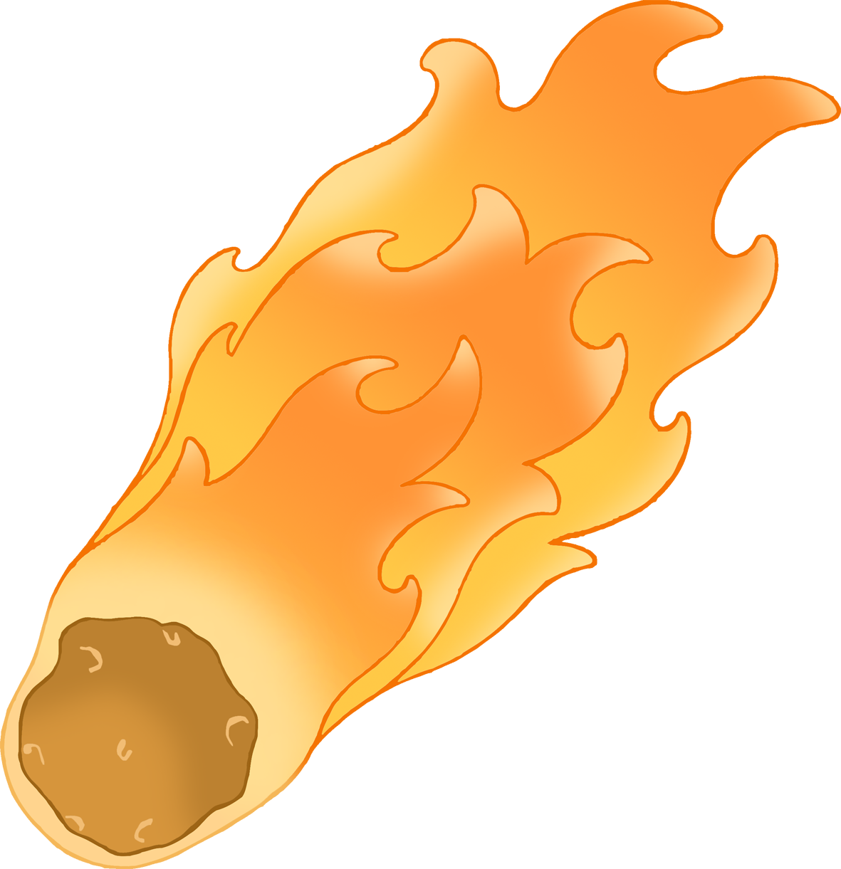

* Most of the Perseid meteors are the size of grain of sand. Some are as big as a pea or a marble.
* The bright streak is the Perseid burning up in the Earth’s atmosphere.
* It is very rare that a Perseid will get to the ground. If it does it is then called a ‘meteorite’.
* The Perseids are small remnants from the tail of Comet Swift-Tuttle.
* The Perseids enter the atmosphere at over 130,000 mph (60 km/s).
* You don’t need any equipment to see the Perseids; just your eyes and a dark clear night!
* The Perseids can be seen between July 17 – Aug 24 each year. The peak day is usually around 12th Aug.

© 2021 Little Owls Resources