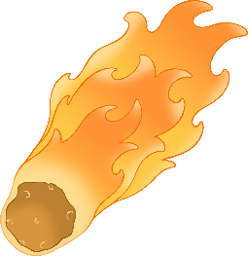

**Perseids** - Fact Card

© 2021 Little Owls Resources



Most of the Perseid meteors are the size of grain of sand. Some are as big as a pea or a marble.

The Perseids enter the atmosphere at over

130,000 mph

(60 km/s)



**Perseids** - Fact Card

© 2021 Little Owls Resources



The bright streak is the meteor burning up in the Earth’s atmosphere.

x

You don’t need any equipment to see the Perseids; just your eyes and a dark clear night!



**Perseids** - Fact Card

© 2021 Little Owls Resources



**Perseids** - Fact Card

© 2021 Little Owls Resources



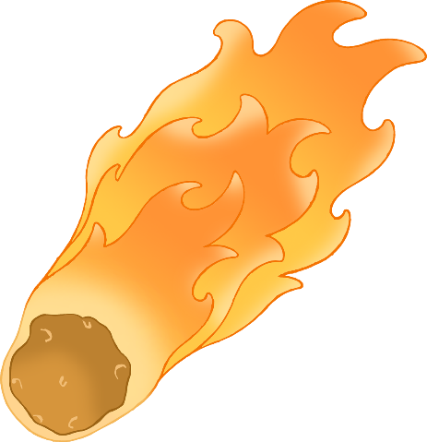

The Perseids are small remnants from the tail of Comet Swift-Tuttle.

If a meteor makes it to the ground, it is called a meteorite.



**Perseids** - Fact Card

© 2021 Little Owls Resources



**Perseids** - Fact Card

© 2021 Little Owls Resources

