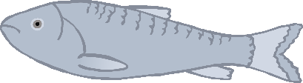

Make **1** fish.

Can you make some fish for the penguin using playdough?

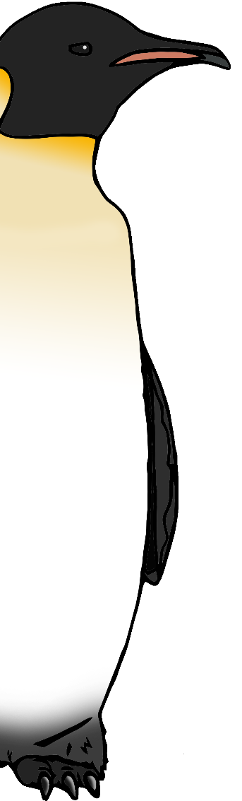

© 2020 Little Owls Resources

Make **2** fish.

© 2020 Little Owls Resources

Can you make some fish for the penguin using playdough?

Make **3** fish.

Can you make some fish for the penguin using playdough?



© 2020 Little Owls Resources

© 2020 Little Owls Resources

Make **4** fish.

© 2020 Little Owls Resources

Can you make some fish for the penguin using playdough?

Make **5** fish.

Can you make some fish for the penguin using playdough?



© 2020 Little Owls Resources

Make **6** fish.

Can you make some fish for the penguin using playdough?



© 2020 Little Owls Resources

Make **7** fish.

Can you make some fish for the penguin using playdough?



© 2020 Little Owls Resources

Make **8** fish.

Can you make some fish for the penguin using playdough?



© 2020 Little Owls Resources

Make **9** fish.

Can you make some fish for the penguin using playdough?



© 2020 Little Owls Resources

Make **10** fish.

© 2020 Little Owls Resources

Can you make some fish for the penguin using playdough?