Feed the Penguin Game

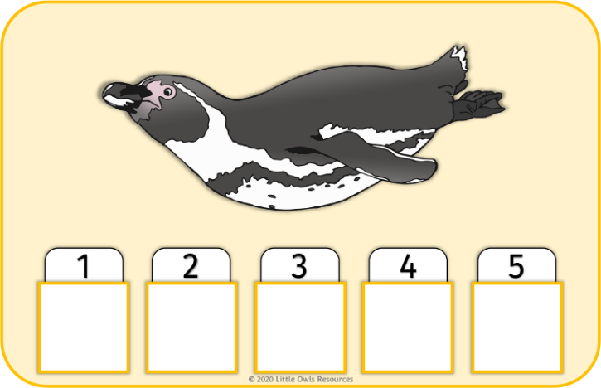

Help the penguins find fish!

Game for three players.

Takes turns to turn a card. If it is an ‘**X**’ turn the card back over. If it is a fish put it on your collection card.

The first player to get five fish is the winner!

© 2020 Little Owls Resources

1

2

3

4

5

© 2020 Little Owls Resources

1

2

3

4

5

© 2020 Little Owls Resources

1

2

3

4

5





