**Penguin body parts**

© 2020 Little Owls Resources

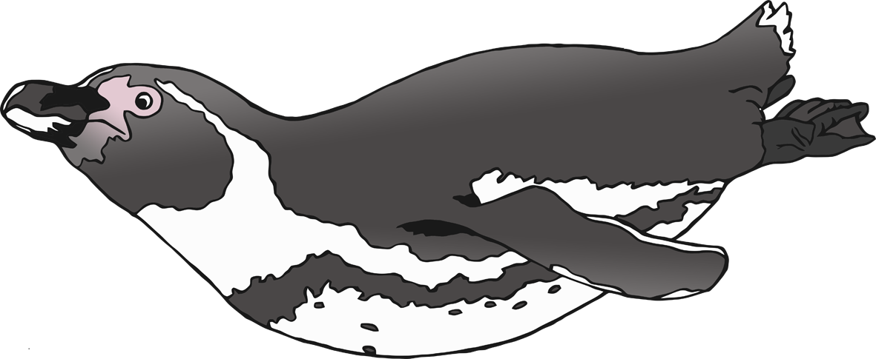

t

f

f

f

b

**Penguin body parts**

© 2020 Little Owls Resources



foot

tail

flipper

feathers

bill

**Penguin body parts**

© 2020 Little Owls Resources

