Kiddush Cup

Haggadah

seder plate

© 2021 Little Owls Resources

© 2021 Little Owls Resources

© 2021 Little Owls Resources

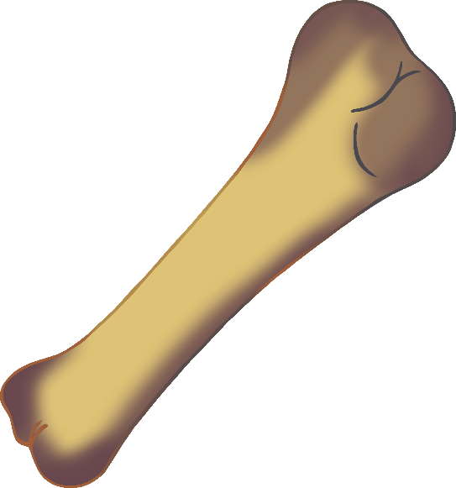

www.littleowlsresources.com

www.littleowlsresources.com

www.littleowlsresources.com

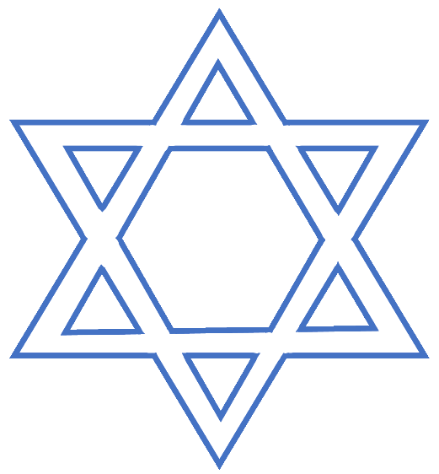

shank bone

parsley

© 2021 Little Owls Resources

Star of David

© 2021 Little Owls Resources

© 2021 Little Owls Resources

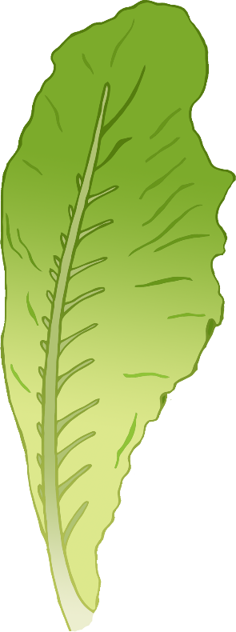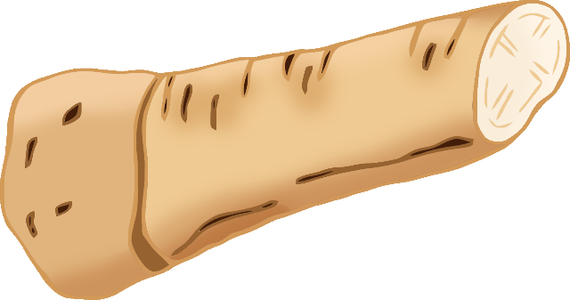

lettuce

horseradish

roasted egg

© 2021 Little Owls Resources

© 2021 Little Owls Resources

© 2021 Little Owls Resources

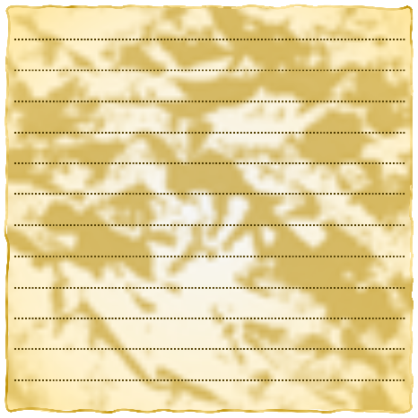



© 2021 Little Owls Resources

© 2021 Little Owls Resources

matzah

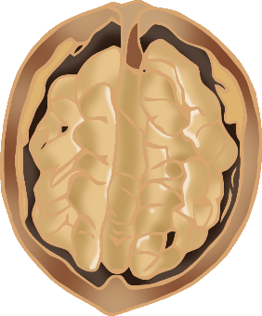

apple and walnut