**Passover Word Mat**

© 2021 Little Owls Resources

matzah

seder plate

Kiddush Cup

horseradish

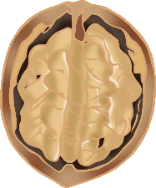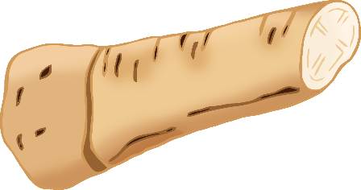

apple and walnut

lettuce

roasted egg

Star of David

Haggadah

shank bone

parsley