**Passover – Seder Plate**

Zeroah

Beitzah

(Shank Bone)

(Roasted Egg)

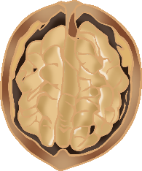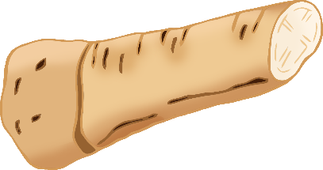

© 2021 Little Owls Resources

(Lettuce)

(Mixture of

Apple & Walnuts)

(Horseradish)

Charoset

Chazeret

Karpas

(Parsley)

Maror

© 2021 Little Owls Resources