© 2023 Little Owls Resources

Passover Memory Game

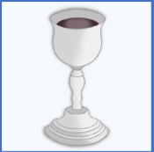

Lay out the cards face down and then take it in turns to try and find matching pairs!

© 2023 Little Owls Resources

© 2023 Little Owls Resources

© 2023 Little Owls Resources

© 2023 Little Owls Resources

© 2023 Little Owls Resources

© 2023 Little Owls Resources

© 2023 Little Owls Resources

© 2020 Little Owls Resources

© 2023 Little Owls Resources

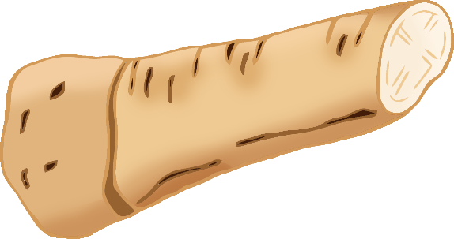

© 2023 Little Owls Resources

© 2023 Little Owls Resources

© 2023 Little Owls Resources

© 2023 Little Owls Resources

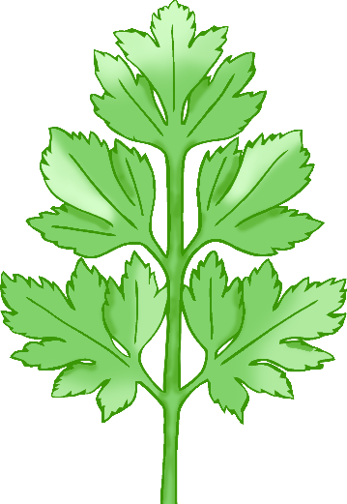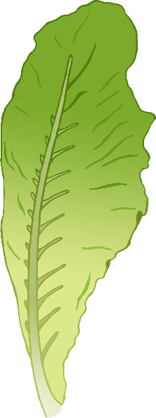

© 2023 Little Owls Resources

© 2023 Little Owls Resources

© 2023 Little Owls Resources

© 2023 Little Owls Resources

© 2023 Little Owls Resources

© 2023 Little Owls Resources

© 2023 Little Owls Resources

© 2023 Little Owls Resources

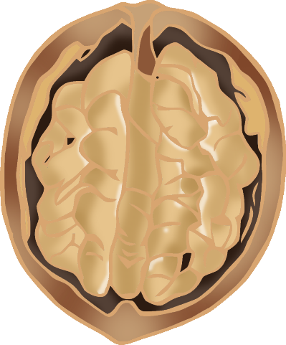

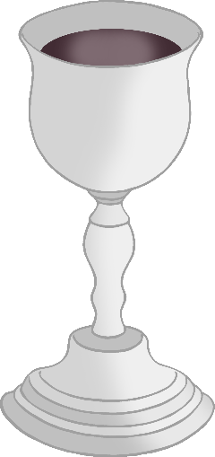

© 2023 Little Owls Resources

© 2023 Little Owls Resources

© 2023 Little Owls Resources

© 2023 Little Owls Resources