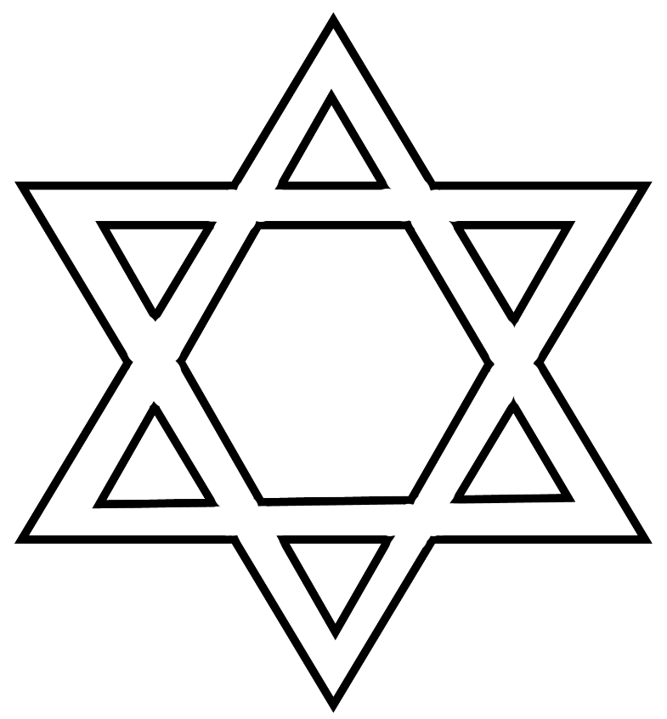

Happy Passover

**Seder plate**

**Kiddush Cup**

**matzah**

**פסח**

**Passover**

**Pesach**

**Happy Passover Holiday**

**Chag Pesach Sameach**

**חג פסח שמח**

