Happy

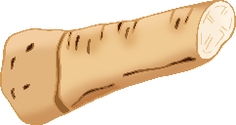

פסח

Passover

© 2021 Little Owls Resources

‘Happy Passover Holiday!”

חג פסח שמח

Chag Pesach Sameach!

© 2021 Little Owls Resources