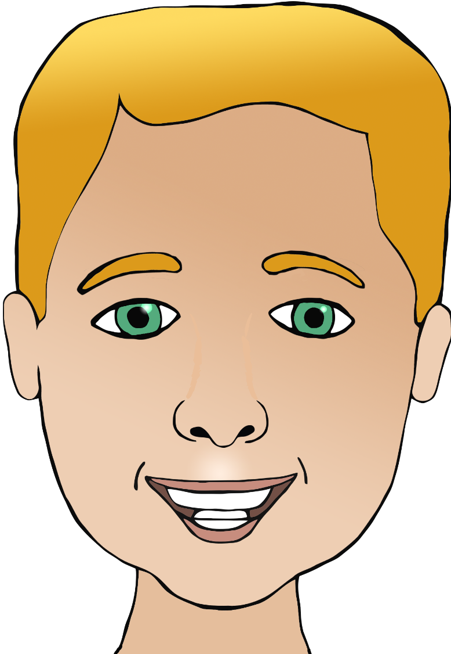

**Parts of the face**

Name:



**Parts of the face**

Name:

ch

e

m

e

h

h

mouth

chin

ear

eye

head

hair



**Parts of the face**

Name: