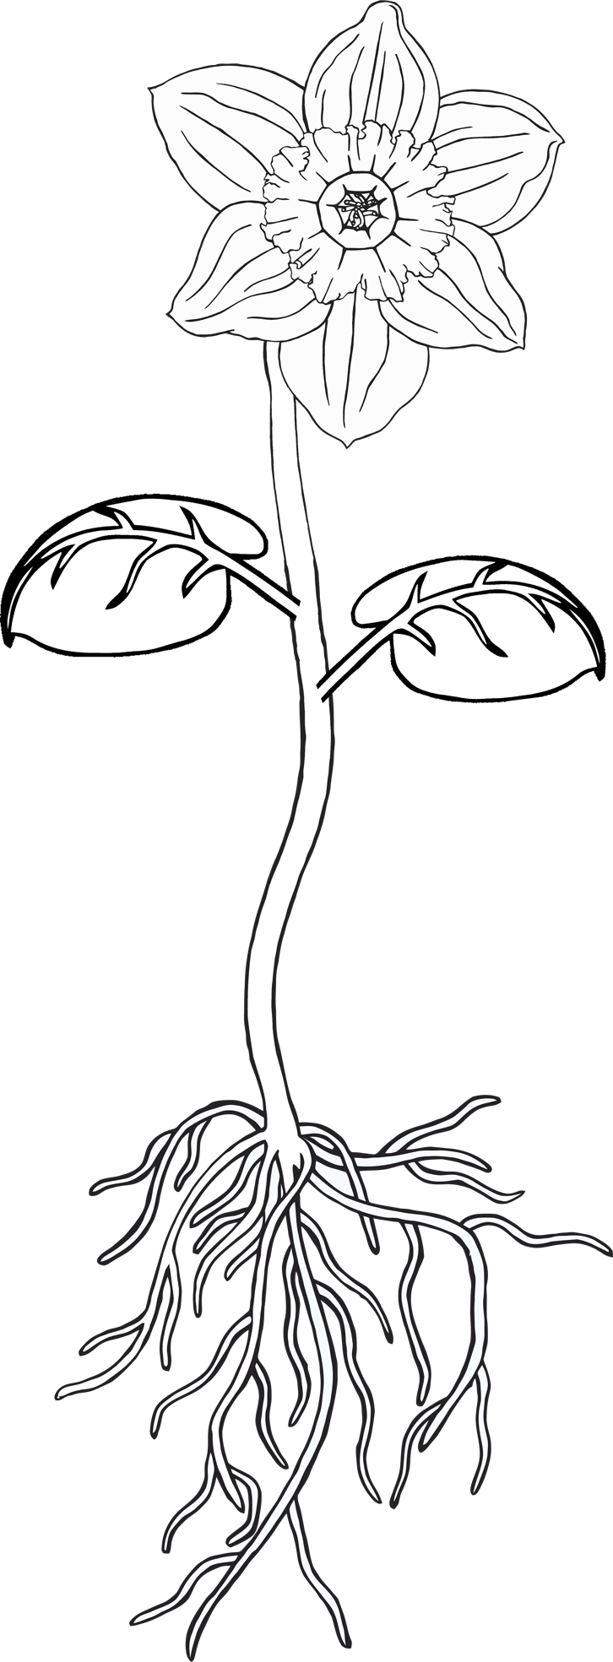

© 2021 Little Owls Resources

**Parts of a plant**

**roots**

**petal**

**leaf**

**stem**

**Parts of a plant**

p

r

s

l

© 2021 Little Owls Resources

© 2021 Little Owls Resources

**Parts of a plant**