People Who Help Us

Paramedic

* Information Posters
* Information Posters (Colouring)
* Drawing/Writing Sheets
* Draw items Sheet
* Draw items Sheet (Colouring)
* Item Poster
* Item Poster (Colouring)
* Multimats for Art & Craft/Loose Parts/Playdough
* 5x 2-Piece individual items puzzles
* 1x 4-Piece all items puzzle

The pages of this pack give some general information about the role of a paramedic and some fun and engaging activities to foster and develop children’s interest in this role in society.

This pack includes:

© 2021 Little Owls Resources

I use an ambulance to travel quickly to and from emergencies.

© 2021 Little Owls Resources

I’m a **paramedic**.

My job is to help people who are badly hurt or seriously ill.

If they need extra help, I transport them quickly and carefully to a hospital where they will be cared for by doctors and nurses.

Paramedic

Paramedic

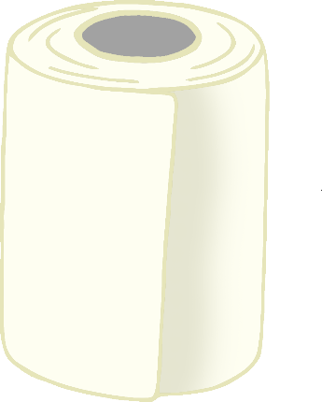

© 2021 Little Owls Resources

If someone is injured, I use a bandage to dress their wound.

Sometimes I use medical shears to cut off clothing.

I use medical gloves when I am helping people.

© 2021 Little Owls Resources

**I’m a paramedic.**

**My job is to help people who are badly hurt or seriously ill.**

**If they need extra help, I transport them quickly and carefully to a hospital where they will be cared for by doctors and nurses.**

Paramedic

**I use an ambulance to travel quickly to and from emergencies.**

**Paramedic**

**If someone is injured, I use a bandage to dress their wound.**

**Sometimes I use medical shears to cut off clothing.**

**I use medical gloves when I am helping people.**

© 2021 Little Owls Resources

© 2021 Little Owls Resources

Draw a Paramedic!

© 2021 Little Owls Resources

Draw and write about a Paramedic!

_________________________________________________________

© 2021 Little Owls Resources

Draw and write about a Paramedic!

________________________________________________________________________________________________________________________________________________

**Can you draw the items a paramedic needs?**

© 2021 Little Owls Resources

**Can you draw the items a paramedic needs?**

© 2021 Little Owls Resources

Paramedic

© 2021 Little Owls Resources

Medical Shears

Bandage

Medical Gloves

Ambulance

**Paramedic**

© 2021 Little Owls Resources

**Medical Shears**

**Bandage**

**Medical Gloves**

**Ambulance**

Paramedic Multimat - Bandage

© 2021 Little Owls Resources

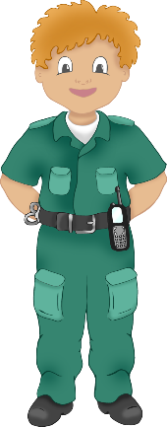

Paramedic Multimat – Medical Glove

© 2021 Little Owls Resources

Paramedic Multimat - Ambulance

© 2021 Little Owls Resources

Paramedic Multimat – Medical Shears

© 2021 Little Owls Resources

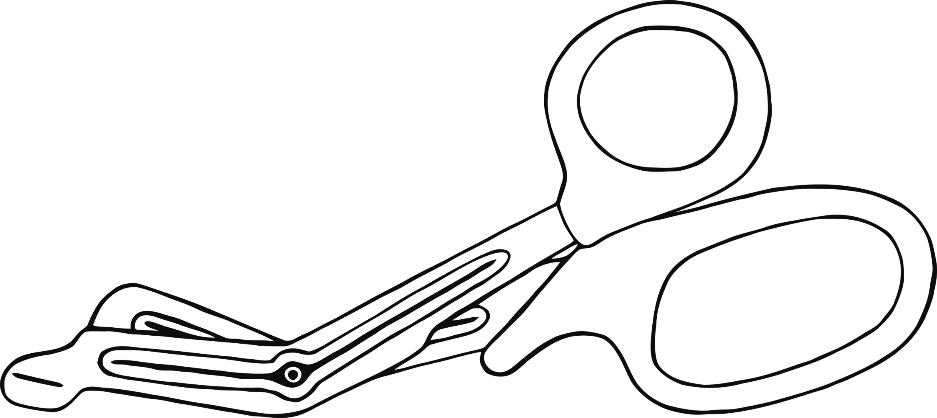

© 2021 Little Owls Resources

© 2021 Little Owls Resources

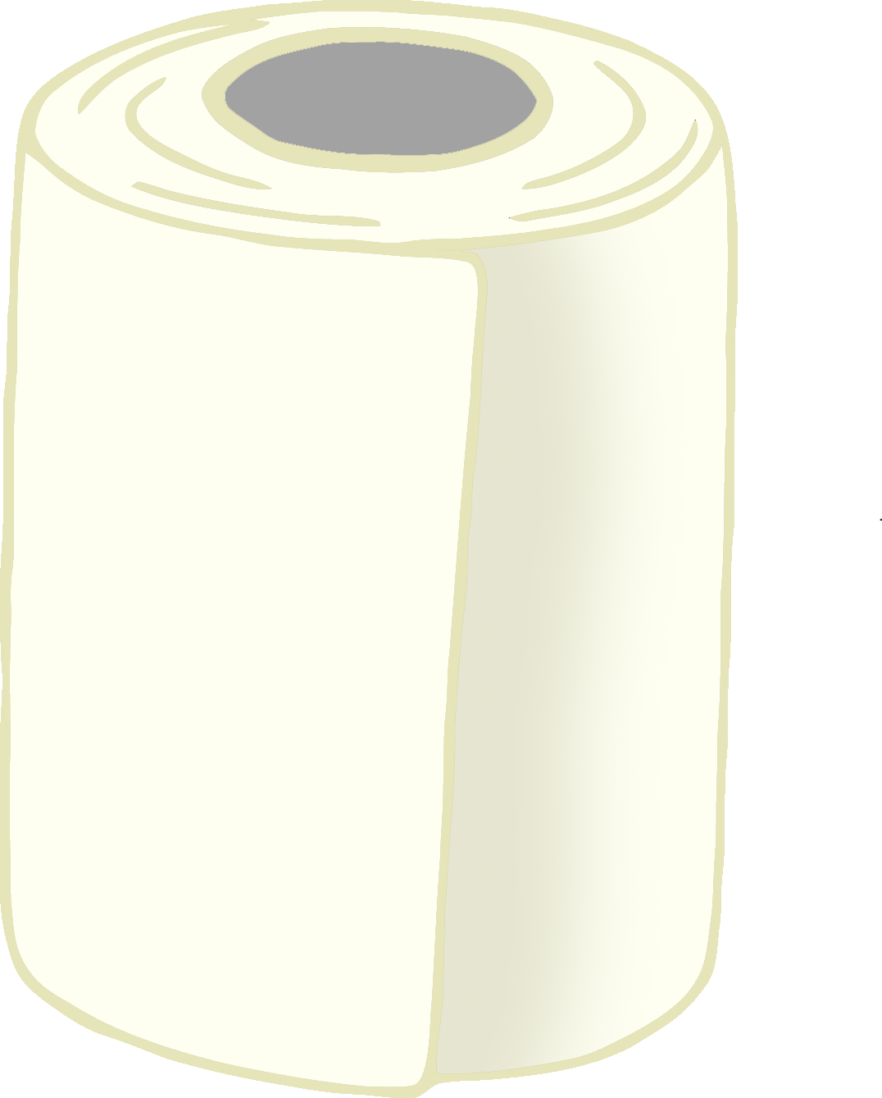

© 2021 Little Owls Resources

© 2021 Little Owls Resources

© 2021 Little Owls Resources

Paramedic

© 2021 Little Owls Resources

Medical Shears

Bandage

Ambulance

Medical Gloves