© 2020 Little Owls Resources

**What will you put on your pancake?**

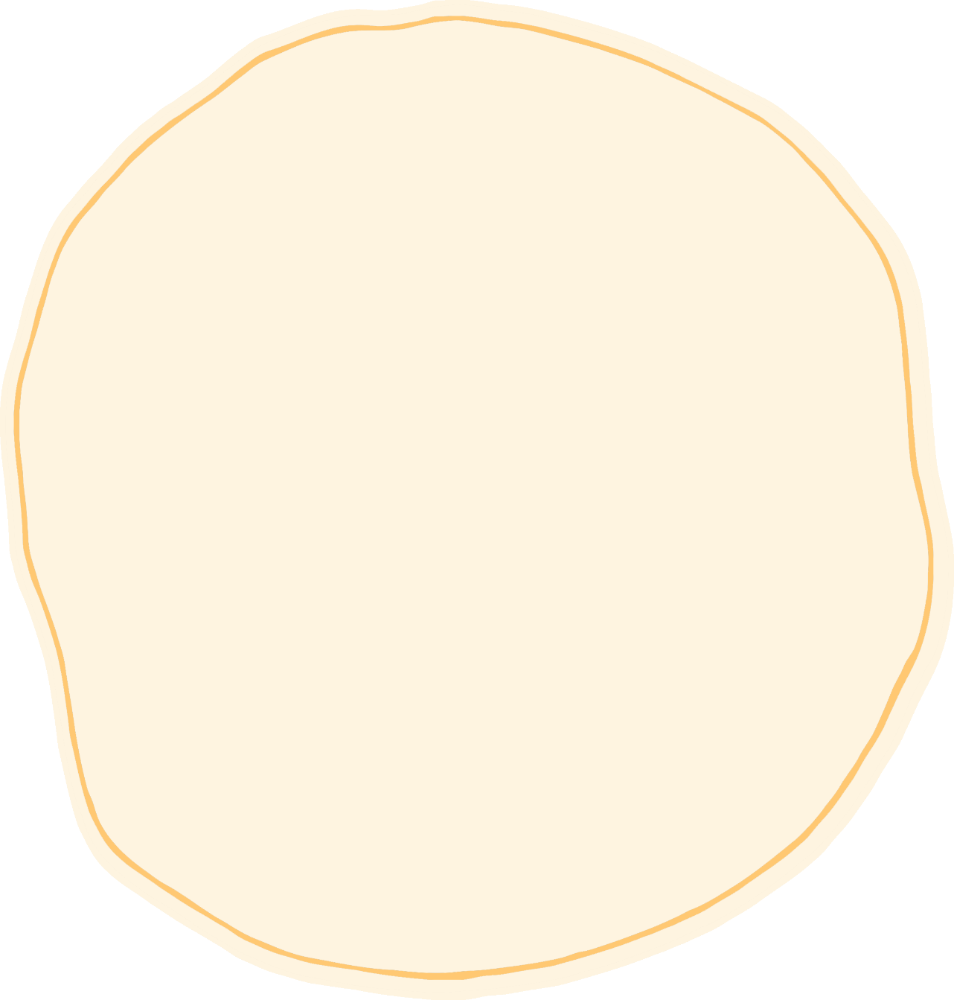

© 2020 Little Owls Resources

**What will you put on your pancake?**



