N.B. Fold along the line and laminate before use.

© 2021 Little Owls Resources

PE Games A5 Cards

PE Games

Swim & Sharks

Lay several hoops out in the play space. When you say ‘SWIM’ the children must move around avoiding the hoops. When you say ‘SHARKS’ they must quickly stand inside a hoop. You can limit the number of children who can stand in each hoop. The hoops can be removed one at a time as the game progresses.

© 2021 Little Owls Resources

PE Games

Dash - Colours

Place different coloured cones around the play space. At the start of the game, the children move around the area, either walking or jogging. When you call a colour, they must run to the correct colour cone.

© 2021 Little Owls Resources

PE Games

Traffic Lights

When you call ‘RED’ the children must freeze like statues.

When you call ‘AMBER’ the children must walk around the space.

When you call ‘GREEN’ the children must jog around the space.

© 2021 Little Owls Resources

PE Games

Dino Freeze

The children find a space and stay as still as a statue. You move around the space like a hunting dinosaur looking for anyone who moves. Remind the children to keep absolutely still because your dino vision is based on movement!

© 2021 Little Owls Resources

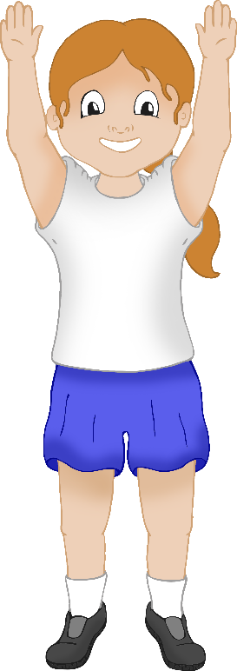

PE Games

Grow like a plant

Children to find a space and then curl up like a small seed on the floor. Encourage them to ‘grow’ into a plant/flower very slowly and gracefully.

‘How slow can you grow?’

© 2021 Little Owls Resources

“3”

3

PE Games

Dash - Numbers

Place different number cards around the play space. At the start of the game, the children move around the area, either walking or jogging. When you call a number, they must run to the correct number card.

© 2021 Little Owls Resources

ch

“ch”

PE Games

Dash - Phonics

Place different letters and sounds around the play space. At the start of the game, the children move around the area, either walking or jogging. When you call a letter or a sound, they must run to the corresponding card.

© 2021 Little Owls Resources

PE Games

Home

Place colour cones around the play space. Assign each child to a colour and get them to sit near the corresponding cone. Tell the children that that colour is their home. Then get the children to move about the play space with jumps, toe-touches, etc. When you say ‘HOME’ the children must get back to their home colour cone!

© 2021 Little Owls Resources