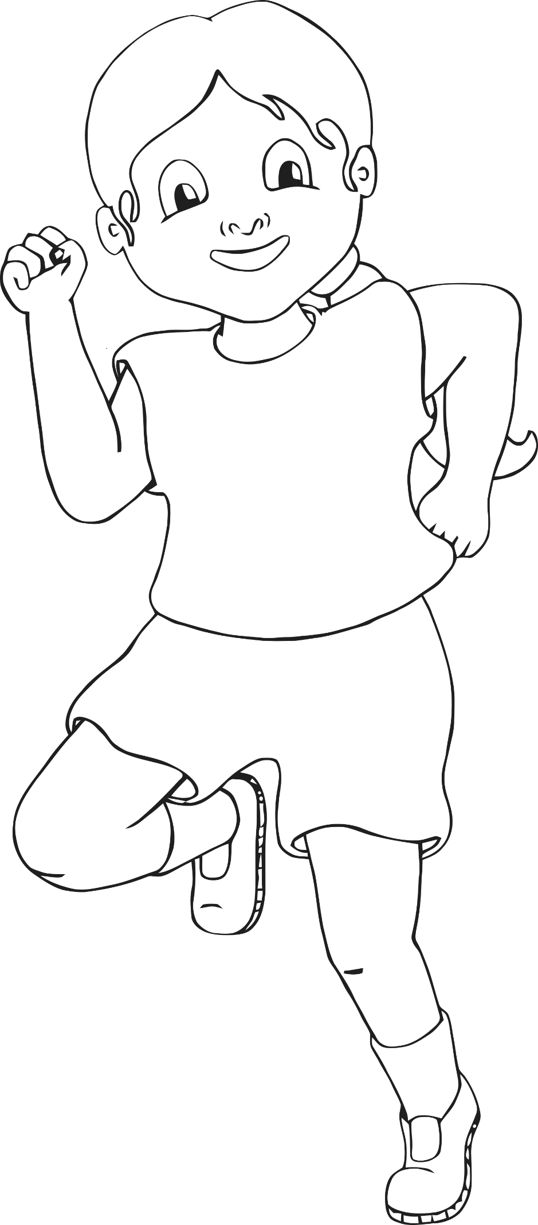

**Running**

© 2021 Little Owls Resources

**Kick**

© 2021 Little Owls Resources

© 2021 Little Owls Resources

**Balance**

**Star Jump**

© 2021 Little Owls Resources

**Stretch**

© 2021 Little Owls Resources

© 2021 Little Owls Resources

**Walking**

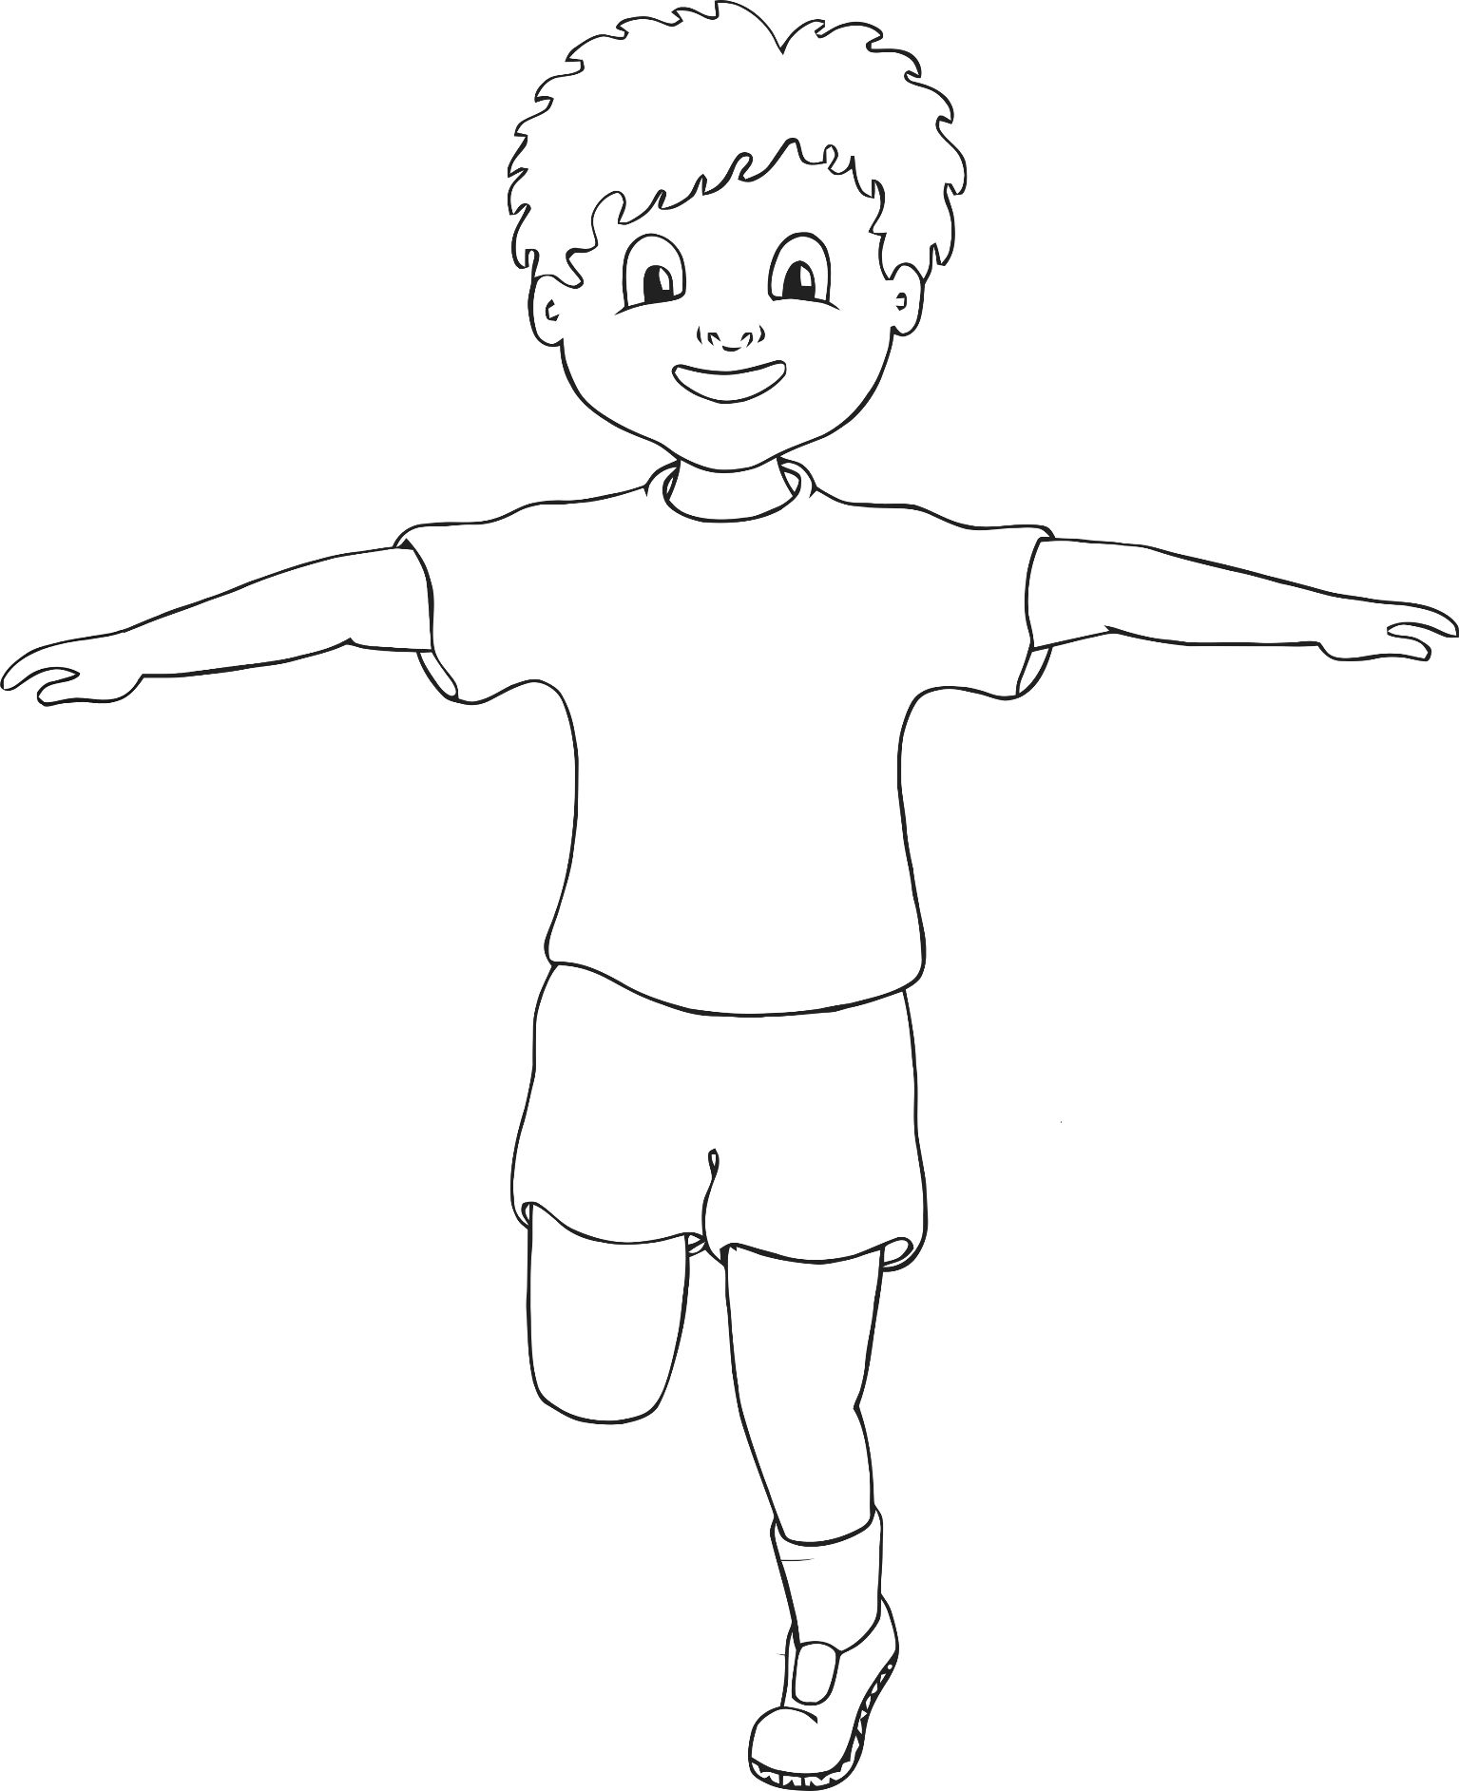

© 2021 Little Owls Resources

**Hopping**

© 2021 Little Owls Resources

**Bounce**

**Throw and Catch**

© 2021 Little Owls Resources

© 2021 Little Owls Resources

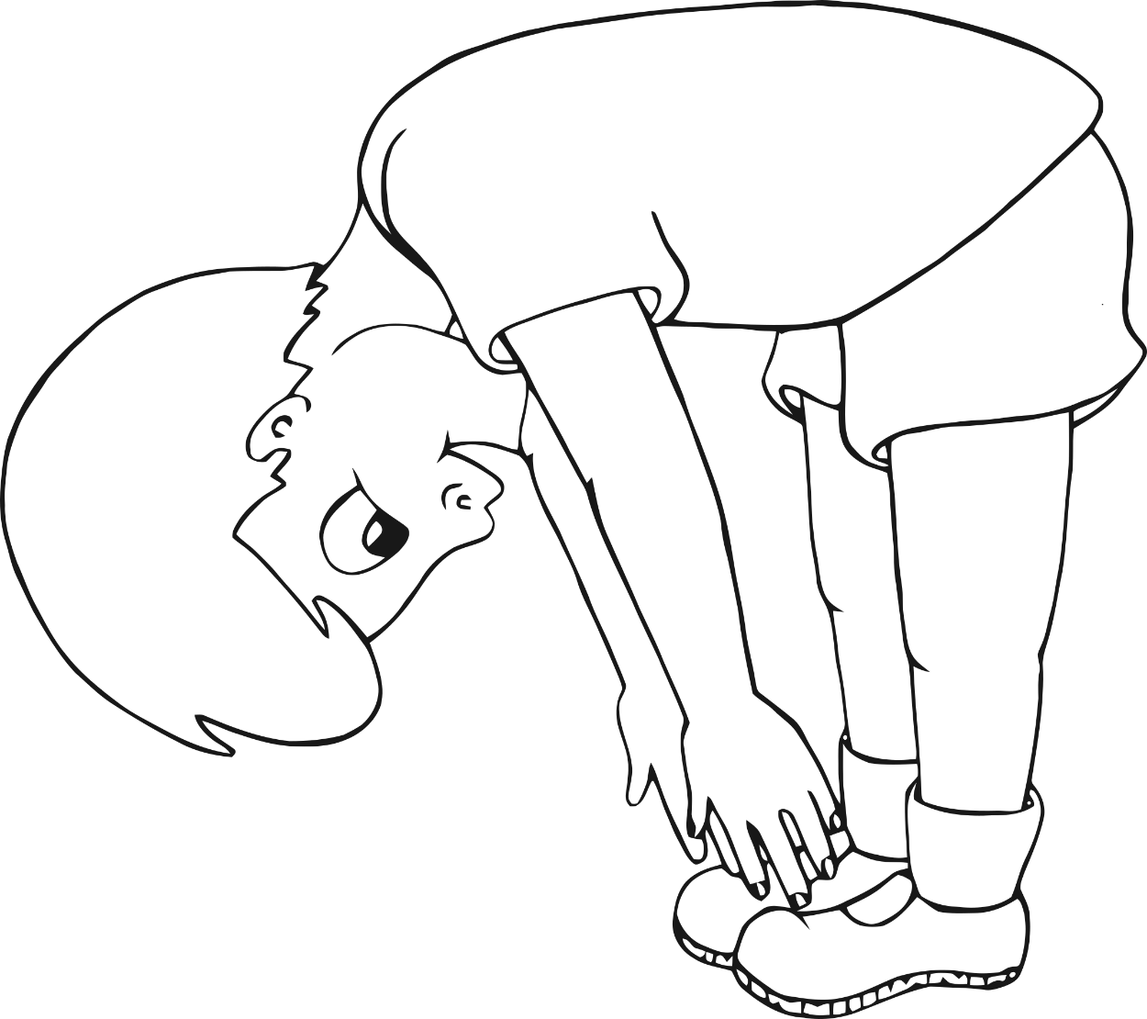

**Touch toes**

© 2021 Little Owls Resources

© 2021 Little Owls Resources

**Balancing Pose**

© 2021 Little Owls Resources

**Curled up**