* Fact posters x3 (Could be used as stimuli for a lesson input)
* Number slice activity (1-10) (Can be pre-cut for a pure number ordering activity or left to be cut by child to add scissor practice)
* Number slice activity - colouring version (1-10) (As above but to be coloured before cutting)
* Description sheet (Can be used as an independent writing activity or with an adult scribing the ideas of a younger child)
* Draw and write sheets x3 (blank sheet, wide lines and narrow lines)
* A4 poster
* A4 poster - colouring version
* ‘Body Parts’ x3 (fully labelled, initial sounds only, blank)
* 1x 4-piece puzzle
* Multimats x2 (for Colouring/Art & Craft/Loose Parts/Playdough)

**Barn Owl**

The pages of this pack give some general information about tigers and some fun and engaging activities to foster and develop children’s interest in them.

**This pack includes:**

© 2021 Little Owls Resources

This pack includes:

The pages of this pack give some general information about the role of a paramedic and some fun and engaging activities to foster and develop children’s interest in this role in society.

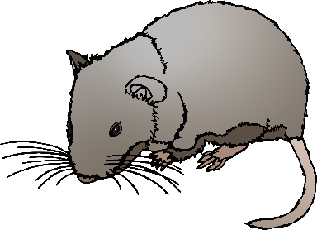

© 2021 Little Owls Resources

**Barn Owl Facts**

**NIGHT**

Barn Owls can live for

years.

**4**

Owls eat

**small mammals**.

Barn Owls mostly hunt at !

Climate change is affecting the ability of Barn Owls to find food through the year.

Many Barn Owls are killed when hit by road vehicles.

**Barn Owls are** Protected.

© 2021 Little Owls Resources

**How big is a Barn Owl?**

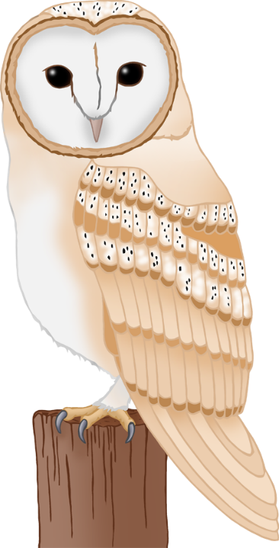

30-40cm

© 2021 Little Owls Resources

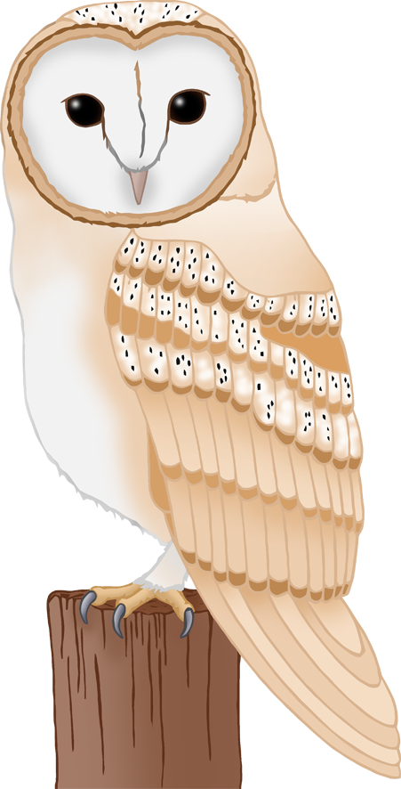

1

2

3

4

5

6

7

8

9

10

© 2021 Little Owls Resources

10

9

8

7

6

5

4

3

2

1

© 2021 Little Owls Resources

© 2021 Little Owls Resources

**What words would you use to describe a Barn Owl?**

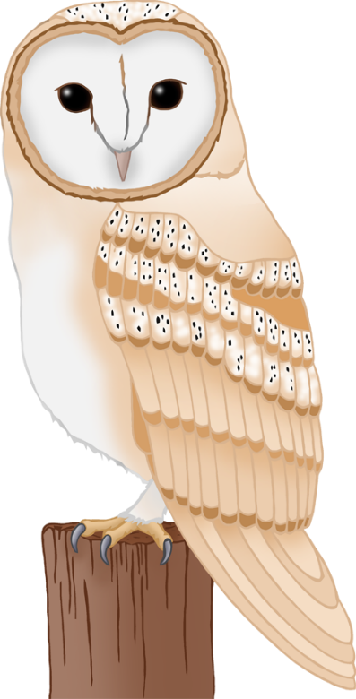

© 2021 Little Owls Resources

**Draw a Barn Owl!**

© 2021 Little Owls Resources

**Draw and write about a Barn Owl!**

____________________________________________________

© 2021 Little Owls Resources

**Draw and write about a Barn Owl!**

______________________________________________________________________________________________________

**Barn Owl**



© 2021 Little Owls Resources

**Barn Owl**

© 2021 Little Owls Resources

© 2021 Little Owls Resources

**Barn Owl body parts**



talon

beak

head

eye

**w**ing

© 2021 Little Owls Resources

**Barn Owl body parts**



t

b

h

e

**w**

© 2021 Little Owls Resources

**Barn Owl body parts**





**Barn Owl**

© 2021 Little Owls Resources

**Barn Owl Multimat – Barn Owl**

© 2021 Little Owls Resources

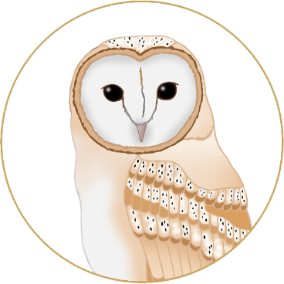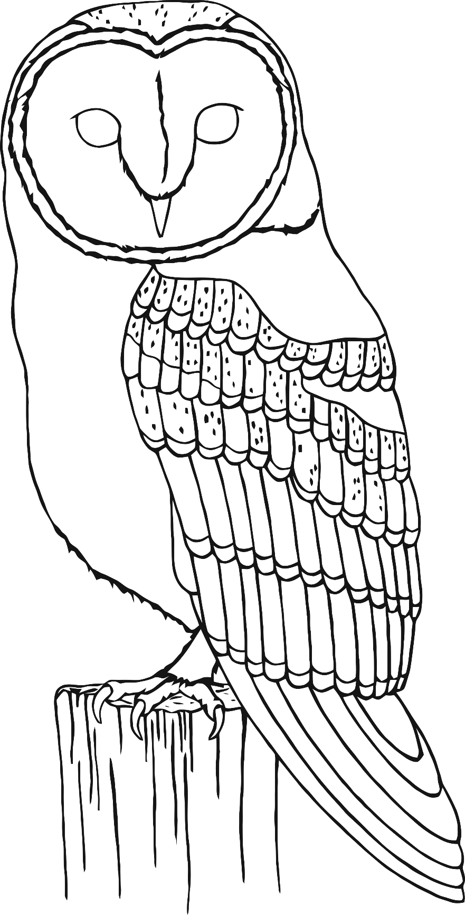

**Barn Owl Multimat – Food**

© 2021 Little Owls Resources



