**Outdoor Winter Number Cards**

These cards could be used as part of a winter number display or laminated for use in a number/counting activity.

© 2023 Little Owls Resources

© 2023 Little Owls Resources

© 2023 Little Owls Resources

0

1

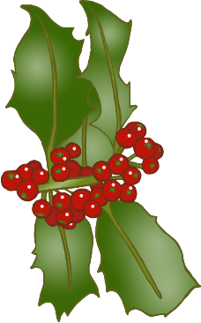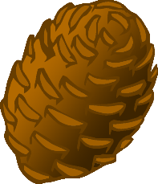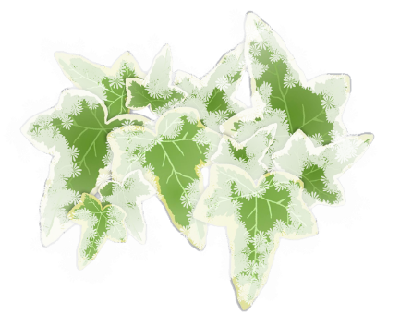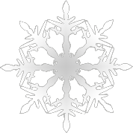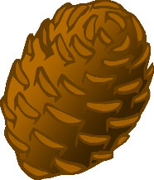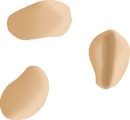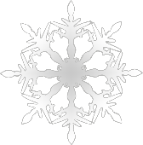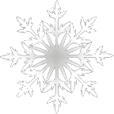

© 2023 Little Owls Resources

© 2023 Little Owls Resources

2

3

© 2023 Little Owls Resources

© 2023 Little Owls Resources

4

5

© 2023 Little Owls Resources

© 2023 Little Owls Resources

6

7

© 2023 Little Owls Resources

© 2023 Little Owls Resources

8

9

