**Outdoor Spring Letter Cards**

These cards could be used as part of a spring letter display or laminated for repeated use.

© 2022 Little Owls Resources



a

b

© 2022 Little Owls Resources

© 2022 Little Owls Resources

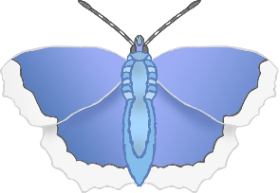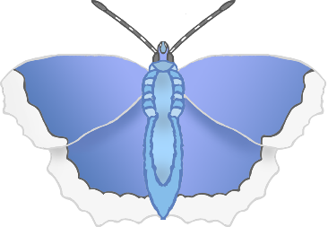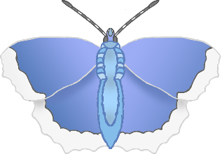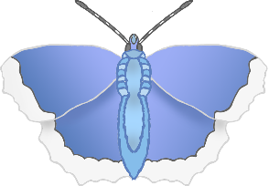

c

d

© 2022 Little Owls Resources

© 2022 Little Owls Resources



e

f

© 2022 Little Owls Resources

© 2022 Little Owls Resources



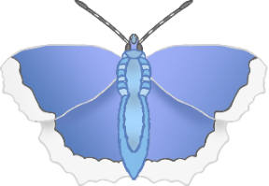

g

h

© 2022 Little Owls Resources

© 2022 Little Owls Resources



i

j

© 2022 Little Owls Resources

© 2022 Little Owls Resources



k

l

© 2022 Little Owls Resources

© 2022 Little Owls Resources



m

n

© 2022 Little Owls Resources

© 2022 Little Owls Resources



o

p

© 2022 Little Owls Resources

© 2022 Little Owls Resources



q

r

© 2022 Little Owls Resources

© 2022 Little Owls Resources



s

t

© 2022 Little Owls Resources

© 2022 Little Owls Resources



u

v

© 2022 Little Owls Resources

© 2022 Little Owls Resources



**w**

x

© 2022 Little Owls Resources

© 2022 Little Owls Resources



y

z

© 2022 Little Owls Resources

© 2022 Little Owls Resources

