**Outdoor Mark Making Cards**

© 2021 Little Owls Resources

These cards can be laminated for repeated use. Each of the six minibeasts has a dotted line card and a card with a blank space.

© 2021 Little Owls Resources

© 2021 Little Owls Resources

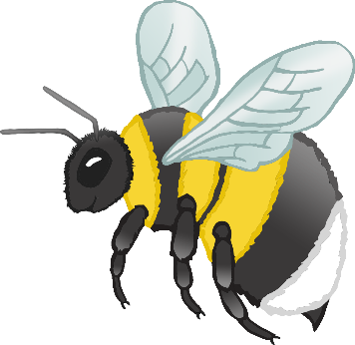

© 2021 Little Owls Resources

© 2021 Little Owls Resources

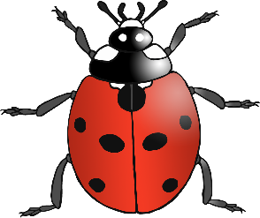

© 2021 Little Owls Resources

© 2021 Little Owls Resources

© 2021 Little Owls Resources

© 2021 Little Owls Resources

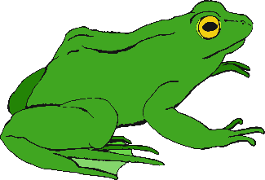

© 2021 Little Owls Resources

© 2021 Little Owls Resources

© 2021 Little Owls Resources

© 2021 Little Owls Resources