These cards are intended to be used as a stimulus for making numbers with natural materials in the outdoor area.

It is not intended for these representations to be copied exactly; any combination of natural resources will do!

**Outdoor Autumn Number Cards**

© 2021 Little Owls Resources

© 2021 Little Owls Resources

© 2021 Little Owls Resources

0

1

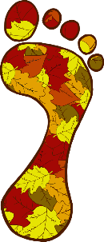

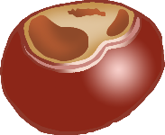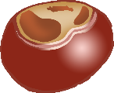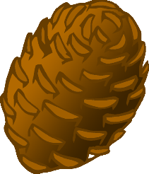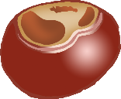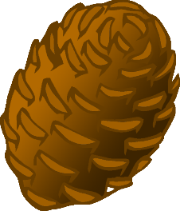

© 2021 Little Owls Resources

© 2021 Little Owls Resources

2

3



© 2021 Little Owls Resources

© 2021 Little Owls Resources

4

5



© 2021 Little Owls Resources

© 2021 Little Owls Resources

6

7



© 2021 Little Owls Resources

© 2021 Little Owls Resources

8

9

