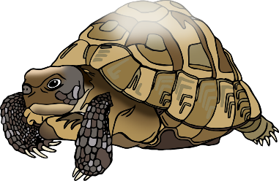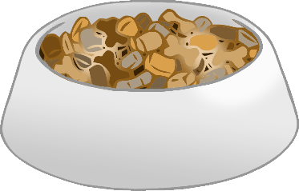

**Our**

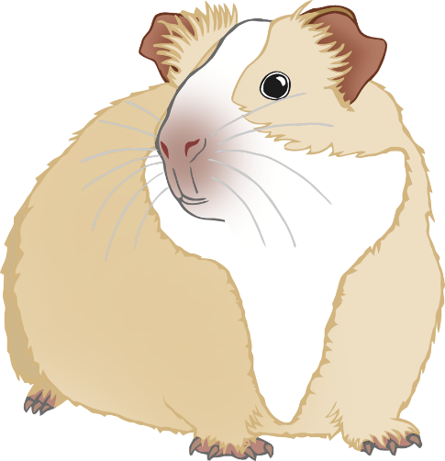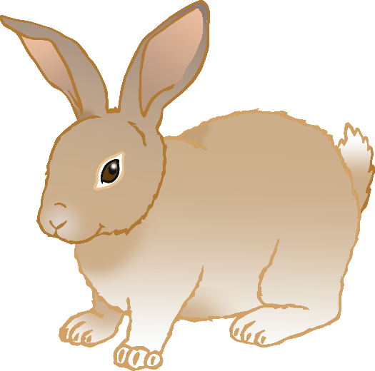

© 2021 Little Owls Resources

**Pets**

**Kippur**