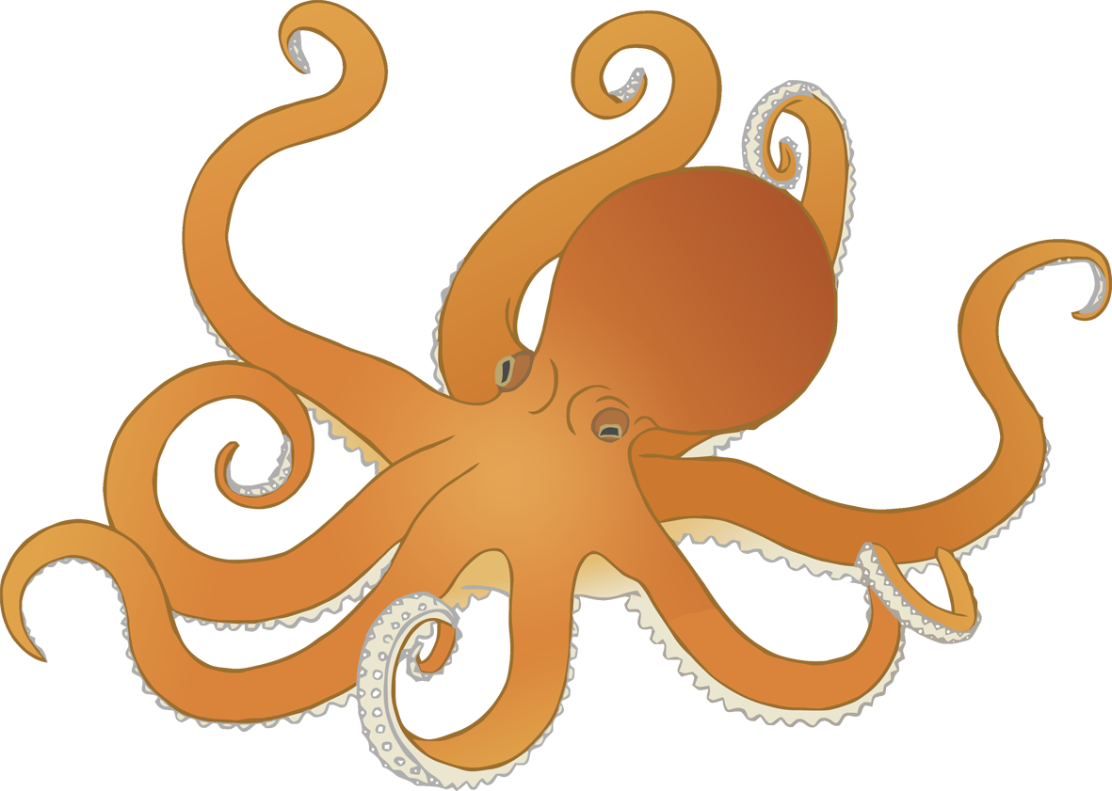

**Octopus body parts**

© 2020 Little Owls Resources



**Octopus body parts**

© 2020 Little Owls Resources

s

m

e

h

t



**Octopus body parts**

© 2020 Little Owls Resources

suckers

mantle

eye

head

tentacle