1, 2, 3, 4, 5, Once I caught a fish alive

Why did you let it go?

Because it bit my finger so.

Which finger did it bite?

This little finger on my right.

One, two, three, four, five

Once I caught a fish alive,

Six, seven, eight, nine, ten,

Then I let it go again.

If you’re happy and you know it…

If you're happy and you know it, clap your hands!

If you're happy and you know it, clap your hands!

If you're happy and you know it,

and you really want to show it,

If you're happy and you know it, clap your hands!

* If you're happy and you know it, stamp your feet!
* If you're happy and you know it, nod your head!
* If you're happy and you know it, touch your ear!
* If you're happy and you know it, turn around!
* If you're happy and you know it, touch your nose!
* If you're happy and you know it, say "we are!"

Hey Diddle Diddle

Hey Diddle Diddle,

The cat and the fiddle,

The cow jumped over the moon.

The little dog laughed

To see such fun

And the dish ran away with the spoon.

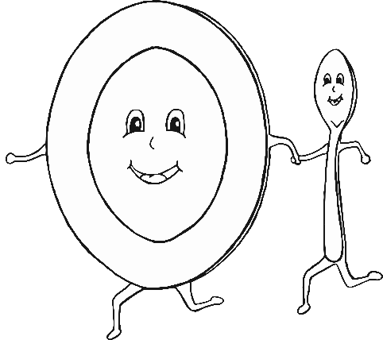

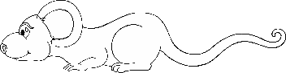

Hickory Dickory Dock

Hickory Dickory Dock,

The mouse ran up the clock.

The clock struck one,

The mouse ran down!

Hickory Dickory Dock.

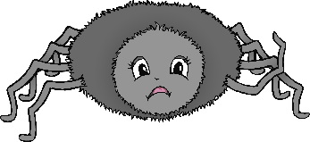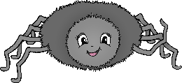

Incy Wincy Spider

Incy Wincy Spider went up the water spout.

Down came the rain and washed the spider out.

Out came the sun and dried up all the rain.

So, Incy Wincy Spider climbed up the spout again.

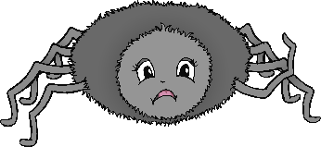

Itsy Bitsy Spider

Itsy Bitsy Spider went up the water spout.

Down came the rain and washed the spider out.

Out came the sun and dried up all the rain.

So, Itsy Bitsy Spider climbed up the spout again.

Round and round the garden

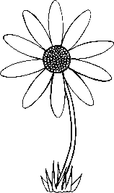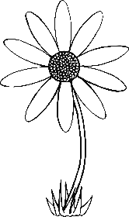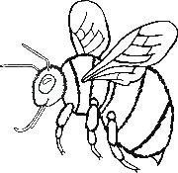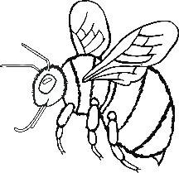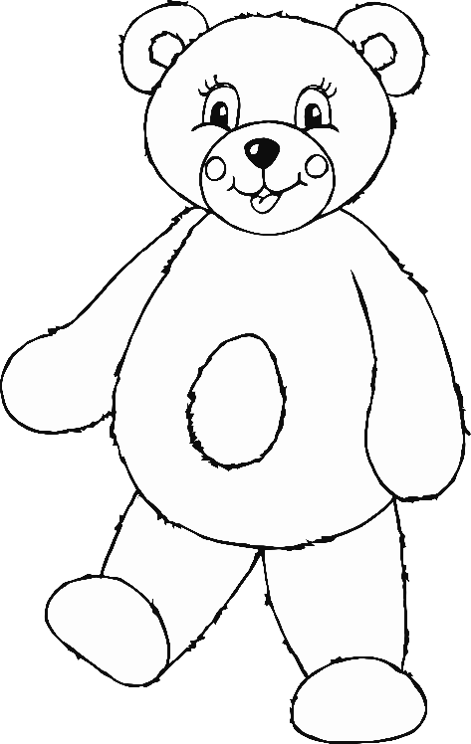

Round and round the garden,

like a teddy bear,

one step, two step,

tickle you under there.

Twinkle Twinkle Little Star

Twinkle, twinkle, little star,

How I wonder what you are.

Up above the world so high,

Like a diamond in the sky.

Twinkle, twinkle, little star,

How I wonder what you are.

